R5: BIOGRAPHY

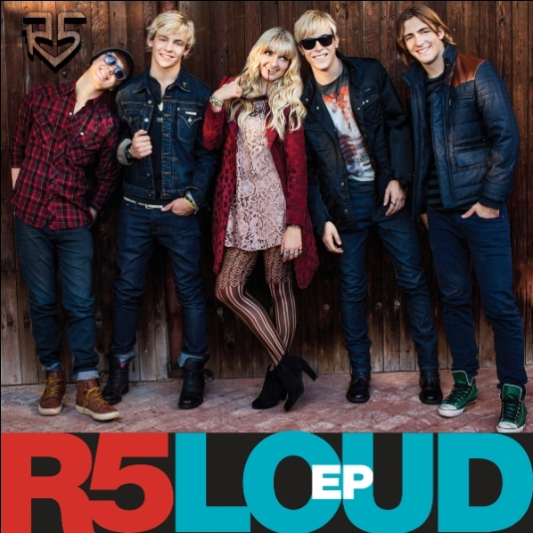
Ask the members of R5 about the best way to play their music and you get a one-word answer: Loud. Whether on stage or in the studio, siblings Riker, Rydel, Rocky and Ross Lynch, along with best friend Ratliff, tend to crank it. But it doesn’t stop there. They hope their rapidly growing army of fans will pump up the volume when they sample R5’s new Hollywood Records EP, aptly titled “Loud.”

“Our basic mindset was that we wanted to make everyone feel excited and happy,” says Riker Lynch of the new EP. “It’s about driving down the highway with the top down and blasting music. We didn’t want anything too deep and dark.”

Bright and sunny is more like it. To perfect their sound, R5 worked with producer-songwriters Emanuel “Eman” Kiriakou (Selena Gomez, Hot Chelle Rae) and Evan “Kidd” Bogart, who won a Grammy for writing the Beyonce hit, “Halo.” The team wrote three tracks for the band while R5 members Riker and Ross contributed an original.

The 4-song EP covers a lot of musical ground, starting with the heart-stopping title track. The doo-wop-influenced rocker “I Want You Bad” tackles the theme of longing for someone else’s girlfriend, while “Fallin’ For You” counts off the reasons why that one special girl is so special. The up-tempo ballad “Here Comes Forever,” written by Riker and Rocky, riffs on a score of clever movie references to sum up the perfect romance.

At the end of a typical rom-com, the heroes usually walk into the sunset. But now is a time of sunrise for R5, undisputedly the teen band to watch in 2013.
If Riker and Ross look familiar, it’s because the former is a regular on "Glee" (as a member of the a cappella group, the Warblers) while Ross stars in the Disney Channel Original smash hit series, "Austin & Ally." Each band member is a virtuoso musician and all write, especially lead guitarist Rocky and bassist Riker, who serve as R5’s in-house songwriters.

The R5 story actually begins in the Denver suburb of Littleton, Colo. There, as a child, Riker got things started when he revealed a talent for singing. With Elvis, the Beatles and the Stones playing in background, soon Riker and his siblings started taking music seriously.
Once they set on a show business career, the entire family moved to Los Angeles in 2007. The Lynch kids experienced success quickly, finding professional acting, dance and commercial opportunities.

Though the Lynchs had their musical act down, something was missing: a drummer. That’s when they turned to friend Ellington Ratliff, who rounded out the line-up. "Being an only child, the Lynchs are my second family," Ratliff says. "I get the best of both worlds: my own family and then this huge family."

Though no one would fail to see the family resemblance among the Lynch siblings, each is unique. "Rydel is the giggly innocent," says Ross of his sister. "The fans love her and the girls look up at her. Yet she’s also one of the boys." Says Rocky of lead singer Ross, "He’s good at everything and he knows it. He’s the most confident kid."

All agree Riker is the "captain of the ship," Ratliff the funny one and Rocky the best composer. As the only girl in the group, keyboard player Rydel says she’s having the time of her life. "Ratliff and my brothers are the best," she says, adding with a laugh, "but I usually get my way."

For much of 2012, the band honed its performing chops, headlining club shows in Chicago, Phoenix, Toronto, New York, New Jersey and beyond. “There’s something cool that happens when we’re on stage together,” Riker says. “There’s nothing more fun in the world. We try to be very personable, and meet the entire audience after shows. Fans you meet on the road stick with you forever.”

That theory panned out, as R5 boasts more than 112,000 Facebook page likes. And that was the tally before the release of “Loud.” Now that the EP is out, the band is set for a spring 2013 tour, though a national TV audience got a sneak peek when R5 performed at the Progressive Skating and Gymnastics Spectacular, broadcast on NBC.

After a lifetime of prep, it’s time for R5 to bring it. The band members say they are more than ready, and feel confident their new EP will impress. All fans have to do is turn it up loud. How’s that sound?

# # #
CONTACT:
Lillian Matulic
V.P. Publicity, Disney Music Group
Lillian.Matulic@Disney.com

