FOR IMMEDIATE RELEASE:
R5 ANNOUNCE SPRING TOUR DATES;
DEBUT EP LOUD OUT FEBRUARY 19
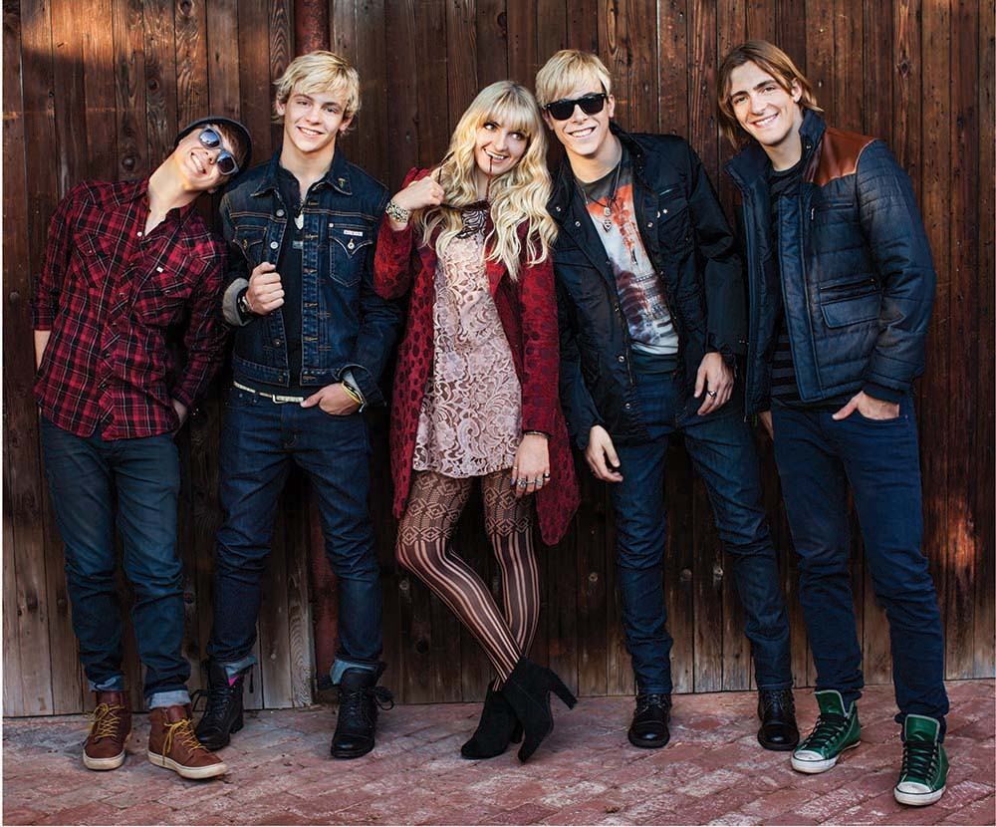
L to R: Ratliff (drums/vocals), Ross (guitar/vocals), Rydel (keyboard/vocals), Riker (bass/vocals), Rocky (guitar/vocals)
February 1, 2013 (Burbank, CA) – Hollywood Records recording artists R5 announced their North American Spring tour dates which kick off March 15 in Santa Ana, California. The tour comes on the heels of their hotly anticipated debut EP, Loud, produced by Emanuel “Eman” Kiriakou and Evan “Kidd” Bogart and set for release February 19.
The bands full-length debut to be released this fall.
Watch the official video for “Loud” here: http://youtu.be/aLXO88Sl12Y and a special acoustic versions of “Loud”: http://smarturl.it/R5LoudAcoustic “Fallin’ for You”: http://youtu.be/ZDXaLQkunGE
“I Want You Bad”: http://youtu.be/NqScwvw8yvU

Originally from Colorado, the L.A. based R5 is comprised of siblings Riker (bass/vocals), Ross (guitar/vocals), Rocky (guitar/vocals) and Rydel Lynch (keyboard/vocals); and their childhood best friend Ellington “Ratliff” (drums/vocals). For much of 2012, the band honed its performing chops, headlining sold-out club shows in Chicago, Phoenix, Toronto, New York among others. “There’s something cool that happens when we’re on stage together,” Riker says. “There’s nothing more fun in the world. We meet the entire audience after the show, and we love our fans.”
Ross and Riker Lynch have already made names for themselves, starring in Disney Channel Original Series “Austin & Ally” and “Glee” respectively.
Tickets for R5 Fan Club members and VIP tickets will go on sale February 5, followed by the official on sale date February 8. The band announced the tour dates on their R5rocks.com website and @officialR5twitter.
Pre-sale and VIP tickets can be purchased exclusively on the R5 website: bit.ly/r5fanclub
Watch this special tour announcement video from R5! http://youtu.be/W7kOdWiMBA8
The R5 Loud Spring tour dates are below, with additional dates coming soon.
March 15 | Santa Ana, CA | Yost Theatre
March 16 | San Diego, CA | Epicenter
March 17 | Phoenix, AZ | Celebrity Theatre
March 19 | Salt Lake City, UT | In The Venue
March 20 | Denver, CO | Bluebird Theater
March 22 | Dallas, TX | House of Blues SOLD OUT
March 24 | Austin, TX | Stubbs, Jr. SOLD OUT
March 25 | Tulsa, OK | Cains
March 26 | Columbia, MO | The Blue Note
March 28 | Lawrence, KS | Granada Theatre
March 29 | Minneapolis, MN | Mill City
March 30 | Chicago, IL | House of Blues SOLD OUT
April 1 | St. Louis, MO | Firebird SOLD OUT
April 2 | Indianapolis, IN | Deluxe
April 4 | Cleveland, OH | House of Blues
April 5 | Detroit, MI | Cro Foot
April 6 | Buffalo, NY | Town Ballroom
April 7 | Allentown, PA | Croc Roc
April 9 | Lancaster, PA | The Chameleon
April 11 | New York, NY | Irving Plaza
April 12 | Huntington, NY | Paramount Theatre
April 13 | Richmond, VA | The National
April 14 | Virginia Beach, VA | The Norva
April 16 | Charlottesville, VA | Jefferson Theatre
April 18 | Cincinnati, OH | 20th Century Theatre SOLD OUT
April 19 | Nashville, TN | Rocketown SOLD OUT
April 20 | Atlanta, GA | Masquerade
April 21 | Tampa, FL | The Palladium
April 23 | Orlando, FL | The Plaza Live SOLD OUT
April 25 | Baltimore, MD | Ramshead
April 26 | Philadelphia, PA | Theatre of Living Arts SOLD OUT
April 28 | Freehold, NJ | Encore Events Center SOLD OUT
April 30 | Albany, NY | Upstate Music Hall
May 2 | Boston, MA | Paradise SOLD OUT
May 4 | Montreal, QC | Corona SOLD OUT
May 5 | Ottawa, ON | Bronson Center SOLD OUT
May 6 | Hamilton, ON | The Studio at Hamilton Place SOLD OUT
May 7 | London, ON | London Music Hall SOLD OUT
May 10 | Winnipeg, MB | Garrick Center SOLD OUT
May 11 | Saskatoon, SK | Louis SOLD OUT
May 12 | Edmonton, AB | The Starlite Room SOLD OUT
May 14 | Vancouver, BC | The Rio SOLD OUT
May 15 | Seattle, WA | El Corazon
May 16 | Portland, OR | Hawthorne Theatre
May 18 | San Francisco, CA | Great American Music Hall SOLD OUT
May 19 | Los Angeles, CA | House of Blues SOLD OUT
May 24 | Houston, TX | House of Blues
May 25 | San Antonio, TX | Sam’s Burger Joint
June 30 | Paris, France | Nouveau Casion
July 5 | London, UK | Dingwalls
July 27 | Rye, NY | Rye Playland
July 28 | Whitehouse Station, NJ | Solberg Airport, Festival of Ballooning
Aug. 18 | Aurora, IL | RiverEdge Park

For More Info on R5, visit:
Official Website / www.R5rocks.com
www.facebook.com/officialR5
twitter.com/officialR5
www.youtube.com/user/officialR5
http://www.fuse.tv/videos/2013/05/r5-interview-parent-fans-new-ep - FUSE interview
# # #
CONTACT:
Sharrin Summers
Hollywood Records Publicity
Sharrin.summers@disney.com / 818.560.5787

