FOR IMMEDIATE RELEASE PUBLICITY

MEDIA CONATCT:
Sharrin Summers – Hollywood Records Publicity
818.560.5787 / sharrin.summers@disney.com

R5 ENTER BILLBOARD TOP 200 AT #24
DEBUT ALBUM LOUDER HITS #2 ON iTUNES POP CHART

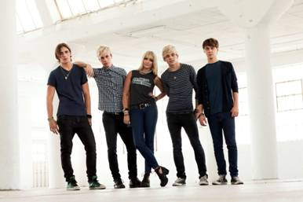

L to R: Rocky (guitar/vocals), Riker (bass/vocals), Rydel (keyboard/vocals), Ross (guitar/vocals), Ratliff (drums)

(BURBANK, CA, October 2, 2013) – Fueled by lead tracks “Pass Me By” and “Loud” and an electrifying performance on Good Morning America, R5 have rocketed onto the Billboard Top 200 at No. 24 and hit No. 2 on the iTunes Pop chart with debut album Louder, produced by Emanuel "Eman" Kiriakou and Andrew Goldstein for Mod Squad Music Inc., and co-written by the band.

R5, who recently appeared on MTV’s "10 on Top," teamed with VEVO for the premiere of the "Pass Me By" video, which was directed by Ryan Pallota (Demi Lovato, Ariana Grande).The quintet also starred in a 5-part VEVO series titled "R5 on R5," which saw cameras follow them on a sold-out worldwide tour that included shows in the U.S., Australia, England and France.

R5 has rapidly emerged as an exciting new voice in the world of pop rock. Originally from Littleton, Colo., the L.A.-based band is comprised of siblings Riker (bass/vocals), Ross (guitar/vocals), Rocky (guitar/vocals) and Rydel Lynch (keyboard/vocals); along with friend Ellington "Ratliff" (drums/vocals).

Ross also starred in the hit 2013 Disney Channel Original Movie Teen Beach Movie, and was featured on the soundtrack album which hit the #2 spot on the iTunes overall album chart and #3 on the Billboard 200 chart. The soundtrack spent five consecutive weeks in the top 10 on the Billboard 200 chart and has sold over 300,000 albums to date. Between R5’s Loud EP and debut album Louder, Teen Beach Movie Soundtrack and the Austin & Ally soundtrack, Ross has over sold 500,000 albums.

To date, R5 combined has amassed 15.5 million YouTube/VEVO views, over 1.75 million Facebook likes, 1.3 million Instagram followers and more than 2.3 million Twitter followers worldwide, all before the release of their album debut.

R5 is slated to make a string of concert appearances in the weeks ahead. Tour dates are as follows:

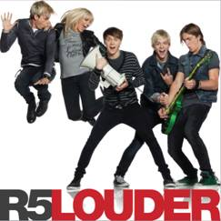

Sat., Oct. 26 | Dallas | South Side Music Hall SOLD OUT
Sun., Oct. 27 | Boston | House of Blues SOLD OUT
Mon., Oct. 28 | Huntington, NY | The Paramount SOLD OUT
Wed., Oct. 30 | Chicago | House of Blues
Fri., Nov. 1 | Orlando, FL | Plaza Theatre SOLD OUT
Sat., Nov. 2 | Toms River, NJ | Pine Belt Arena
Sat., Nov. 16 | Los Angeles, CA | Club Nokia
Sat., Dec. 7 | Mexico City, Mexico | Teatro Metropolitan
Sun., Nov. 24 | Tokyo, Japan | Ikspiari
Mon., Nov. 25 | Tokyo, Japan | Tower Records Shinjuku
Sat., Jan. 4 | San Juan, Puerto Rico | Coliseo de Puerto Rico
Sun., Jan. 5 | Santo Domingo, Dominican Republic | Teatro Nacional
###
iTunes Smart Link: Amazon Smart Link:
http://smarturl.it/r5iTunesa1 http://smarturl.it/r5Amazona1

R5 – Media kit page: www.hollywoodrecords.com/press/r5
“Pass Me By” official video; http://www.youtube.com/watch?v=lVe6SEH9IsM
“Pass Me By” behind the scenes: http://youtu.be/0SZzUYdu23s
R5 on R5:
Episode 1- The Band: http://vevo.ly/ybpp4B
Episode 2 – The R5 Family: http://vevo.ly/TYNmhl
Episode 3 – The Music: http://vevo.ly/UzTfYo
Episode 4 – The Road: http://youtu.be/QzZ2tQtc_l8
Episode 5 – The World: http://vevo.ly/PTJFUd
R5 on Good Morning America: http://www.youtube.com/watch?v=57zRgRc2f78&feature=player_embedded

For More Info on R5, visit:
Official Website - www.R5rocks.com
Facebook - http://facebook.com/OfficialR5:
Twitter - http://twitter.com/OfficialR5: @officialR5; @rossR5; @rockyR5; @rikerR5;@rydelR5; @ratliffR5
Instagram - http://instagram.com/officialr5
VEVO - http://youtube.com/R5VEVO
YouTube - www.youtube.com/user/officialR5
R5 tour video: http://www.youtube.com/watch?v=sBel8B8cCMk

