NEW HOPE CLUB RELEASE NEW SINGLE
LOVE AGAIN OUT MAY 3
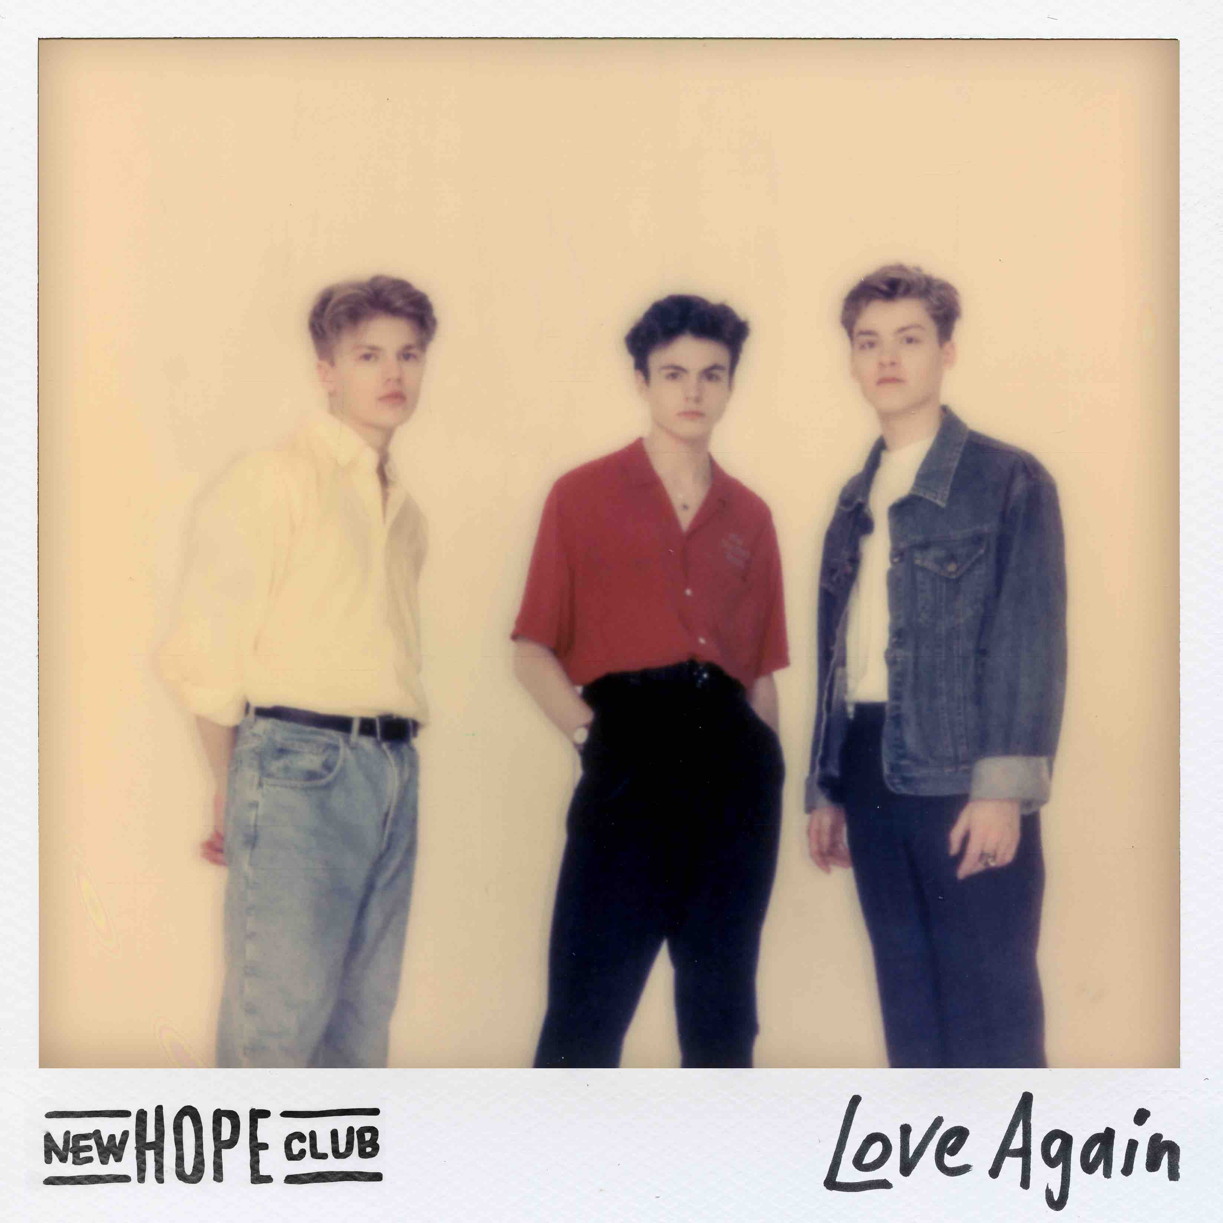

British trio New Hope Club have announced the release of their newest track, “Love Again.” The anthemic song has a contemporary-classic coming of age feel to it, exploring the
unfolding of a new relationship. “Love Again” will be available to stream (HERE) and download (HERE) across all digital partners, on 3rd May.

The song’s release follows the announcement of New Hope Club’s first ever UK headline tour. Kicking off September 24 at the 02 Academy in Oxford, England, the band will make their way across the UK with stops in major cities including Leeds, Manchester, Glasgow and Birmingham as well as London’s legendary O2 Shepherd’s Bush Empire on 4th October.

Showing no signs of slowing down, this weekend sees New Hope Club join The Vamps on their Four Corners UK & Ireland arena tour. Following that the band headline multiple dates across Asia including Manila, Bangkok, Jakarta and Seoul where they have a rapidly growing fanbase. There are also plans in place for NHC to return to the U.S. this summer where they have previously toured with Sabrina Carpenter and performed on The Today Show and the Teen Choice Awards.

New Hope Club are raising stars with an ever-growing fan base on social media, YouTube and Spotify. They have picked up over 77 million views across their YouTube channel, scored over 70 million streams on Spotify alone and garnered around 590,000 monthly Spotify listeners. Over the last 12 months, they have released single “Permission” and their second EP Welcome To The Club Pt. 2 which topped the iTunes preorder chart in 10 countries including the UK.

New Hope Club are: George Smith, Blake Richardson and Reece Bibby

Find out more about them by visiting their Facebook, Twitter, Instagram and YouTube.

Four Corners Tour supporting The Vamps

5/1 –Royal Concert Hall, Nottingham
5/3 – Arena Birmingham, Birmingham
5/5 – M&S Bank Arena, Liverpool
5/7 – Sheffield City Hall, Sheffield
5/8 – Newcastle City Hall, Newcasstle-Under-Lyme
5/10 – BHGE Arena, Aberdeen
5/11 SSE Hydro, Glasgow
5/13 Sands Centre, Carlisle
5/15 – Hull Arena, Hull
5/17 Harrogate Int’l Center, Harrogate
5/18 02 Apollo, Manchester
5/20 – De Montfort Hall, Leicester
5/22-Norwich UEA, Norwich
5/23 – Cambridge Corn Exchange, Cambridge
5/25 – The 02, London
5/28 – Belfast The SSE Arena, Belfast
5/31 – The Brighton Center, Brighton
6/1 – Bournemouth International Center, Bournemouth

6/8 – New Frontier Theatre, QC, Philippines*
6/9 – Novotel Bangkok Sukhumvit 20, Khet Khlong Toei, Thailand*
6/15 – Hyndai Card Understage, Seoul, South Korea*
*=headline shows

New Hope Club’s Love Again headlining tour:

9/24 – O2 Academy, Oxford
9/26 – University Of Leeds, Leeds
9/28 – Academy 2, Manchester
9/29 – O2 Institute, Birmingham
10/1 – O2 Academy, Bristol
10/2 – Engine Rooms, Southampton
10/4 – O2 Shepherd’s Bush Empire, London
10/6 – The Waterfront, Norwich
10/8 – Junction, Cambridge
10/9 – Leadmill, Sheffield
10/11 – University Student Union, Newcastle
10/12 – The Garage, Glasgow
10/13 – O2 Academy, Liverpool
10/15 – The Academy, Dublin

For U.S. press enquiries please contact: sharrin.summers@disney.com

