NEW HOPE CLUB ANNOUNCE RELEASE OF NEW EP
WELCOME TO THE CLUB PT. 2
OUT ON 30TH OCTOBER

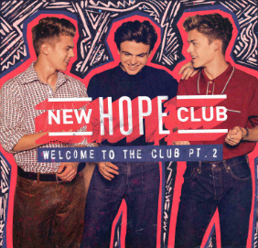

DOWNLOAD | STREAM

Due to phenomenal fan demand, New Hope Club have just announced the release of their new EP Welcome To The Club Pt. 2 to be released via Hollywood Records in the U.S. and Virgin EMI in all other territories on October 30th.

The four-track EP will include previous released tracks “Medicine” and “Crazy,” as well as brand-new track “Karma” and a special live version of fan favorite “Let Me Down Slow.”

“Medicine” and “Crazy” were released earlier this year and both have been picking up attention from some of the UK’s most esteemed tastemakers including Radio 1. In the U.S., the band recently made their national television debut performing “Medicine” on The Today show (watch here). The track’s companion video has racked up over a million views on YouTube (check it out here) while the recently released video for “Crazy,” (view here) is quickly approaching half a million views. The band’s combined audio streams have surpassed the 30 million mark and video views combined are over 47 million.

New Hope Club are a three-piece from the UK who have spent the past 18 months building up a loyal and rabid fanbase of over half a million followers on social media, and are quickly becoming one of the hottest emerging bands coming out of the UK. Over the past 18 months, they have released buzz tracks, posted covers of their favorite artists online and toured relentlessly around the world. Earlier this Summer they sold out two headline shows at London’s O2 Shepherd’s Bush Empire.

New Hope Club are Reece Bibby, Blake Richardson and George Smith.

Find out more about them by visiting their Facebook, Twitter, Instagram, YouTube or
check out the Who Are New Hope Club video.

For all press enquiries please contact:
sharrin.summers@disney.com
lyssa.hurvitz@disney.com

