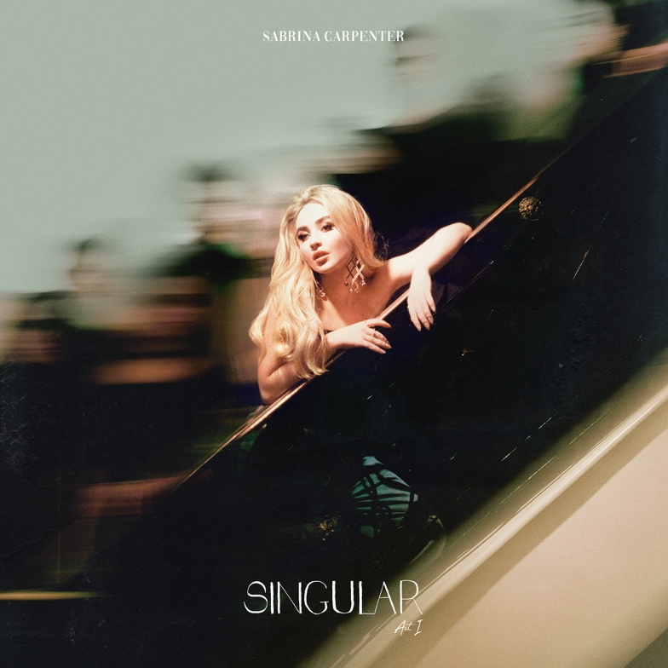

Sabrina Carpenter is on the edge of a new beginning with her new album Singular: Act I. This marks her third record, and she has grown considerably as an artist and writer between each release – something that especially shines through on Singular: Act I. "I'm beginning in a different place than I was before," says nineteen-year-old Carpenter of her latest project. In short, Carpenter knows herself better than ever.

Carpenter approached Singular: Act I a little bit older and a little bit wiser than she was when she began writing songs for her first album. She opted to push herself out of her comfort zone, flaunting the confidence of someone who has entered young adulthood and found their own voice. That same sense of empowerment is weaved throughout Singular: Act I: a set of eight sonic epiphanies (all of which she co-wrote) blending Carpenter's R&B-style vocals with the atmospheric pop sensibilities she helmed on her sophomore record EVOlution. “With every song I wanted to act and be able to tell the story theatrically, and that was something I don't think I got to do with EVOlution,” she said. To do that, Carpenter enlisted a group of musical power players to help craft Singular: Act I including Stargate, Jason Evigan, Oak Felder, Johan Carlsson and Oscar Gorres.

Singular: Act I follows Carpenter as she revels in her confidence as a young woman, making her voice the main instrument of the record. In the club-ready “Almost Love,” she pushes against her impulse control. “We could give it a minute, but what’s the fun in a minute?” she muses, her breathy vocals cascading over a seductive electro-pop beat. Carpenter recounts her love affair in France on her 18th birthday with “Paris,” fusing the idealistic, cinematic qualities of the city with her sultry lilt. The R&B-flavored “Hold Tight” is perhaps Carpenter’s most experimental track and pairs nicely with “PRFCT,” a pure R&B slow jam, which longtime Carpenter fans will appreciate for its catchy chorus. “So sue me, for looking too pretty tonight,” Carpenter teases on “Sue Me,” a confident anthem that encourages embracing and prioritizing your self-worth above anyone else’s perceptions – and surrounding yourself with those who want you at your best and worst. "What I can legally say, is that it's inspired by real-life experiences,” Carpenter says coyly of the track. The alluring, vocoder-heavy “Bad Time” defiantly flips the script, establishing the upper hand in a fair-weathered relationship. “Don’t leave me hangin’ like the Mona Lisa,” Carpenter seductively pleads on “Mona Lisa,” meditating on the effects of unspoken attraction. On the final track, “Diamonds Are Forever,” Carpenter asserts her self-confidence by belting her powerhouse vocals: “Money don’t buy class and I can’t be bought like that.”

Carpenter’s new album comes after a big year for the burgeoning pop star. Earlier this year she released “Alien” with Jonas Blue, as well as the first single from Singular: Act I, “Almost Love.” She most recently starred in the feature film The Hate U Give, based on Angie Thomas’ 2017 novel of the same name, she’ll be seen in the upcoming Netflix comedy Tall Girl and will take on her first leading role in The Short History of The Long Road in 2019 in addition to releasing Singular: Act II.

Instagram | Twitter | Facebook | Website

020519

