LIMITED-EDITION, SABRINA CARPENTER INSPIRED SHARE A COKE® BOTTLES AVAILABLE FOR LIMITED TIME BEGINNING
AUGUST 24 THROUGH SEPTEMBER 30

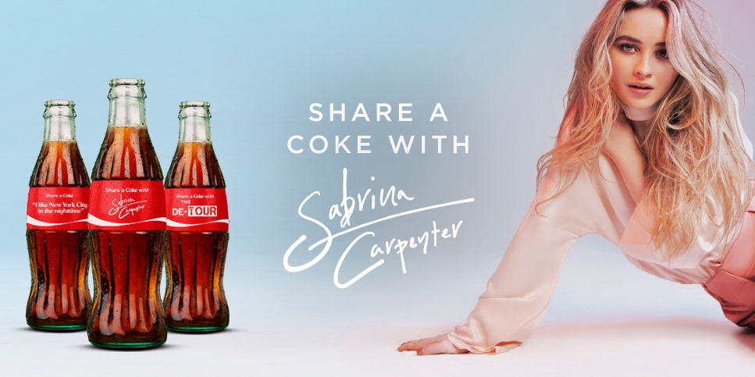

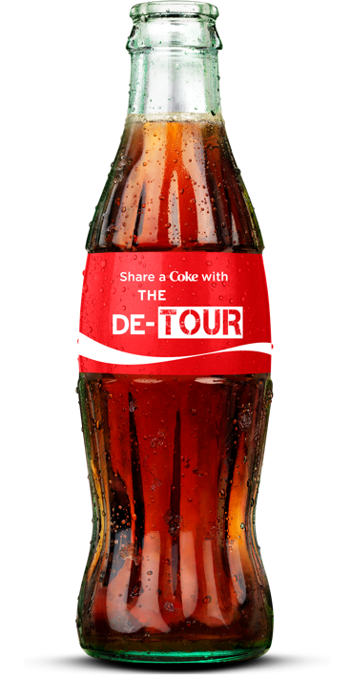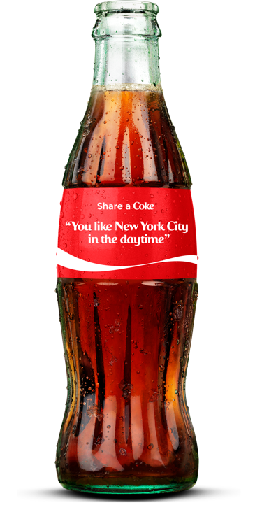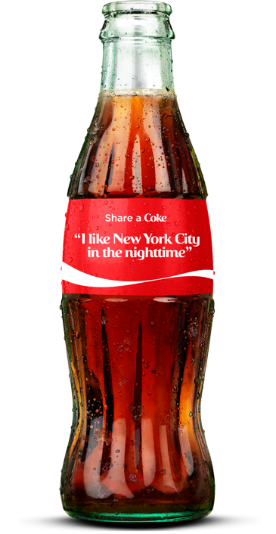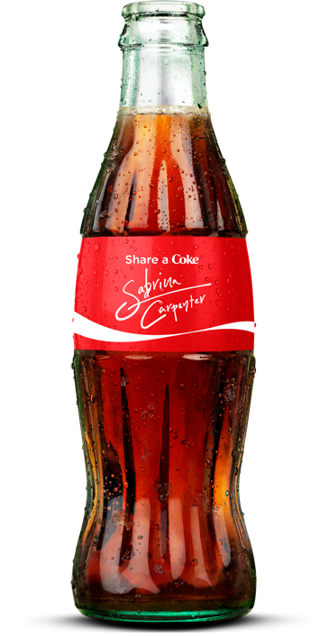

(August 24, 2017) –Hollywood Records recording artist Sabrina Carpenter is partnering with Coca-Cola® to offer fans limited-edition, Sabrina inspired, collectable Coca-Cola bottles in support of her new single “Why,” the lead track from Carpenter’s as-yet-titled third album, and The De-Tour North American headlining tour.

From August 24 through September 30 fans can go to https://buy.shareacoke.com/music to get one, or all four, of the special collection bottles featuring Sabrina’s autograph, the official De-Tour logo and select lyrics from her new single, “Why,” and shop Sabrina’s favorite Coca-Cola apparel including the fuzzy Coca-Cola polar bear slippers to the Coca-Cola can clutch. Through September 30, fans can also enter a sweepstakes for a chance to win a trip to meet Sabrina Carpenter at a special event this winter.

Visit https://buy.shareacoke.com/music for the sweepstakes entry details, including free entry information and rules.

Carpenter recently performed “Why” on Live with Kelly and Ryan. The track was the No. 2 most added song on pop radio the week of August 15. In addition, the companion music video, featuring Riverdale’s Casey Cott, has amassed over 8 million views since its release last month. “Why,” co-written by Carpenter, Jonas Jeberg and Brett McLaughlin, is available at all digital providers HERE and all streaming providers HERE. Watch the “Why” official music video HERE.

The De-Tour, which kicked off July 6 in Vancouver BC, continues to bring a summer of fun and music across major North American cities such as Detroit, Pittsburgh, Cleveland, Boston and Philadelphia before concluding on August 27 in Toronto, ON. The tour, presented by American Tourister, will feature special guests Alex Aiono & New Hope Club. For more information, please visit www.sabrinacarpenter.com.

###

ABOUT SABRINA CARPENTER:
Eighteen-year-old singer, songwriter and actress Sabrina Carpenter’s journey into music, television and film began at the age of two when she followed in her older sister’s footsteps as a beginning ballerina. As her passion and skill in dance flourished, Sabrina surprised her family and friends by discovering her unique vocal talents. Her budding acting career began in theater before moving from the stage to film & television, landing her first role as a guest start on Law & Order SVU. Subsequent roles have included Young Chloe on Fox’s The Goodwin Games and Maya Hart in the Disney Channel series Girl Meets World, which concluded in early 2017. Staying true to her first love of music, Carpenter released her debut album Eyes Wide Open at the age of 15. Fueled by youthful exuberance and irresistibly buoyant singles such as “Eyes Wide Open” and “We’ll Be the Stars,” the album reflected Carpenter’s life over the previous three years. With the release of her sophomore album EVOLution in October 2016, the gestation period was shorter, but clearly encompassed even more growth. Having co-written on the album, Carpenter sought to “work with people who are young and hungry — people like me.” “Thumbs,” the first single from the album, was certified Gold in August 2017. Outside of the studio, Carpenter’s live shows reflect her boundless energy. She embarked on her first-ever, sold out headline EVOLution Tour, traveling across 35+ cities in the United States, and joined The Vamps as a special guest on their UK arena tour this May as well as Ariana Grande’s Dangerous Woman tour in Brazil this June before heading out on The De-Tour, her 30+ date summer headline trek.

Sabrina Carpenter
Website: http://www.sabrinacarpenter.com
Facebook: http://www.facebook.com/sabrinacarpenter
Instagram: @sabrinacarpenter
Twitter: @SabrinaAnnLynn

Press Contacts for Sabrina Carpenter
Brit Reece & Natasha Desai – PMK*BNC
British.Reece@pmkbnc.com / Natasha.Desai@pmkbnc.com

Lillian Matulic & Sharrin Summers – Hollywood Records
Lillian.Matulic@disney.com / Sharrin.Summers@disney.com

