PUBLICITY

HOLLYWOOD RECORDS’ SABRINA CARPENTER TEAMS UP WITH UNIVERSAL MUSIC GERMANY AND AMAZON FOR FIRST-OF-ITS-KIND ALEXA EXPERIENCE
EIGHT EPISODE “SABRINA CARPENTER EXTENDED” SKILL TAKES FANS ON AN IMMERSIVE TRIP THROUGH THE MAKING OF SABRINA’S NEW ALBUM SINGULAR: ACT I

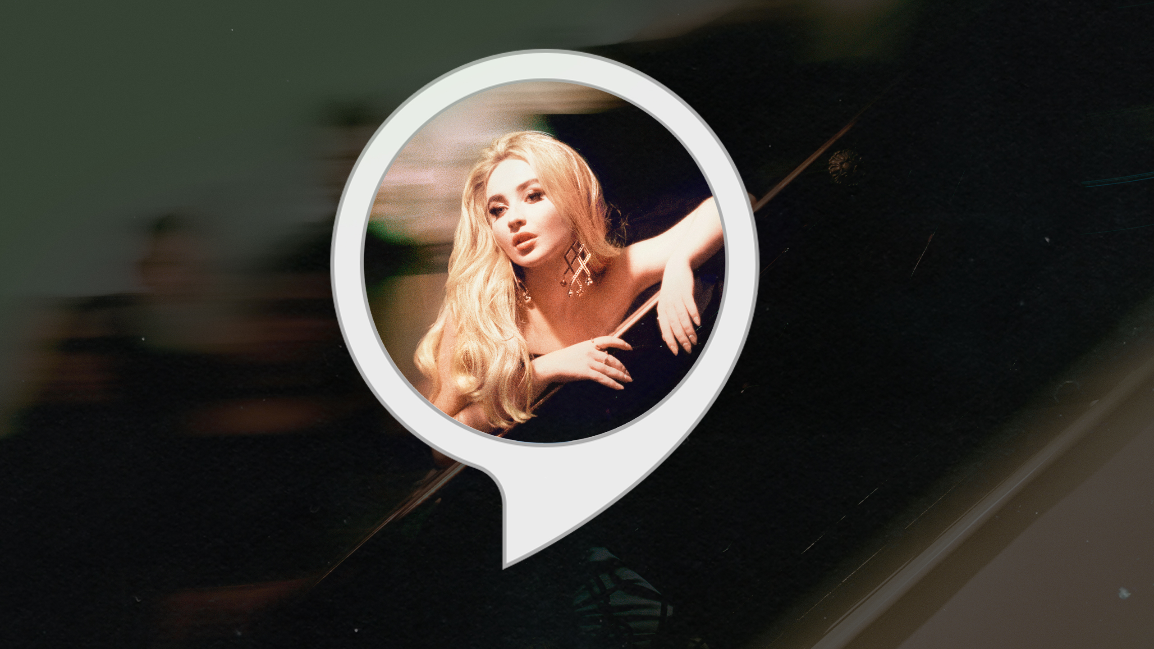

(March 5, 2019) – Hollywood Records pop artist Sabrina Carpenter has teamed up with Amazon and Universal Music Germany’s Marketing Labs to create “Sabrina Carpenter Extended,” a first-of-its-kind Alexa skill to date. Through a fully immersive voice experience, Carpenter will take fans on a deep dive into the making of her album Singular: Act I.

Over the course of eight episodes, with each focusing on a specific track from the album, Sabrina will tell the stories behind her songs, shed light on the songwriting process, give insight into her lyrics and let fans ask questions in a virtual Q&A session. Available on any Alexa-enabled device, fans can get started by simply saying “Alexa, open Sabrina Carpenter Extended.”

“Sabrina Carpenter Extended” is the first-ever artist-based skill to use proactive notifications, with fans being alerted when new episodes are available. What makes the skill truly special is its ability to allow Sabrina and her fans to interact conversationally. The skill’s focus is on natural language, letting users respond in an open-ended manner, rather than having to rely on key words or phrases. In otherwords, fans will feel like they are talking with Sabrina one-on-one when interacting through Alexa.

The multimodal skill makes use of the latest technology available for Amazon Alexa, combining striking visuals with voice to create an engaging and interactive experience for users. It was developed by Marketing Labs, a division of Universal Music Germany.

Sabrina, who was spotlighted on Amazon Music’s “Best Pop of 2018” with her single “Almost Love,” is one of a handful of artists to have her own Alexa skill.

Sabrina, whose “Sue Me” single is rising up the Top 40 chart, is also gearing up for the launch of The Singular Tour, a 16-city North American headline run that kicks off March 2 in Orlando, Florida, and will make stops in major cities such as Atlanta, Boston, DC, New York, Detroit and Chicago before concluding on March 25 in Los Angeles (see itinerary below). For more information, please visit www.sabrinacarpenter.com/tour

Later this year Carpenter will release Singular: Act II. She’ll also take on her first leading film role in The Short History of The Long Road and will also be seen in the upcoming Netflix comedy Tall Girl.

Sabrina Carpenter’s The Singular Tour Dates as follows:
Date | City | Venue
March 2 | Orlando, FO | Universal Studios - Hollywood Stage
March 3 | Atlanta, GA | Buckhead Theatre
March 4 | Charlotte, NC | The Fillmore
March 6 | Philadelphia, PA | Theatre of Living Arts
March 7 | Boston, MA | Paradise Rock Club
March 9 | Montclair, NJ | Wellmont Theater
March 10 | Washington, DC | The 9:30 Club
March 12 | New York, NY | Irving Plaza
March 14 | Toronto, ON | The Opera House
March 15 | Mashantucket, CT | Foxwoods Resort Casino-Fox Theater
March 17 | Detroit, MI | St. Andrew’s Hall
March 18 | Chicago, IL | House of Blues
March 21 | Las Vegas, NV | House of Blues
March 22 | San Diego, CA | House of Blues
March 24 | Berkeley, CA | The UC Theatre
March 25 | Los Angeles, CA | The Fonda Theatre

About Sabrina Carpenter Extended Alexa Skill
The Alexa Skill was concepted and developed in-house by Allan Zhang, who oversees the creation of Alexa Skills at Marketing Labs, a division of Universal Music Germany.

Andreas Erker, Director of Consumer Development at Marketing Labs, said the following: “I am excited that Universal Music Germany is delivering high-quality innovation to our artists and partners. With Allan Zhang developing new technologies for voice platforms, we are scaling up our production of apps and skills for our domestic artists and international partners.”

Connect with Sabrina Carpenter
Official Website │ Facebook │ Instagram │ Twitter │ YouTube

SINGULAR: ACT I – stream it HERE

Sabrina Carpenter Media Kit HERE

PRESS CONTACTS:
Sharrin Summers / Hollywood Records
Sharrin.Summers@disney.com

DPR
Carleen Donovan carleen@donovanpublicrelations.com
Elisa Kupelian elisa@donovanpublicrelations.com

