SABRINA CARPENTER & JONAS BLUE JOIN FORCES ON
“ALIEN”
NEW SINGLE AVAILABLE NOW

DUO TO MAKE TELEVISION DEBUT OF “ALIEN” ON
JIMMY KIMMEL LIVE! MARCH 21

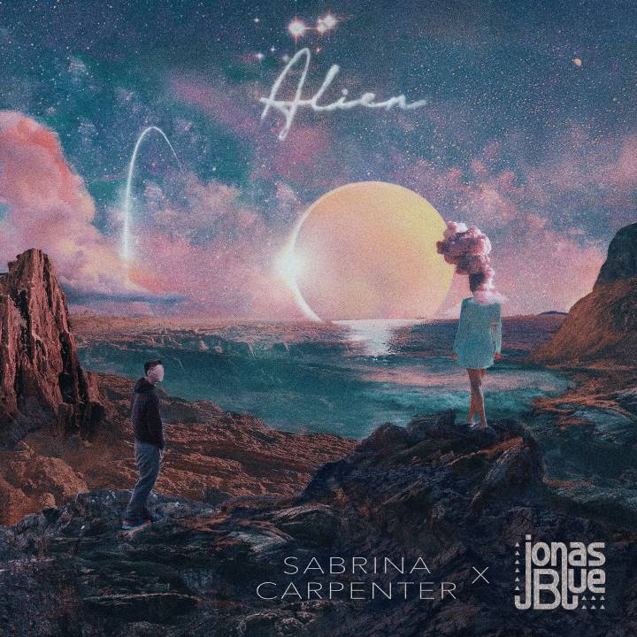

FOR MEDIA USE:
Single cover art
Sabrina Carpenter approved photo (credit Sarah Carpenter)
Jonas Blue approved photo (credit Phil Knott)

(March 16, 2018) – Today global hit-makers Sabrina Carpenter and multi-platinum selling UK DJ/producer/songwriter Jonas Blue released their new single, “Alien,” on Hollywood Records. The track, co-written by Carpenter, Blue and Janee “Jin Jin” Bennett, and produced, arranged, recorded and mixed by Blue, is available at all digital providers HERE and all streaming providers HERE. Additionally, a vertical video for the song is now live on Spotify.

In support of the track, Sabrina and Jonas will make their television debut performance together March 21 on Jimmy Kimmel Live! The track’s official music video, recently shot in London, will have its worldwide premiere later this month.

“Alien” marks the first collaboration between the two rising pop powerhouse talents.“Over a year ago I tweeted Jonas about how much I loved a song of his and he dm’ed me .. and now here we are,” Carpenter says of the song’s origin. “We wrote it about how alienating it can feel to be trapped in your own emotions. Lyrically, it’s really inspired by the words we keep in our heads when a relationship is unclear.”

“It was such a pleasure to work with the amazingly talented Sabrina on this song, what a pro! We went in the studio with a completely blank canvas along with a songwriter from London named Jin Jin, and came up with this cool concept of Alien,” Jonas adds. “It’s a love song but it goes deep and takes you on a metaphorical journey. The music flowed really easily and I managed to fuse some different vibes in there along with the trademark JB sounds."

###

About Sabrina Carpenter
Eighteen-year-old singer, songwriter and actress Sabrina Carpenter released her debut album Eyes Wide Open in 2015 at the age of fifteen. The album’s themes reflected Carpenter’s life over the previous three years. In 2016, she released her sophomore album, the Gold-certified EVOLution, and launched her first ever sold-out headline tour of the same name, traveling to 35+ cities across the United States. In the spring of 2017, she joined The Vamps as a special guest on their UK arena tour as well as Ariana Grande’s Dangerous Woman tour in Brazil before heading out on The De-Tour, her 30+ date summer headline trek. Prior to The De-Tour, Carpenter co-wrote and released her single “Why,” which Billboard hailed as “..highly promising of what’s to come,” and it proved to be a hit on Top 40 radio. She has performed on numerous prestigious television shows, including The Tonight Show Starring Jimmy Fallon, The Late Late Show with James Corden, TODAY Show and LIVE! with Kelly & Ryan. Carpenter’s vocals are featured on Lost Kings’ latest track “First Love,” released in October 2017. Capping off an extraordinary 2017 was Carpenter’s amazing run on iHeartRadio’s annual Jingle Ball Tour. In March 2018, she released the track “Alien” co-written and performed with platinum selling UK artist Jonas Blue. Carpenter is currently in the studio writing her third album, slated for release this year. On the television and film side, Carpenter graced TV screens as Maya Hart on the Disney Channel series Girl Meets World until the show’s January 2017 conclusion. Most recently, she wrapped filming on the feature film The Hate U Give for Fox and was cast as a series regular in NBC’s comedy pilot So Close from Greg Malins (Friends, Will & Grace), Hazy Mills (Grimm, Hot in Cleveland) and Universal TV.

About Jonas Blue
Multi-platinum-selling BRIT-nominated hit-maker Jonas Blue is the UK’s biggest global breakthrough artist thanks in part to his debut single and global smash “Fast Car” featuring Dakota. The track became the biggest selling single globally from a British debut artist in 2016. ‘Fast Car’ achieved multi-platinum, platinum and gold status in over 20 territories. His second single, “Perfect Strangers” featuring songwriter JP Cooper, hit #2 on the UK Official Singles Chart and went on to receive multi-platinum, platinum and gold status across Europe, Australia and North America. In May 2017 Jonas released his fourth single, “Mama” featuring Australian singer and viral phenomenon William Singe. The track became a worldwide hit peaking at #4 in the UK singles chart. Having sold over 1.5 million adjusted units globally, and achieving Platinum status in Australia and Sweden, “Mama” became one of the biggest summer anthems of 2017. In addition to this, the British producer released his debut compilation album, Electronic Nature - The Mix 2017. Equally comfortable with remixing as creating original productions, he recently lent his hand to the massive Zedd production “Stay” ft Alessia Cara. With the original already a certified hit, Jonas laced the track with his signature melodic sound to create a fresh and addictive remix which garnered worldwide radio play. In 2016, Jonas made numerous festival appearances, including Tomorrowland, V Festival and Lollapalooza Berlin to name a few. In May 2017, he embarked on a debut European tour, performing headline shows in Cologne, Amsterdam, Paris and London. He also made appearances at We Are FSTVL, the Isle of Wight Festival, Tomorrowland, SW4, and V Festival. Overall, Jonas’ records have hit more than 2 billion Spotify streams. In 2016, he sold more singles in the UK than the likes of Clean Bandit, Ellie Goulding, Olly Murs and Zayn Malik. He was also the only artist to have two songs included on MTV’s global list of most played videos in 2016. Jonas was also selected as the VEVO LIFT Artist of 2017, following in the footsteps of Sam Smith, James Bay, Years and Years and Rag ‘N’ Bone Man.

Alien
Wide download: http://hollywoodrecs.co/AlienDL
Wide streaming: http://hollywoodrecs.co/Alien
Spotify: http://hollywoodrecs.co/Alien/spotify
Amazon Music: http://hollywoodrecs.co/Alien/amazonmusiclisten
Apple Music: http://hollywoodrecs.co/Alien/applemusic

Sabrina Carpenter
Website: http://www.sabrinacarpenter.com
Facebook: http://www.facebook.com/sabrinacarpenter
Instagram: @sabrinacarpenter
Twitter: @SabrinaAnnLynn

Jonas Blue
Website: http://www.jonasblue.com
Facebook: https://www.facebook.com/JonasBlueMusic/
Instagram: https://www.instagram.com/jonasblue/
Twitter: https://twitter.com/JonasBlue

PRESS CONTACTS:
For Sabrina Carpenter:
Brit Reece & Natasha Desai – PMK*BNC
British.Reece@pmkbnc.com / Natasha.Desai@pmkbnc.com

Lillian Matulic & Sharrin Summers – Hollywood Records
Lillian.Matulic@disney.com / Sharrin.Summers@disney.com

For Jonas Blue:
MacKenzie Reynolds – Capitol Records
MacKenzie.Reynolds@umusic.com

