SABRINA CARPENTER ANNOUNCES
THE DE-TOUR
30+ CITY SUMMER 2017 TOUR KICKS OFF JULY 6 IN VANCOUVER
FEATURING SPECIAL GUESTS ALEX AIONO & NEW HOPE CLUB

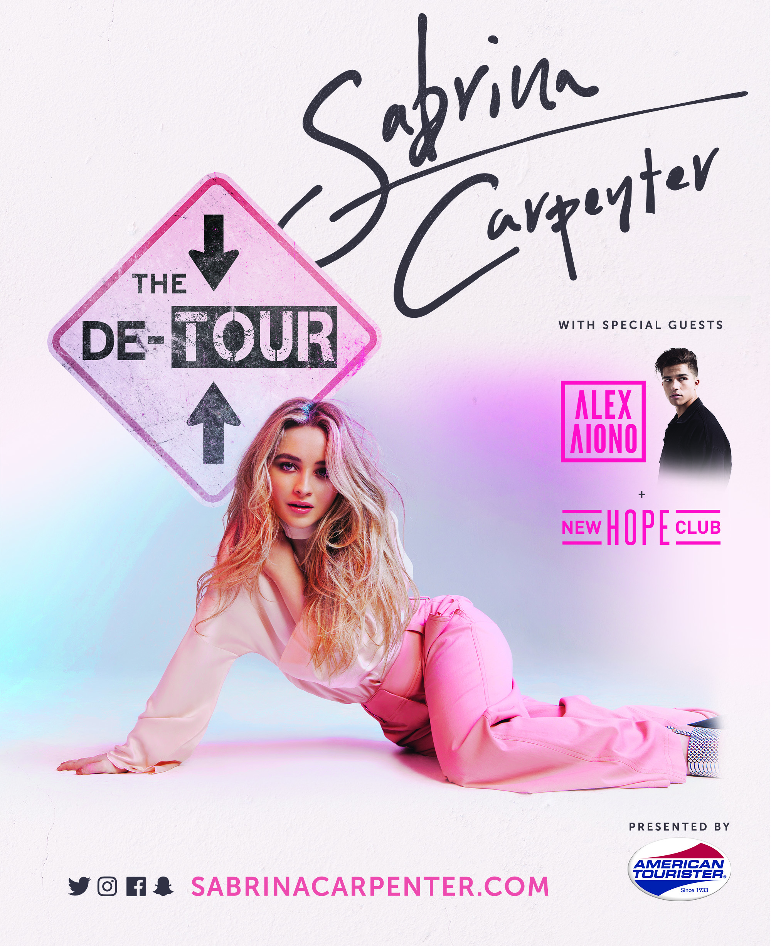

APPROVED PHOTO FOR MEDIA USE (credit Elias Tahan):
https://www.dropbox.com/s/9j5njiutp2pdkjt/SC%20-%20Elias%20Tahan%202017.jpg?dl=0

FAN CLUB PRESALES STARTS FRIDAY, APRIL 28 AT 10AM LOCAL TIME
TICKET PRESALES BEGINS FRIDAY, APRIL 28 AT 3PM LOCAL TIME
GENERAL PUBLIC ON-SALE STARTS SATURDAY, APRIL 29 AT 10AM LOCAL TIME

(April 26, 2017) – Following her sold out, first ever headline tour last fall, singer/songwriter and actress Sabrina Carpenter is set to bring a summer of fun and music across the continent with The De-Tour, a 30+ date summer headline tour. The De-Tour will begin July 5 in Vancouver, BC and continue across major North American cities such as Seattle, San Francisco, Los Angeles, Dallas, New Orleans, Orlando, Atlanta, Nashville, and Boston before concluding on August 27 in Toronto, ON. The De-Tour, presented by American Tourister, will feature special guests Alex Aiono and New Hope Club on all dates.

Fan club and ticket pre-sales begin Friday, April 28 at 10am and 3pm local time, respectively. Tickets for The De-Tour will go on sale to the general public beginning Saturday, April 29 at 10am local time. For more information, please visit www.sabrinacarpenter.com.

“Ever since I got off the road from my first tour, all I can think about is going back out. Now this time, everything is gonna be bigger, better and very, very unexpected,” says Sabrina of the upcoming trek. “I can’t wait to show everyone what we’ve been working so hard on. I want the live experience to be indelible.”

This weekend, Sabrina will take to the 2017 Radio Disney Music Awards stage to perform her current, infectious single “Thumbs” off her sophomore album EVOLution. The album’s first single, “On Purpose,” is nominated for XOXO – Best Crush Song. The 2017 Radio Disney Music Awards air April 30 at 7 p.m. on the Disney Channel.

In May, Sabrina will embark as special guest on The Vamp’s UK and Ireland tour and in June, join Ariana Grande’s Dangerous Woman World Tour in Brazil as special guest.

The De-Tour Summer 2017 Tour Dates:
Date | City | Venue
July 6 | Vancouver, BC | Vogue Theatre
July 8 | Edmonton, AB | Winspear Centre
July 11 | Seattle, WA | Neptune Theatre
July 13 | Portland, OR | Crystal Ballroom
July 15 | San Francisco, CA | The Masonic
July 16 | Santa Rosa, CA | Luther Burbank Center for the Arts
July 18 | San Diego, CA | Balboa Theatre
July 19 | Anaheim, CA | House of Blues
July 21 | Los Angeles, CA | The Wiltern
July 22 | Phoenix, AZ | Comerica Theatre
July 24 | Denver, CO | Paramount Theatre
July 26 | Dallas, TX | Majestic Theatre
July 28 | New Orleans, LA | Saenger Theatre
July 29 | Hot Springs, AR | Timberwood Amphitheater
July 30 | Houston, TX | Revention Music Center
Aug. 2 | Jacksonville, FL | Florida Theatre
Aug. 4 | Miami Beach, FL | The Fillmore Miami Beach at the Jackie Gleason Theater
Aug. 5 | Orlando, FL | Dr. Phillips Center for the Performing Arts – Walt Disney Theater
Aug 6. | Atlanta, GA | The Tabernacle
Aug. 8 | Nashville, TN | Ryman Auditorium
Aug. 9 | Indianapolis, IN | Murat Theatre at Old National Centre
Aug. 11 | West Allis, WI | Wisconsin State Fair
Aug. 12 | Detroit, MI | The Fillmore
Aug. 13 | Tinley Park, IL | Hollywood Casino Amphitheatre
Aug. 16 | Pittsburgh, PA | Byham Theater
Aug. 17 | Cleveland, OH | Connor Palace at Playhouse Square
Aug. 19 | Hershey, PA | Hersheypark Stadium
Aug. 20 | Boston, MA | House of Blues
Aug. 22 | Montclair, NJ | The Wellmont Theater
Aug. 25 | Charlotte, NC | Belk Theater At North Carolina Blumenthal Performing Arts Center
Aug. 26 | Timonium, MD | Maryland State Fair
Aug. 27 | Toronto, ON | Budweiser Stage (formerly Molson Canadian Amphitheatre)

###

ABOUT SABRINA CARPENTER:
Seventeen-year-old singer, songwriter and actress Sabrina Carpenter’s journey into music, television and film began at the age of two when she followed in her older sister’s footsteps as a beginning ballerina. As her passion and skill in dance flourished, Sabrina surprised her family and friends by discovering her unique vocal talents. Her budding acting career began in theater before moving from the stage to film & television, landing her first role as a guest start on Law & Order SVU. Subsequent roles have included Young Chloe on Fox’s The Goodwin Games and Maya Hart in the Disney Channel series Girl Meets World, which concluded in early 2017. Staying true to her first love of music, Carpenter released her debut album Eyes Wide Open at the age of 15. Fueled by youthful exuberance and irresistibly buoyant singles such as “Eyes Wide Open” and “We’ll Be the Stars,” the album reflected Carpenter’s life over the previous three years. With the release of her sophomore album EVOLution in October 2016, the gestation period was shorter, but clearly encompassed even more growth. Having co-written on the album, Carpenter sought to “work with people who are young and hungry — people like me.” The album’s current single, the instantly catchy “Thumbs” is pushing through to Top 40 all across the country with more than 23+ million streams on Spotify. Outside of the studio, Carpenter’s live shows reflect her boundless energy. She embarked on her first-ever, sold out headline EVOLution Tour, traveling across 35+ cities in the United States, and will join The Vamps as a special guest on their UK arena tour this May before heading out on The De-Tour, her 30+ date summer headline trek.

Sabrina Carpenter
Website: http://www.sabrinacarpenter.com
Facebook: http://www.facebook.com/sabrinacarpenter
Instagram: @sabrinacarpenter
Twitter: @SabrinaAnnLynn

PRESS CONTACTS:
Brit Reece & Natasha Desai – PMK*BNC
British.Reece@pmkbnc.com / Natasha.Desai@pmkbnc.com

Lillian Matulic & Sharrin Summers – Hollywood Records
Lillian.Matulic@disney.com / Sharrin.Summers@disney.com

