SABRINA CARPENTER UNVEILS NEW SONG “PUSHING 20”

CURRENTLY ON NORTH AMERICAN HEADLINING TOUR

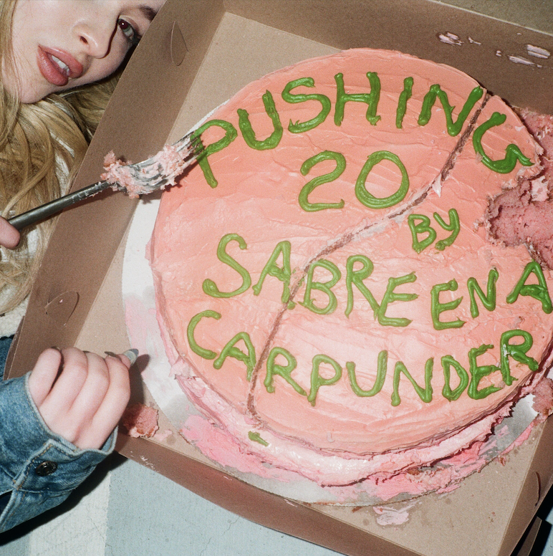

“…she’s one to watch as she grows into her musical identity.” –Time

“…Sabrina Carpenter has proven to be a multi-threat with a bona fide music career and a fan base that rivals those triple her age.” –NYLON

“…dead-on pop instincts…” –Billboard

“…effortless vocal progression reminiscent of a pop star ready to make her mark on an ever competitive and comparative genre.” –Earmilk

(Los Angeles, CA—March 8, 2018)—Singer, songwriter and actress Sabrina Carpenter unveils new song “Pushing 20” today. The track release comes ahead of the singers 20th birthday this spring and was written by Sabrina, alongside Warren “Oak” Felder (Alessia Cara, Kehlani, Demi Lovato) and Paul Phamous (Frank Ocean, Lennon Stella, Nick Jonas). Download HERE and click HERE to listen!

The release of “Pushing 20” also comes in the midst of Sabrina’s headlining North American Tour. The 16 city run kicked off in Orlando, Florida on March 2nd and will wrap on March 25th in Los Angeles, CA. Click HERE for more info and see full routing below.

Later this year, Sabrina will release Singular: Act II, the highly anticipated follow up to her acclaimed third studio album, Singular: Act I. She’ll also take on her first leading film role in The Short History of The Long Road, as well as seen in the upcoming Netflix comedy Tall Girl.

2019 TOUR DATES
March 6 Philadelphia, PA Theatre of Living Arts
March 7 Boston, MA Paradise Rock Club
March 9 Montclair, NJ Wellmont Theater
March 10 Washington, DC The 9:30 Club
March 12 New York, NY Irving Plaza
March 14 Toronto, ON The Opera House
March 15 Mashantucket, CT Foxwoods Resort Casino—Fox Theatre
March 17 Detroit, MI St. Andrew’s Hall
March 18 Chicago, IL House of Blues
March 21 Las Vegas, NV House of Blues
March 22 San Diego, CA House of Blues
March 24 Berkeley, CA The UC Theatre
March 25 Los Angeles, CA The Fonda Theatre

FOLLOW SABRINA CARPENTER:
Website | iTunes |Spotify | Facebook | Twitter | Instagram

