SABRINA CARPENTER & JONAS BLUE PERFORM “ALIEN” ON JIMMY KIMMEL LIVE!

WATCH HERE!

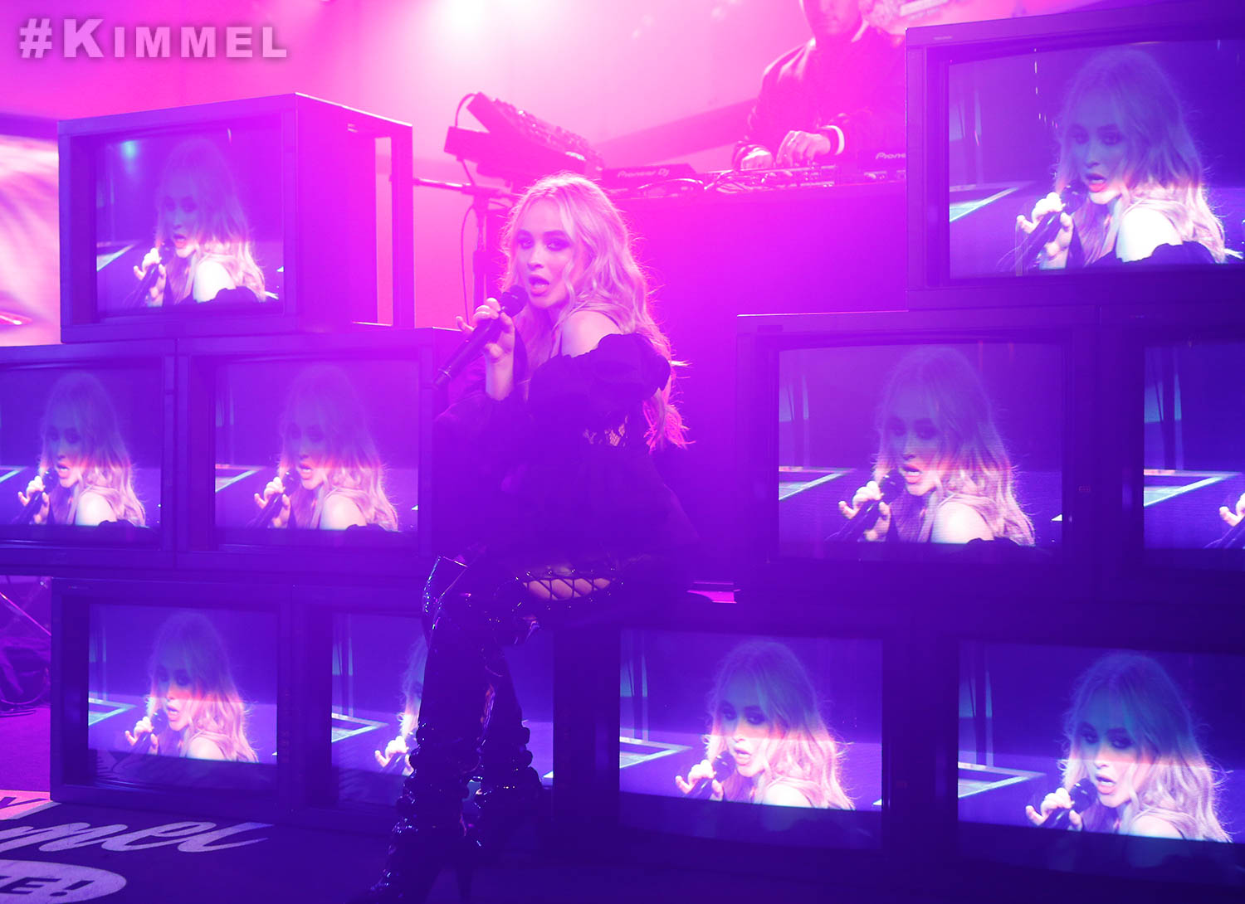

March 23, 2018 – Rising pop powerhouse talents Sabrina Carpenter and Jonas Blue celebrated the release of their new single “Alien” with the song’s debut television performance Wednesday night on Jimmy Kimmel Live! in Hollywood. The performance marks the first time either artist has performed on the show. Watch the performance HERE.

The track, co-written by Carpenter, Blue and Janee “Jin Jin” Bennett, and produced, arranged, recorded and mixed by Blue, is available at all digital providers HERE and all streaming providers HERE.

The song’s official music video, recently shot in London, will premiere worldwide later this month.

###

Sabrina Carpenter
Website: http://www.sabrinacarpenter.com
Facebook: http://www.facebook.com/sabrinacarpenter
Instagram: @sabrinacarpenter
Twitter: @SabrinaAnnLynn

Jonas Blue
Website: http://www.jonasblue.com
Facebook: https://www.facebook.com/JonasBlueMusic/
Instagram: https://www.instagram.com/jonasblue/
Twitter: https://twitter.com/JonasBlue

PRESS CONTACTS:
For Sabrina Carpenter:
Brit Reece & Natasha Desai – PMK*BNC
British.Reece@pmkbnc.com / Natasha.Desai@pmkbnc.com

Lillian Matulic & Sharrin Summers – Hollywood Records
Lillian.Matulic@disney.com / Sharrin.Summers@disney.com

For Jonas Blue:
MacKenzie Reynolds – Capitol Records
MacKenzie.Reynolds@umusic.com

