R5 TO PERFORM ON GOOD MORNING AMERICA JULY 4

BAND ANNOUNCES OPENING ACTS, HAILEY KNOX,
ALEXANDER JEAN AND NEW BEAT FUND, ON THE
NEW ADDICITON TOUR KICKING OFF JUNE 24 IN DENVER, CO

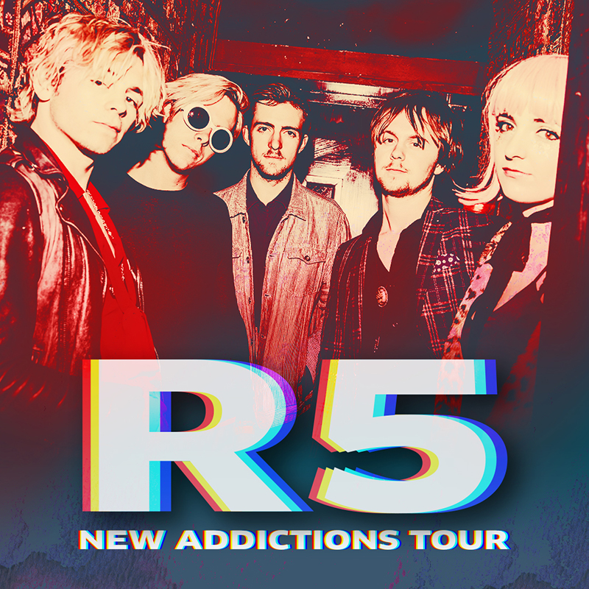

Stream New Addictions HERE

(June 5, 2017) – Pop-rock group R5 are kicking off the summer with an appearance on Good Morning America July 4th performing “If” from their recently released EP, New Addictions.

R5 has also announced the openers for the first leg of the New Addictions Tour, kicking off June 24 in Denver, CO; Hailey Knox will be joining the band for the US tour dates, while Alexander Jean will support from June 26 through July 12 and New Beat Fund will support from July 14 through July 20. R5 also announced three dates in Mexico, August 10, 12 and 13. More dates across Latin America and in Europe will be announced shortly. For VIP Meet & Greet upgrades and tickets for the tour, please go to www.R5Rocks.com

R5 is earning kudos for their recently released EP, New Addictions (Hollywood Records), which Rolling Stone just praised for being “full of sharply constructed pop confections that ride galloping basslines.” New Addictions, which hit #3 on the iTunes Pop Chart and #10 on the overall chart, marks a bold new era for the L.A.-based band with R5 taking a greater writing and production role than ever before. The EP finds the musicians refining their song-craft building on powerful grooves and sharply crafted hooks and channels the infectious energy R5 have recently shown playing festivals alongside artists like The Chainsmokers, Panic! At The Disco, Charlie Puth and Weezer

R5 recently released the video for first track, “If,” which was directed by Michael Borden and pays homage to famous movie scenes from “Risky Business,” “Pulp Fiction,” “Boogie Nights” and “Goodfellas,” among others. Click HERE to watch.

About the openers:
Hailey Knox recently wrapped a tour with AJR, following runs with Charlie Puth and Us The Duo. Having spent much of the last six months on the road, Knox has incorporated an electric guitar to her live show in addition to her captivating acoustic guitar and loop pedal atmospherics, with moodier, more intimate songs. She's added more layers to EP tracks while including the occasional surprise cover, and is even teasing new, unreleased songs.

Indie duo, Alexander Jean, featuring BC Jean and Mark Ballas, are creating the freshest, most honest, heartfelt music of their careers. The duo, who first met in 2012 at a Los Angeles singer-songwriter showcase, and then married in 2016, released their debut EP in 2016 titled “Head High,” which debuted at #1 on iTunes’ Singer/Songwriter chart. Their power-pop ballad and debut single “Roses and Violets,” also hit #1 on the iTunes singer/songwriter chart and #6 on the iTunes overall chart; reaching the Top 20 on Billboard’s Hot 100 “Bubbling Under” chart. This tour will be in support of their soon to be released ep which will be announced shortly.

Los Angeles' New Beat Fund make a loose, cheeky mix of electronic-tinged garage rock and rap. Formed in 2011, the group features the talents of guitarist/lead-vocalist Jeff Laliberte, bassist Paul Laliberte, guitarist Shelby Archer, and drummer Michael Johnson. Inspired by an eclectic combination of sounds from Southern California punk bands like Green Day and Sublime, funk outfits like Red Hot Chili Peppers and Fishbone, and West Coast rap acts like Snoop Dogg and Dr. Dre, New Beat Fund coined their music "G-punk." The group has toured with Blink-182 and 3OH!3.

R5 Summer New Addictions 2017 Tour Dates
Date | City | Venue
June 24 | Denver, CO | Elitch Gardens #
June 26 | Chicago, IL | Bottom Lounge ^*
June 27 | Detroit, MI | St. Andrew’s Hall ^*
June 28 | Toronto, ONT | Phoenix Concert Theatre ^*
June 30 | Boston, MA | Paradise ^*
July 1 | Darien Lake, NY | Darien Lake PAC #
July 2 | Philadelphia, PA | Theatre of Living Arts (TLA) ^*
July 4 | Baltimore, MD | Sound Stage Baltimore ^*
July 5 | Charlotte, NC | The Underground ^*
July 7 | Atlanta, GA | The Loft ^*
July 8 | Orlando, FL | Plaza Live ^*
July 10 | Houston, TX | White Oak ^*
July 11 | Dallas, TX | Trees ^*
July 12 | Austin, TX | Parish ^*
July 14 | Tuscson, AZ | Rialto ^+
July 15 | San Diego, CA | SOMA ^+
July 16 | Pomona, CA | Glasshouse ^+
July 17 | San Francisco, CA | Great American Music ^+
July 19 | Seattle, WA | Crocodile ^+
July 20 | Portland, OR | Wonder Ballroom ^+
August 10 | Monterrey, MX | Arena Monterrey #
August 12 | Guadalajara, MX | Teatro Diana #
August 13  August 19 | Mexico City, MX  Oklahoma City, OK | Pepsi Center #  Starlight Ampitheater #

^* Hailey Knox and Alexander Jean support dates
^+ Hailey Knox and New Beat Fund support dates
# Ryland support dates

ABOUT R5:
Led by vocalist/rhythm guitarist Ross Lynch, R5 came together in 2009 and is comprised of Lynch's siblings Riker (bass/vocals), Rocky (lead guitar/vocals) and Rydel (keyboard/vocals) and friend Ellington "Ratliff" (drums/vocals). Originally from Littleton, Colorado, discovered their love for music at a very early age, thanks to their music-obsessed parents. All of them learned to play an instrument soon after moving to L.A. in 2007, forming a band with their friend Ratliff completing the lineup. Quickly landing their first gig, R5 self-released the EP Ready Set Rock in early 2010, then signed to Hollywood Records in early 2012.

Releasing their sophomore EP Loud in early 2013, R5 made their full-length debut with Louder that September and saw the album shoot to No. 1 on iTunes in 10 countries. The band supported Louder with nearly two years of international touring, and in 2015 had their unforgettable live performance captured in the concert documentary R5: All Day, All Night. With the release of Sometime Last Night, which debuted top 10 on the Billboard 200 chart, and another round of heaving touring, R5 saw their Spotify presence grow to over100 million streams to date, the band’s social--media following has now surpassed 25 million combined fans and over 250 million Vevo views. R5 has performed on Good Morning America, LIVE! with Kelly & Michael, Ellen and Jimmy Kimmel Live!

In addition to leading R5, Ross Lynch can also be seen in the upcoming indie movie, My Friend Dahmer. The film premiered at the Tribeca Film Festival and garner buzz for Ross’s portrayal of the cannibalistic serial killer (Variety, Den of Geek!, Entertainment Weekly, Rolling Stone, Vogue)

Official Website | Facebook | Instagram l VEVO | YouTube |
Twitter - @officialR5; @rossR5; @rockyR5; @rikerR5; @rydelR5; @ratliffR5

R5 PRESS CONTACTS:

Hollywood Records
Sharrin Summers
Sharrin.Summers@disney.com

Lyssa Hurvitz
Lyssa.hurvitz@disney.com

