PUBLICITY
R5 RELEASE 5-SONG EP NEW ADDICTIONS TODAY
CURRENTLY AT #10 ON THE iTUNES OVERALL CHART
#3 ON THE iTUNES POP CHART

SUMMER HEADLINING DATES KICK OFF JUNE 24 IN DENVER, CO

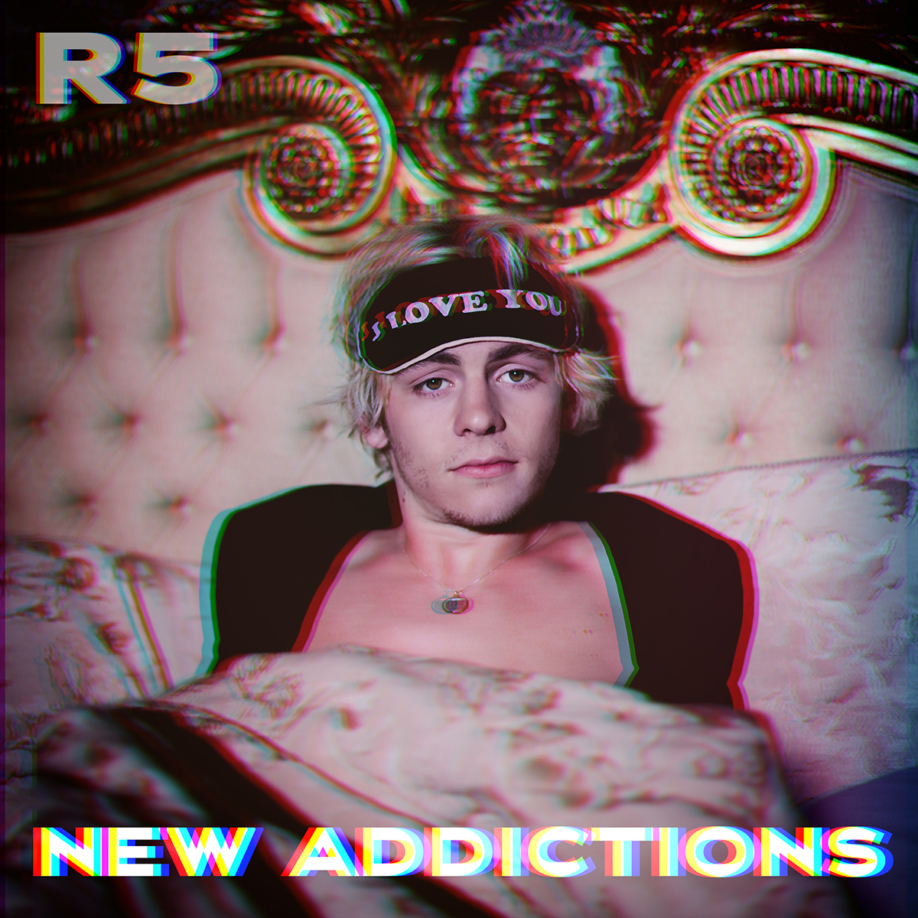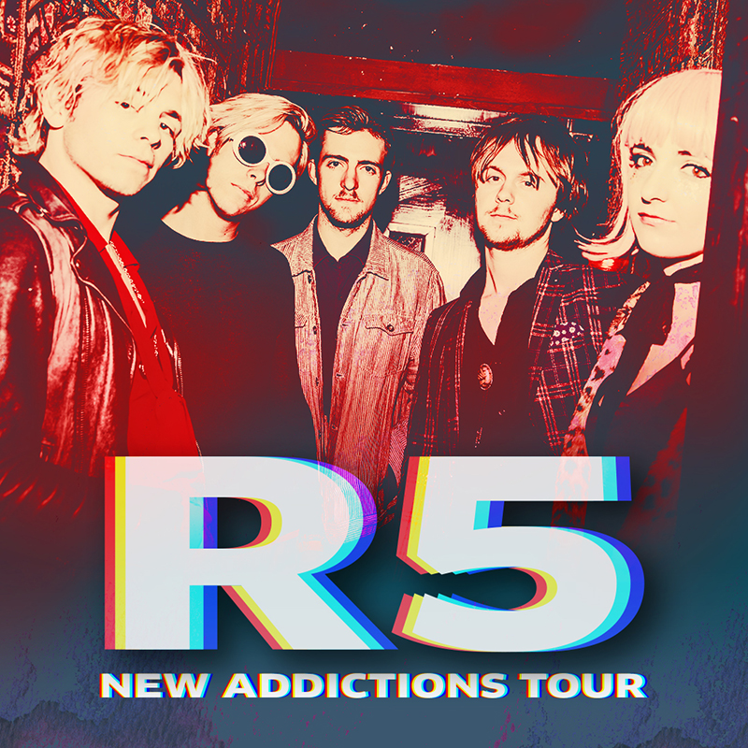

PRESALE BEGINS MONDAY, MAY 15 AT 1PM LOCAL TIME AT WWW.R5ROCKS.COM
FANCLUB MEMBERS WILL RECEIVE PASSWORD MAY 15 AT 7AM
FOR PRESALE ACCESS TO PURCHASE TICKETS

VIDEO FOR FIRST SINGLE “IF” PREMIERED TODAY – WATCH IT HERE

Stream New Addictions HERE / Buy HERE

(May 11, 2017) – Pop-rock quintet R5 has announced the release of their 5-song EP, NEW ADDICTIONS, and the first leg of the New Addictions Tour kicking off on June 24 in Denver, CO. Dates in Mexico, across Latin American and in Europe will be announced shortly.

The follow-up to Sometime Last Night – a 2015 release that debuted in the top 10 on the Billboard 200 – New Addictions, currently #3 on the iTunes Pop Chart and #10 on the overall chart, marks a bold new era for the L.A.-based band. With R5 taking a greater writing and production role than ever before, the EP finds the musicians refining their song-craft. Built on powerful grooves and sharply crafted hooks, New Addictions also channels the unstoppable energy R5 have recently shown playing festivals alongside artists like The Chainsmokers, Panic! At The Disco, Charlie Puth and Weezer

The first leg of the New Addictions Tour will bring R5’s groove-heavy pop to their hometown of Denver, CO, playing Elitch Gardens, and will include stops in Chicago, Detroit, Boston, Philadelphia, Atlanta and Houston.

R5 fan club members will have first access to concert tickets through the band’s fan club presale beginning May 15 at 10 a.m. local time. Fan club members will receive a password for access to the presale on May 15 at 7am local time. VIP Meet & Greet upgrades are only available on https://www.r5rocks.com/tour. Tickets for the tour will go on sale to the general public starting May 19 at 10 a.m. local time. For more information, please visit www.R5Rocks.com.

In addition, R5 today premiered the video for the first single, “If,” exclusively on Vevo. The song, one of the EP’s most blissed-out moments, fuses disco grooves and dance-pop rhythms to a real-life account of social-media obsession. “The song’s basically a fantasy of running away with this girl we randomly found online,” says lead singer Ross Lynch.
The video was shot in San Diego with video director Michael Borden and pays homage to famous movie scenes from Risky Business, Pulp Fiction and Boogie Nights to Fear and Loathing in Las Vegas and Good Fellas.

R5 Summer 2017 Tour Dates
Date | City | Venue
June 24 | Denver, CO | Elitch Gardens
June 26 | Chicago, IL | Bottom Lounge
June 27 | Detroit, MI | St. Andrew’s Hall
June 28 | Toronto, ONT | Phoenix Concert Theatre
June 30 | Boston, MA | Paradise
July 1 | Darien Lake, NY | Darien Lake PAC
July 2 | Philadelphia, PA | Theatre of Living Arts (TLA)
July 4 | Baltimore, MD | Sound Stage Baltimore
July 5 | Charlotte, NC | The Underground
July 7 | Atlanta, GA | The Loft
July 8 | Orlando, FL | Plaza Live
July 10 | Houston, TX | White Oak
July 11 | Dallas, TX | Trees
July 12 | Austin, TX | Parish
July 14 | Tuscson, AZ | Rialto
July 15 | San Diego, CA | SOMA
July 16 | Pomona, CA | Glasshouse
July 17 | San Francisco, CA | Great American Music
July 19 | Seattle, WA | Crocodile
July 20 | Portland, OR | Wonder Ballroom

**More dates to be announced

ABOUT R5:
Led by vocalist/rhythm guitarist Ross Lynch, R5 came together in 2009 and is comprised of Lynch's siblings Riker (bass/vocals), Rocky (lead guitar/vocals) and Rydel (keyboard/vocals) and friend Ellington "Ratliff" (drums/vocals). R5
Originally from Littleton, Colorado, discovered their love for music at a very early age, thanks to their music-obsessed parents. All of them learned to play an instrument soon after moving to L.A. in 2007, forming a band with their friend Ratliff completing the lineup. Quickly landing their first gig, R5 self-released the EP Ready Set Rock in early 2010, then signed to Hollywood Records in early 2012.

Releasing their sophomore EP Loud in early 2013, R5 made their full-length debut with Louder that September and saw the album shoot to No. 1 on iTunes in 10 countries. The band supported Louder with nearly two years of international touring, and in 2015 had their unforgettable live performance captured in the concert documentary R5: All Day, All Night. With the release of Sometime Last Night, which debuted top 10 on the Billboard 200 chart, and another round of heaving touring, R5 saw their Spotify presence grow to over100 million streams to date, the band’s social--media following has now surpassed 25 million combined fans and over 250 million Vevo views. R5 has performed on Good Morning America, LIVE! with Kelly & Michael, Ellen and Jimmy Kimmel Live!

In addition to leading R5, Ross Lynch can also be seen in the upcoming indie movie, My Friend Dahmer. The film premiered at the Tribeca Film Festival and garner buzz for Ross’s portrayal of the gay cannibalistic serial killer (Variety, Den of Geek!, Entertainment Weekly, Rolling Stone, Vogue)

Official Website | Facebook | Instagram l VEVO | YouTube |
Twitter - @officialR5; @rossR5; @rockyR5; @rikerR5; @rydelR5; @ratliffR5

R5 PRESS CONTACTS:

Hollywood Records
Sharrin Summers
Sharrin.Summers@disney.com

Lyssa Hurvitz
Lyssa.hurvitz@disney.com

