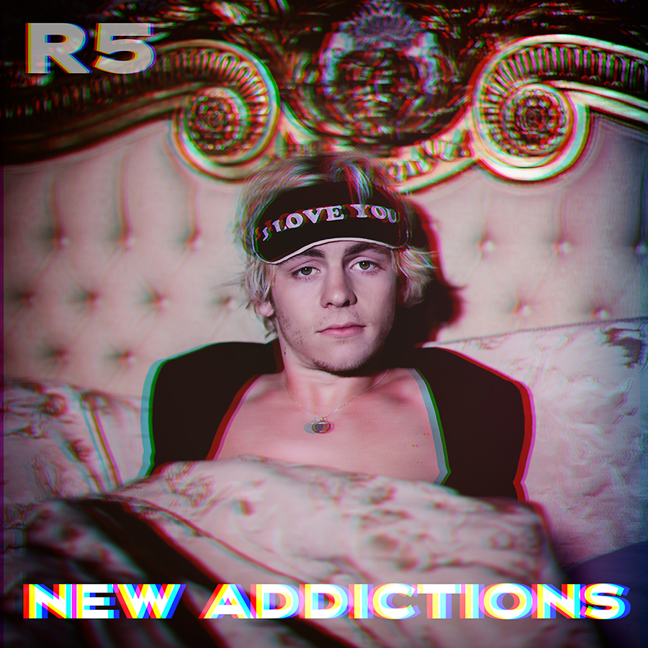

Release date: May 12, 2017

Since releasing their sophomore album Sometime Last Night, R5 have toured incessantly and brought their groove-heavy pop to crowds across the globe. During that time, lead vocalist/rhythm guitarist Ross Lynch, his siblings Riker (bass/vocals), Rocky (lead guitar/vocals), and Rydel (keyboard/vocals), and drummer/vocalist Ellington “Ratliff” also started sketching new songs intimately detailing their adventures around the world. Once back in their home studio, R5 began bringing those songs to life with an irresistible balance of intense feeling and pure pop euphoria.

The follow-up to Sometime Last Night—a 2015 release that debuted in the top 10 on the Billboard 200—New Addictions marks a bold new era for the L.A.-based band. With R5 taking a greater writing and production role than ever before, the EP finds the lifelong musicians both tapping into their formidable instincts and carefully refining their songcraft. Built on powerful grooves and sharply crafted hooks, New Addictions also channels the unstoppable energy R5 have recently shown playing festivals along side artists like The Chainsmokers, Panic! At The Disco, Charlie Puth and Weezer.

Along with underscoring the supremely catchy nature of each song, the title to New Addictions reflects R5’s unchecked passion for making music. “When we’re home we just wake up and go straight into the studio, and we don’t leave until it’s time to sleep,” says Ross. Through their constant writing and recording, R5 ultimately reached a new level of sonic ingenuity and artistic finesse on the EP. “With every song, the goal was to create something that we’d never heard before,” says Rocky, who serves as R5’s main producer. “And since this is the first release that we’ve done mostly on our own, we also had to get to the point where all the songs sound as full and clear and crisp as what you’d hear from other producers. There was a lot I had to teach myself, but I’ve been producing since I was 12-years-old, and all those hours and years have definitely added up.”

Within their lyrics, R5 reveal another layer to the concept of New Addictions: the undeniable pull of sudden infatuation. “All the songs have to do with experiences that felt like an addiction at the time, whether it’s falling in love or just a five-second thing for a girl on Instagram,” says Rocky. One of the EP’s most blissed-out moments, “If” fuses disco grooves and dance-pop rhythms to a real-life account of social-media obsession. “We were trolling the internet and came across this singer who was so beautiful and had the most beautiful voice—the whole nine,” says Ross. “The song’s basically a fantasy of running away with this girl we randomly found online.”

On “Lay Your Head Down,” New Addictions moves beyond fantasy to recount Rocky’s recent getaway with a girl he met while touring Japan. “We hit it off right away but I was leaving at 6am the next morning,” Rocky recalls. “We ended up keeping in touch and going to Curaçao for a week, and later on I went to Korea to see her. ‘Lay Your Head Down’ was written about all the little moments we spent together.” With its soulful piano work and glorious guitar riffs, the track warmly delivers its heart-on-sleeve stories of blue rum and sunrise rendezvous. “For part of the song we used the original vocal from a demo I’d recorded on some cheap old microphone,” Rocky points out. “It had this cool feeling to it that we couldn’t get in the re-recording, so we just decided to go with it.”

Another song showing R5’s romantic sensibilities, the lushly textured “Trading Time” brings complex tempos and massive synth lines to lyrics illuminating the idea that, as Ross explains, “time is our most valuable currency, and so two people choosing to be together means trading the most valuable thing we have.” On “Red Velvet,” New Addictions offers up its most seductive moment, merging falsetto crooning and cleverly-played Prince references with a boom-bap-inspired production approach. “‘Red Velvet’ is all about the groove,” says Rocky, noting that the track was sparked by Ross’s messing around on the piano at a cabin the band rented in Colorado. “About a month after Colorado, I went into the studio at 10 at night and started vibing on ‘Red Velvet.’ I ended up staying up till 6:30 in the morning, making the groove what it is today.”

Rounding out New Addictions is R5’s take on INXS’s “Need You Tonight,” a perfectly executed rendition that introduces glossed-up synth while maintaining the iconic riff and raw sensuality of the original. “We recently did a show in Australia and opened with ‘New Sensation’ and it went off, so we thought it would be cool to cover them again,” says Ross. “Michael Hutchence was such an amazing singer—if I had to pick one artist I wanted to sing like, it would be him.”

Originally from Littleton, Colorado, the Lynches discovered their love for INXS at a very early age, thanks to their music-obsessed parents. All of them learned to play an instrument as kids and, soon after moving to L.A. in 2007, formed a band with their friend Ratliff completing the lineup. Quickly landing their first gig, R5 self-released the EP Ready Set Rock in early 2010, then signed to Hollywood Records in early 2012.

Releasing their sophomore EP Loud in early 2013, R5 made their full-length debut with Louder that September and saw the album shoot to No. 1 on iTunes in 10 countries. The band supported Louder with nearly two years of international touring, and in 2015 had their unforgettable live performance captured in the concert documentary R5: All Day, All Night. With the release of Sometime Last Night lifting R5’s Spotify presence to more than 100 million streams to date, the band’s social-media following has now surpassed 25 million combined fans and over 250 million Vevo views.

As their reach only continues to grow, R5 have made a point of extending the natural sense of closeness and connection that first brought the band together. In creating New Addictions, for instance, the band would play new tracks at the parties they frequently host at their house. “We call them Jam Nights—we’ll set up drums and amps in our living room and just play music with our friends,” says Rocky. “At the last one, I’d go up to a few people at a time, bring them into the studio and play them the new songs to see what they’d vibe with. It really helped us get a good idea of what connects with people.”

Once they’d completed New Addictions, the band members marked the occasion by popping open a bottle of Dom Perignon they’d been saving for years. “We wanted to celebrate and recognize that this is hopefully what we’ll be doing for the rest of our lives—creating our own songs and putting them out into the world,” says Ross. “Every new thing we make will be different from what we’ve done in the past, but on this EP we really got into a whole new groove with our writing,” he continues. “Instead of trying to make this kind of tune or that kind of tune, we’re just completely giving in and letting the music decide for itself.”

Official Website | Facebook | Instagram l VEVO | YouTube | R5: All Day All Night trailer
Twitter - @officialR5 @rossR5 @rockyR5 @rikerR5 @rydelR5 @ratliffR5

042017

