R5 ANNOUNCE EUROPEAN LEG OF NEW ADDICTIONS TOUR
KICKING OFF SEPTEMBER 9 IN DUBLIN, IRELAND

EXCLUSIVE 24-HOUR FAN CLUB PRESALE GOES
LIVE TODAY AT 10AM LOCAL TIME HERE

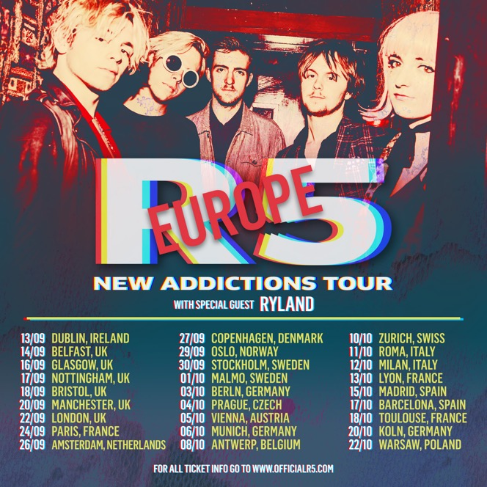

Stream New Addictions HERE

(June 20, 2017) – Supporting the release of their new EP, New Addictions, pop-rock group R5 have announced the second leg of their New Addictions world tour kicking off September 9 in Dublin, Ireland. The European leg, featuring special guest Ryland, will take the band to 27 cities in 15 countries with their final show happening in Warsaw, Poland, on October 22. This marks the band’s third European tour since the release of their debut album in 2013.

Tickets go on sale June 23 at 10 a.m. local time. VIP Meet & Greet upgrades are only available officialr5.com.

R5 is earning kudos for their recently released EP, New Addictions (Hollywood Records), which Rolling Stone just praised for being “full of sharply constructed pop confections that ride galloping basslines.” New Addictions, which hit #3 on the iTunes Pop Chart and #10 on the overall chart, marks a bold new era for the L.A.-based band with R5 taking a greater writing and production role than ever before. The EP finds the musicians refining their song-craft building on powerful grooves and sharply crafted hooks and channels the infectious energy R5 have recently shown playing festivals alongside artists like The Chainsmokers, Panic! At The Disco, Charlie Puth and Weezer

R5 recently released the video for first track, “If,” which was directed by Michael Borden and pays homage to famous movie scenes from “Risky Business,” “Pulp Fiction,” “Boogie Nights” and “Goodfellas,” among others. Click HERE to watch.

R5 Summer New Addictions 2017 European Tour Dates
Sept. 13 | Dublin, Ireland | Vicar Street #
Sept.14 | Belfast, UK | Mandela Hall #
Sept. 16 | Glasgo, UK | ABC #
Sept. 17 | Nottingham, UK | Rock City #
Sept. 18 | Bristol, UK | Fleece #
Sept. 20 | Manchester, UK | Ritz #
Sept. 22 | London, UK | KOKO #
Sept. 24 | Paris, France | Trianon #
Sept. 26 | Amsterdam, Netherlands | Nelkweg #
Sept. 27 | Copenhagen, Denmark | Amager Bio #
Sept. 29 | Oslo, Norway | Vulkan Arena #
Sept. 30 | Stockholm, Sweden | Fryshuset #
Oct. 1 | Malmo, Sweden | KB #
Oct. 3 | Berlin, Germany | Bi Nuu #
Oct. 4 | Prague, Czech | Roxy #
Oct. 5 | Vienna, Austria | WUK #
Oct. 6 | Munich, Germany | Techikum #
Oct. 8 | Antwerp, Belgium | Trix #
Oct. 10 | Zurich, Switzerland | Dynamo #
Oct. 11 | Rome, Italy | Orion Live Club #
Oct. 12 | Milan, Italy | Live Club #
Oct. 13 | Lyon, France | Ninkasi Kao #
Oct. 15 | Madrid, Spain | Sala Visa Alegre #
Oct. 17 | Barcelona, Spain | Razzmatazz #
Oct. 18 | Toulouse, France | Conexion Live #
Oct. 20 | Kohn, Germany | Gebaude 9 #
Oct. 22 | Warsaw, Poland | Progersja #

# Ryland support dates

ABOUT R5:
Led by vocalist/rhythm guitarist Ross Lynch, R5 came together in 2009 and is comprised of Lynch's siblings Riker (bass/vocals), Rocky (lead guitar/vocals) and Rydel (keyboard/vocals) and friend Ellington "Ratliff" (drums/vocals). R5 Originally from Littleton, Colorado, discovered their love for music at a very early age, thanks to their music-obsessed parents. All of them learned to play an instrument soon after moving to L.A. in 2007, forming a band with their friend Ratliff completing the lineup. Quickly landing their first gig, R5 self-released the EP Ready Set Rock in early 2010, then signed to Hollywood Records in early 2012.

Releasing their sophomore EP Loud in early 2013, R5 made their full-length debut with Louder that September and saw the album shoot to No. 1 on iTunes in 10 countries. The band supported Louder with nearly two years of international touring, and in 2015 had their unforgettable live performance captured in the concert documentary R5: All Day, All Night. With the release of Sometime Last Night, which debuted top 10 on the Billboard 200 chart, and another round of heaving touring, R5 saw their Spotify presence grow to over100 million streams to date, the band’s social--media following has now surpassed 25 million combined fans and over 250 million Vevo views. R5 has performed on Good Morning America, LIVE! with Kelly & Michael, Ellen and Jimmy Kimmel Live!

In addition to leading R5, Ross Lynch can also be seen in the upcoming indie movie, My Friend Dahmer. The film premiered at the Tribeca Film Festival and garner buzz for Ross’s portrayal of the cannibalistic serial killer (Variety, Den of Geek!, Entertainment Weekly, Rolling Stone, Vogue)

Official Website | Facebook | Instagram l VEVO | YouTube |
Twitter - @officialR5; @rossR5; @rockyR5; @rikerR5; @rydelR5; @ratliffR5

