BOHEMIAN RHAPSODY IS QUEEN’S HIGHEST-CHARTING ALBUM IN 38 YEARS

HIT-FILLED SOUNDTRACK ALBUM HITS NO. 3 ON BILLBOARD 200
NO. 1 ON THE BILLBOARD ARTIST 100 CHART
NO. 1 ON BILLBOARD’S TOP ROCK ALBUMS CHART

QUEEN’S GREATEST HITS VOL I, II & III: THE PLATINUM COLLECTION JUMPS
FROM NO. 194 TO NO. 9

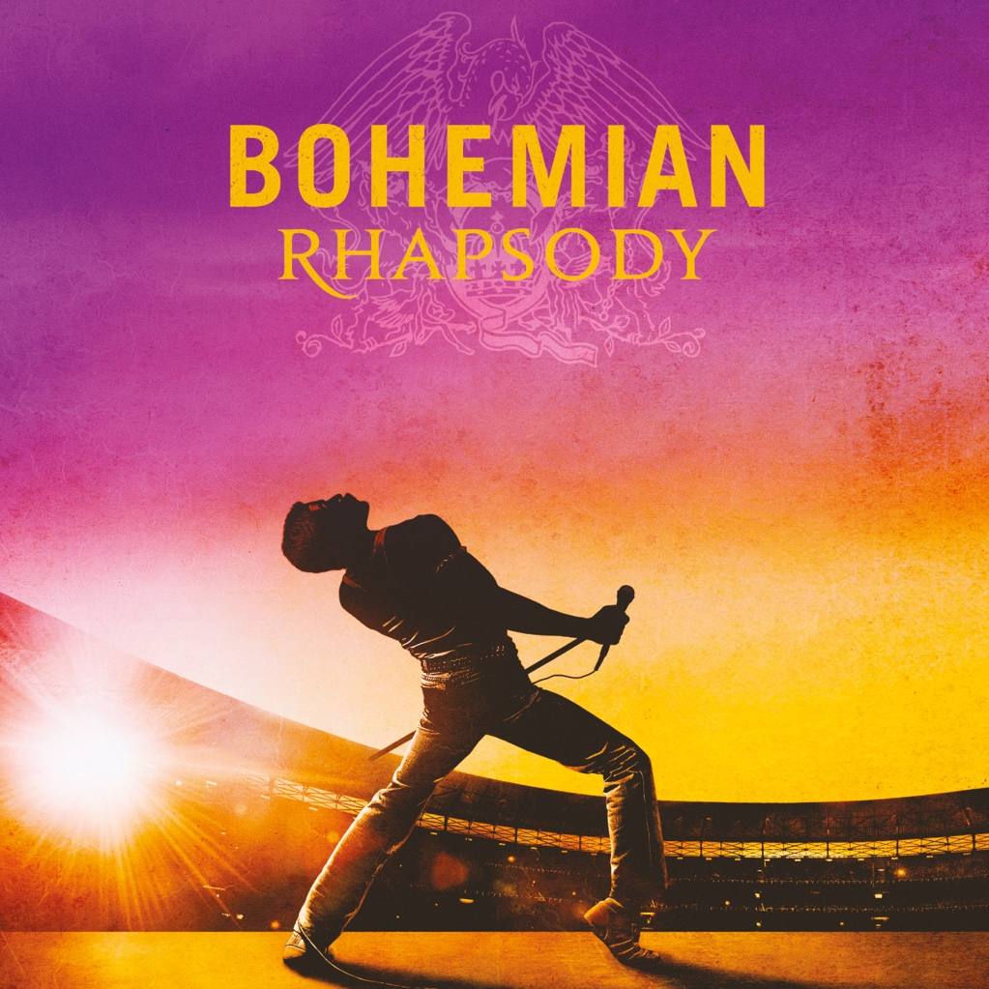

Burbank, CA (November 13, 2018) – Forget about the king, it’s good to be QUEEN: the iconic rock band scored its highest-charting album in 38 years with the Bohemian Rhapsody soundtrack (Hollywood Records), which surged from No. 25 to No. 3 on The Billboard 200 (a 187% increase) and is currently No. 1 on the Billboard Artist 100 and Top Rock Albums charts.

In addition, Queen’s Greatest Hits Vol I, II & III: The Platinum Collection rocketed from No. 194 to No. 9. The chart activity follows the film’s November 2nd opening in theaters across the country. 20th Century Fox and Regency Enterprises’ acclaimed biopic was the No. 1 film at the box office upon its debut with an estimated $50 million in weekend ticket sales.

USA Today said it best: “Bohemian Rhapsody is a hit all over again.”

Bohemian Rhapsody’s hit-packed companion soundtrack is Queen’s highest-reaching album since 1980, when The Game spent five weeks at No. 1.

Alongside the show-stopping Live Aid performances of “Bohemian Rhapsody,” “Radio Ga Ga,” “Hammer To Fall” and “We Are The Champions,” the album features other rare live tracks spanning Queen's entire career, new versions of old favorites, and a choice selection of the band's finest studio recordings. Among them are some of Queen's biggest hits, including eleven all-time greatest anthems that reached No. 1 around the world.

Rolling Stone called the album “more than just a greatest hits,” praising it as “a fun imaginative way to relive the band’s genius.”

Queen currently has a jaw-dropping 22 songs charting on the Digital Rock Tracks Chart, including 7 of the top 10:

#1 “Bohemian Rhapsody”
#5 “We Will Rock You”
#6 “Somebody To Love”
#7 “Another One Bites the Dust”
#8 “We Are The Champions”
#9 “Radio Gaga”
#10 “Under Pressure”
With record sales estimated at 300 million and counting, Queen remain evergreen rock favorites whose glorious catalogue of songs continues to thrill fans of all ages across the globe.
About Bohemian Rhapsody The Film:
Bohemian Rhapsody is a foot-stomping celebration of Queen, their music and their extraordinary lead singer Freddie Mercury. Freddie defied stereotypes and shattered convention to become one of the most beloved entertainers on the planet. The film traces the meteoric rise of the band through their iconic songs and revolutionary sound.

20th Century Fox and Regency Enterprises present a GK Films production “Bohemian Rhapsody”. Starring Rami Malek, Lucy Boynton, Gwilym Lee, Ben Hardy, Joe Mazzello, Aidan Gillen, Tom Hollander and Mike Myers. Executive Music Producers Brian May, Roger Taylor. Music Supervisor Becky Bentham. Co-Producer Richard Hewitt. Edited by John Ottman, ACE. Production Designer Aaron Haye. Director of Photography Newton Thomas Sigel, ASC. Executive Producers Arnon Milchan, Denis O’Sullivan, Justin Haythe, Dexter Fletcher, Jane Rosenthal. Produced by Graham King, Jim Beach. Story by Anthony McCarten and Peter Morgan. Screenplay by Anthony McCarten. Directed by Bryan Singer.

www.queenonline.com || www.BohemianRhapsody.com Facebook: www.facebook.com/BohemianRhapsodyMovie || Twitter: www.twitter.com/BoRhapMovie
Instagram: www.instagram.com/BohemianRhapsodyMovie/ || YouTube: www.youtube.com/queen

U.S. PRESS CONTACT
Sharrin Summers
Hollywood Records / sharrin.summers@disney.com

