QUEEN TO RELEASE BOHEMIAN RHAPSODY
ORIGINAL FILM SOUNDTRACK ON OCTOBER 19

BOHEMIAN RHAPSODY, THE FILM,
RELEASES WORLD-WIDE NOVEMBER 2

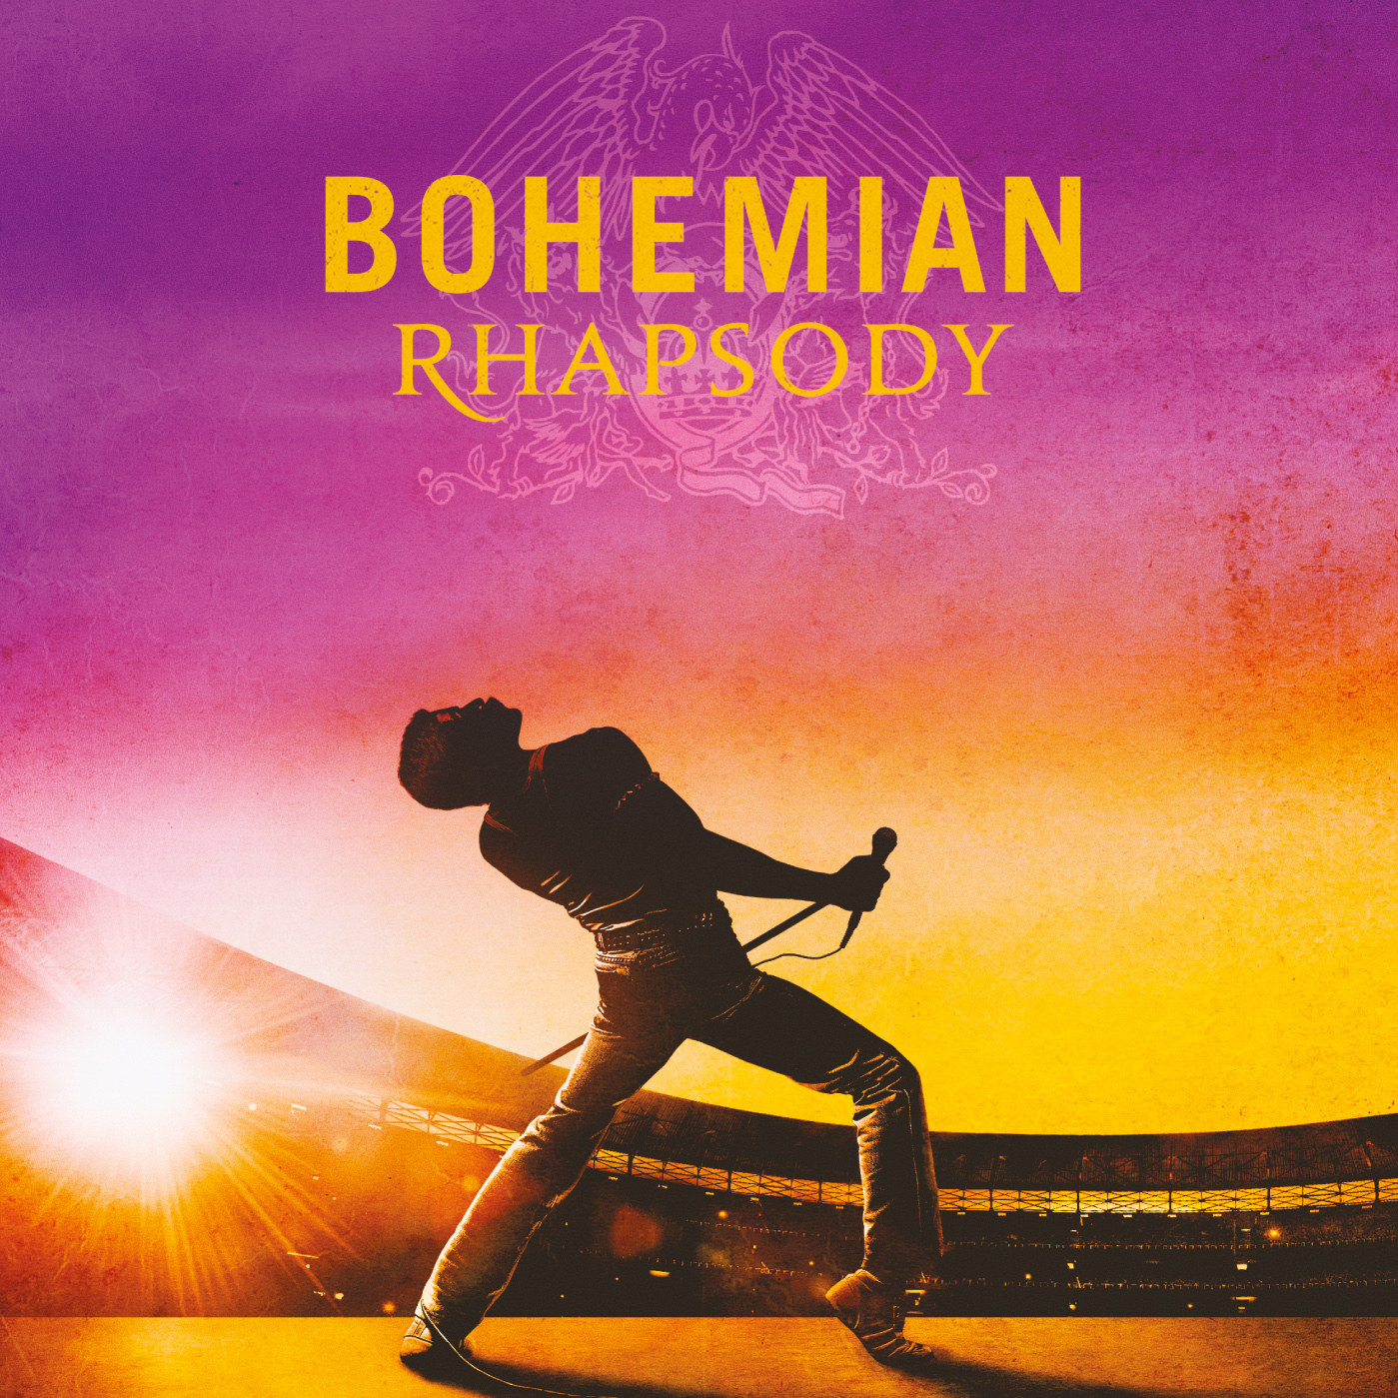

THE 22-SONG ALBUM FEATURES PREVIOUSLY UNAVAILABLE QUEEN PERFORMANCES AT LIVE AID PLUS NEW VERSIONS OF QUEEN CLASSICS

SMILE REUNITES TO RE-RECORD SONG FOR SOUNDTRACK

Available on Virgin Universal /Hollywood Records (USA)
Pre-order the soundtrack HERE

FOR MEDIA USAGE: Art work and press photos
http://www.hollywoodrecords.com/press/queen-bohemian-rhapsody-soundtrack/

(September 5, 2018) For the first time ever audio tracks from Queen's legendary performance at Live Aid are being released as part of the soundtrack album to Bohemian Rhapsody, 20th Century Fox and Regency Enterprises’ forthcoming feature film celebrating the band, their music and their extraordinary lead singer Freddie Mercury. Recorded at the historic Wembley concert in July 1985, these Live Aid songs are among the rare gems and unheard versions from the band’s rich catalogue.

Alongside the show-stopping Live Aid performances of “Bohemian Rhapsody,” “Radio Ga Ga,” “Hammer To Fall” and “We Are The Champions,” the album features other rare live tracks spanning Queen's entire career, new versions of old favorites, and a choice selection of the band's finest studio recordings. Among them are some of Queen's biggest hits, including eleven all-time greatest anthems that reached No. 1 around the world. The track listing was announced today, September 5, 2018, which would have been Freddie's 72nd birthday.

Bohemian Rhapsody will have its world premiere in the UK on October 23 before opening across the globe in early November. It stars Rami Malek as Freddie, Gwilym Lee as Brian May, Ben Hardy as Roger Taylor, Joe Mazzello as John Deacon, and Lucy Boynton as Freddie's lifelong companion Mary Austin. The soundtrack, featuring all-original Queen recordings and vocals, will be released on CD and digital formats on October 19.

The 22 songs on the soundtrack were produced by Brian May and Roger Taylor, with engineering and co-production by long-time Queen studio collaborators Justin Shirley-Smith, Kris Fredriksson and Joshua J Macrae, and mastering by Adam Ayan and Bob Ludwig.

The key task for the team behind the Bohemian Rhapsody soundtrack was sourcing the most suitable versions of the band’s songs, especially live performances, to fit the screenplay's career-spanning narrative. Their brief was not merely to produce a greatest hits playlist package but a soundtrack album to stand on its own merits, underscoring key moments in the screenplay. May, Taylor, and their co-producers worked with the filmmakers to find the best versions of each track to heighten the dramatic power of each scene.

Ensuring that listeners are in no doubt they are listening to a soundtrack album, Brian came up with the inspired idea that Queen should record their own arrangement of the famous 20th Century Fox Fanfare. Featuring May's famous multi-layered guitars and Roger Taylor’s distinctive percussion, this revamped track provides a suitably flamboyant opening fanfare to both film and album.

The five tracks from Queen's 21-minute performance at Live Aid on July 13, 1985, have never been released in audio form before. They’ve only ever been featured on video as a special extra on the DVD/BluRay release of Queen Rock Montreal, which features the Montreal Forum shows of November 1981. The Live Aid audio is exclusive to this new soundtrack album.

Other tracks on the soundtrack have been sourced from different decades and even different continents. “Fat Bottomed Girls” comes from the 1979 Paris shows, part of the Jazz world tour, and has never been released before. “Now I'm Here” was recorded at the band's 1975 Christmas Eve show at London's Hammersmith Odeon. And the history making duet between Freddie and Brian on “Love of My Life” comes from the Rock in Rio festival of January 1985 when 300,000 Brazilians sang along. Previously this track was only available to fans on the video releases of this performance.

The three remaining songs on the soundtrack will be fresh to Queen fans, old and new. “We Will Rock You” starts out as the studio version, then seamlessly blends into a live performance with audience participation. This has been created especially for the film. “Don't Stop Me Now” features Brian's newly recorded guitar parts and is much closer to how the band plays the track live today.

“Doing All Right” was originally recorded by Smile, the predecessor band to Queen that featured Brian and Roger with vocalist Tim Staffell. When Tim later left, Roger and Brian would join forces with Freddie to form Queen. Freddie’s interpretation of the song is featured on the first Queen album. To recreate the original Smile version, Brian and Roger reunited with Staffell at Abbey Road Studios to re-record “Doing All Right” for the Bohemian Rhapsody soundtrack. This session which featured Roger, Tim and Brian all singing lead vocals took place almost 50 years after the original Smile recording.

With record sales estimated at 300 million and counting, Queen remain evergreen rock favorites whose glorious catalogue of songs continues to thrill fans of all ages across the globe. Despite the loss of Freddie in 1991, their following has continued to grow over the decades, boosted by a new wave of fans who first discovered the band's music through their hugely successful stage show We Will Rock You or via hit TV shows like Glee, American Idol and The X-Factor.

The Bohemian Rhapsody film and its original soundtrack album are certain to introduce Queen to a new generation of listeners, and remind existing fans just how magnificent the band was in its prime. Queen remain spectacular performers today, both live and in the studio, their songs having comfortably stood the test of time. After almost 50 years together, Queen remain one of the most exciting and beloved bands in rock history.

Full track listing for Bohemian Rhapsody the original soundtrack is:
1. 20th Century Fox Theme 0:25
2. Somebody To Love 4:56
3. Doing All Right... revisited (Performed by Smile) 3:17
4. Keep Yourself Alive (Live At The Rainbow) 3:56
5. Killer Queen 2:59
6. Fat Bottomed Girls (Live In Paris) 4:38
7. Bohemian Rhapsody 5:55
8. Now I'm Here (Live At Hammersmith Odeon) 4:26
9. Crazy Little Thing Called Love 2:43
10. Love Of My Life (Rock In Rio) 4:29
11. We Will Rock You (Movie Mix) 2:09
12. Another One Bites The Dust 3:35
13. I Want To Break Free 3:43
14. Under Pressure (Performed by Queen & David Bowie) 4:04
15. Who Wants To Live Forever 5:15
16. Bohemian Rhapsody (Live Aid) 2:28
17. Radio Ga Ga (Live Aid) 4:06
18. Ay-Oh (Live Aid) 0:41
19. Hammer To Fall (Live Aid) 4:04
20. We Are The Champions (Live Aid) 3:57
21. Don't Stop Me Now… revisited 3:38
22. The Show Must Go On 4:32

About Bohemian Rhapsody The Film:
Bohemian Rhapsody is a foot-stomping celebration of Queen, their music and their extraordinary lead singer Freddie Mercury. Freddie defied stereotypes and shattered convention to become one of the most beloved entertainers on the planet. The film traces the meteoric rise of the band through their iconic songs and revolutionary sound.

Twentieth Century Fox and Regency Enterprises present a GK Films production “Bohemian Rhapsody”. Starring Rami Malek, Lucy Boynton, Gwilym Lee, Ben Hardy, Joe Mazzello, Aidan Gillen, Tom Hollander and Mike Myers. Executive Music Producers Brian May, Roger Taylor. Music Supervisor Becky Bentham. Co-Producer Richard Hewitt. Edited by John Ottman, ACE. Production Designer Aaron Haye. Director of Photography Newton Thomas Sigel, ASC. Executive Producers Arnon Milchan, Denis O’Sullivan, Justin Haythe, Dexter Fletcher, Jane Rosenthal. Produced by Graham King, Jim Beach. Story by Anthony McCarten and Peter Morgan. Screenplay by Anthony McCarten. Directed by Bryan Singer.
Official Movie Online Channels
www.queenonline.com || www.BohemianRhapsody.com Facebook: www.facebook.com/BohemianRhapsodyMovie || Twitter: www.twitter.com/BoRhapMovie
Instagram: www.instagram.com/BohemianRhapsodyMovie/ || YouTube: www.youtube.com/queen

U.S. PRESS CONTACT
Sharrin Summers
Hollywood Records / sharrin.summers@disney.com

