QUEEN’S ICONIC “BOHEMIAN RHAPSODY” BECOMES THE
MOST-STREAMED SONG FROM THE 20TH CENTURY

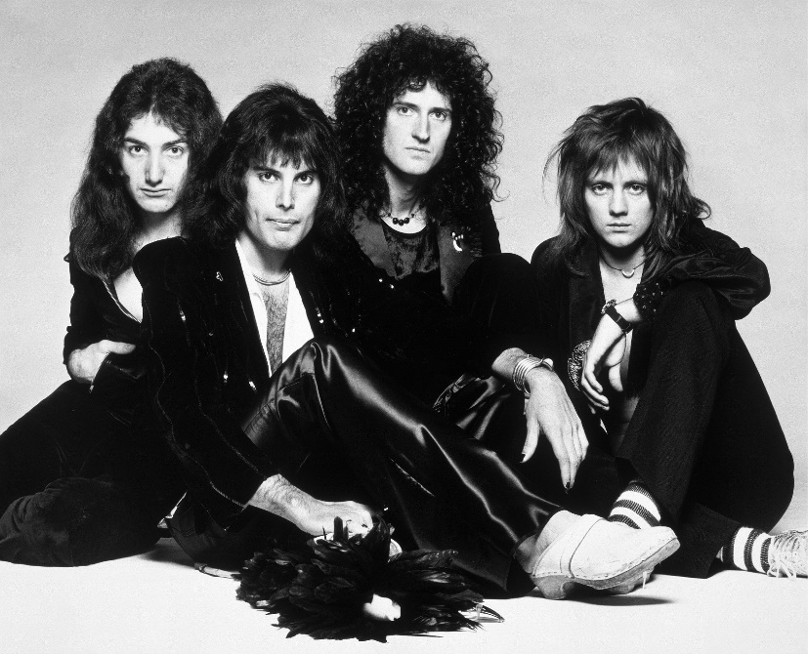
Credit: Photographer Terry O’Neill. Copyright Queen Productions Ltd. 1975
Taken from original Bohemian Rhapsody session

Click here to download hi-res video/photo assets

‘Greatest Rock Song of All Time’ Breaks Records as it passes 1.6 Billion Streams

Santa Monica, December 11, 2018 – Universal Music Group (UMG), the world-leader in music entertainment, today announced “Bohemian Rhapsody,” the iconic single by British rock legends Queen, officially became the world’s most-streamed song from the 20th Century, as well as the most-streamed Classic Rock song of all time. UMG’s teams around the world have actively promoted discovery across streaming platforms, physical reissues, merchandise and experiential programs to introduce ‘Bohemian Rhapsody’ to new fans more than 40 years after it was first recorded. Today, the original song and official video for “Bohemian Rhapsody,” taken from Queen’s seminal 1975 album A Night At The Opera, surpassed 1.6 billion streams globally across all major streaming services.

“Bohemian Rhapsody” is regularly cited as one of the greatest songs ever recorded. In 2004, the song was inducted into the Grammy Hall of Fame and Freddie Mercury’s vocal performance was named by the readers of Rolling Stone magazine as the best in rock history.

The instantly recognizable anthem also has been buoyed by the success of the biographical film Bohemian Rhapsody, which tells the incredible story of the band’s storied career. In just five weeks on release the film has become the highest grossing music biopic in history.

Brian May, Queen’s guitarist and founding member said, “So the River of Rock Music has metamorphosed into streams! Very happy that our music is still flowing to the max!"

Sir Lucian Grainge, Chairman and CEO of Universal Music Group, said, “’Bohemian Rhapsody’ is one the greatest songs by one of the greatest bands in history. We are so proud to represent Queen and are thrilled to see the song still inspiring new fans around the world more than four decades after its release. My congratulations to Queen and Jim Beach on an incredible achievement that is a testament to the enduring brilliance of Queen.”

UMG represents Queen’s iconic catalog globally outside North America, as well as providing support to the band across global merchandise, retail licensing and brand management through Bravado, UMG’s brand-management and merchandise company. UMG also produces and distributes audio-visual releases from from Queen via the company’s Eagle Rock division, the leading producer and distributor of music programming for broadcast, DVD, Blu-Ray, TV and digital media. These releases include Queen documentaries, concert films and their award-winning immersive virtual reality film ‘VR The Champions’. In North America, Queen’s recorded music catalog is represented by Hollywood Records.

The Soundtrack to Bohemian Rhapsody is available now on Walt Disney Co.’s Hollywood Records and UMG’s Virgin EMI.

MEDIA ASSETS:
Queen Hi-Res Images & Bohemian Rhapsody music video in broadcast quality can be downloaded here:
https://umusic.box.com/s/pwdgbtmcx5rk08b0qrwg1lad5ioix5xc

For more information please contact:
james.murtagh-hopkins@umusic.com

NOTES TO EDITORS:

BOHEMIAN RHAPSODY & QUEEN IN NUMBERS
-The track was first released as a single on October 31, 1975
-Bohemian Rhapsody was Queen's first Top 10 hit in the US. In the UK it went to #1 for 9 consecutive weeks, a record at the time.
-Bohemian Rhapsody is the only song in history ever to have topped the U.K. charts twice at Christmas.
-The video for Bohemian Rhapsody is generally recognised as the first promotional music video ever and was based on their Queen II album cover. It was directed by Bruce Gowers and was shot in 3 hours for a cost of £3,500 at the time at the band's rehearsal space.
-Bohemian Rhapsody has been covered by many artists over the years, including Pink, Kanye West, Robbie Williams, The Royal Philharmonic Orchestra, Montserrat Caballe, The Muppets and Elton John & Axl Rose (for the Freddie Mercury tribute concert in April 1992).
-Queen have sold in-excess of 300 million albums worldwide

Methodology
The methodology used to determine the most streamed song of the 20th century includes all registered streams on global on-demand streaming services including Spotify, Apple Music, Deezer, etc., as well as streams from official song/video streams on YouTube.

About Universal Music Group
Universal Music Group (UMG) is the world leader in music-based entertainment, with a broad array of businesses engaged in recorded music, music publishing, merchandising and audiovisual content in more than 60 countries. Featuring the most comprehensive catalog of recordings and songs across every musical genre, UMG identifies and develops artists and produces and distributes the most critically acclaimed and commercially successful music in the world. Committed to artistry, innovation and entrepreneurship, UMG fosters the development of services, platforms and business models in order to broaden artistic and commercial opportunities for our artists and create new experiences for fans. Universal Music Group is a Vivendi company. Find out more here.

