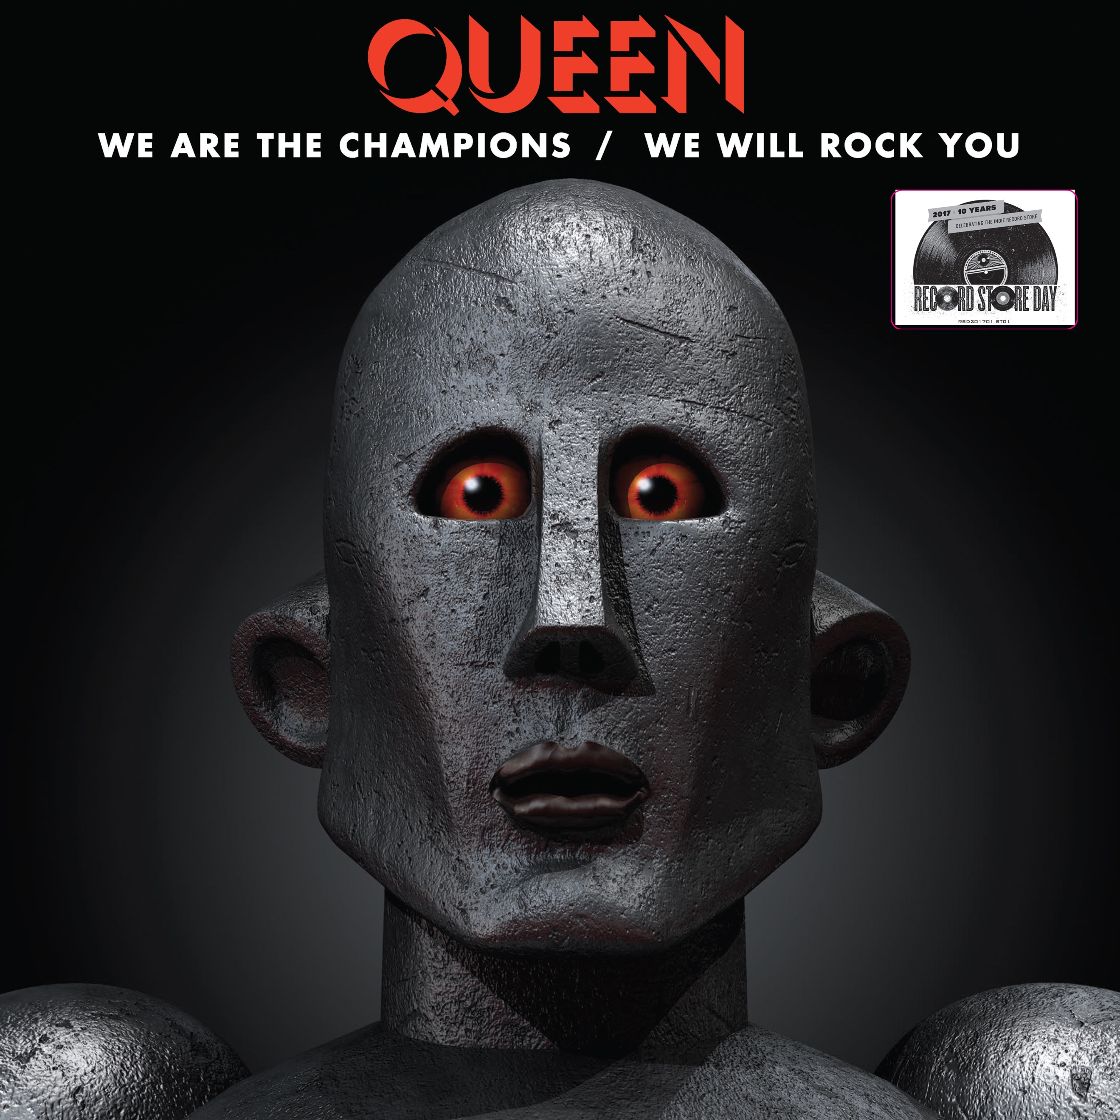

QUEEN TO RELEASE SPECIAL 12-INCH VINYL FOR BLACK FRIDAY RECORD STORE DAY

The limited-edition vinyl will include “We Are the Champions” and “We Will Rock You,” and will be released on November 24th in record stores nationwide.

For general information, including a Black Friday FAQ and participating stores, please visit http://www.recordstoreday.com

About Record Store Day:

Record Store Day, the organization, is managed by the Department of Record Stores and is organized in partnership with the Alliance of Independent Media Stores (AIMS), the Coalition of Independent Music Stores (CIMS) and promotes independent record stores year-round with events, special releases and other fun things.

Record Store Day, the global celebration of the culture of the record store, takes place annually in April.

