Ocean Park Standoff & Seeb team up on ‘Lost Boys’
Melodic anthem for release 2nd February
Ocean Park Standoff v Seeb
‘Lost Boys’
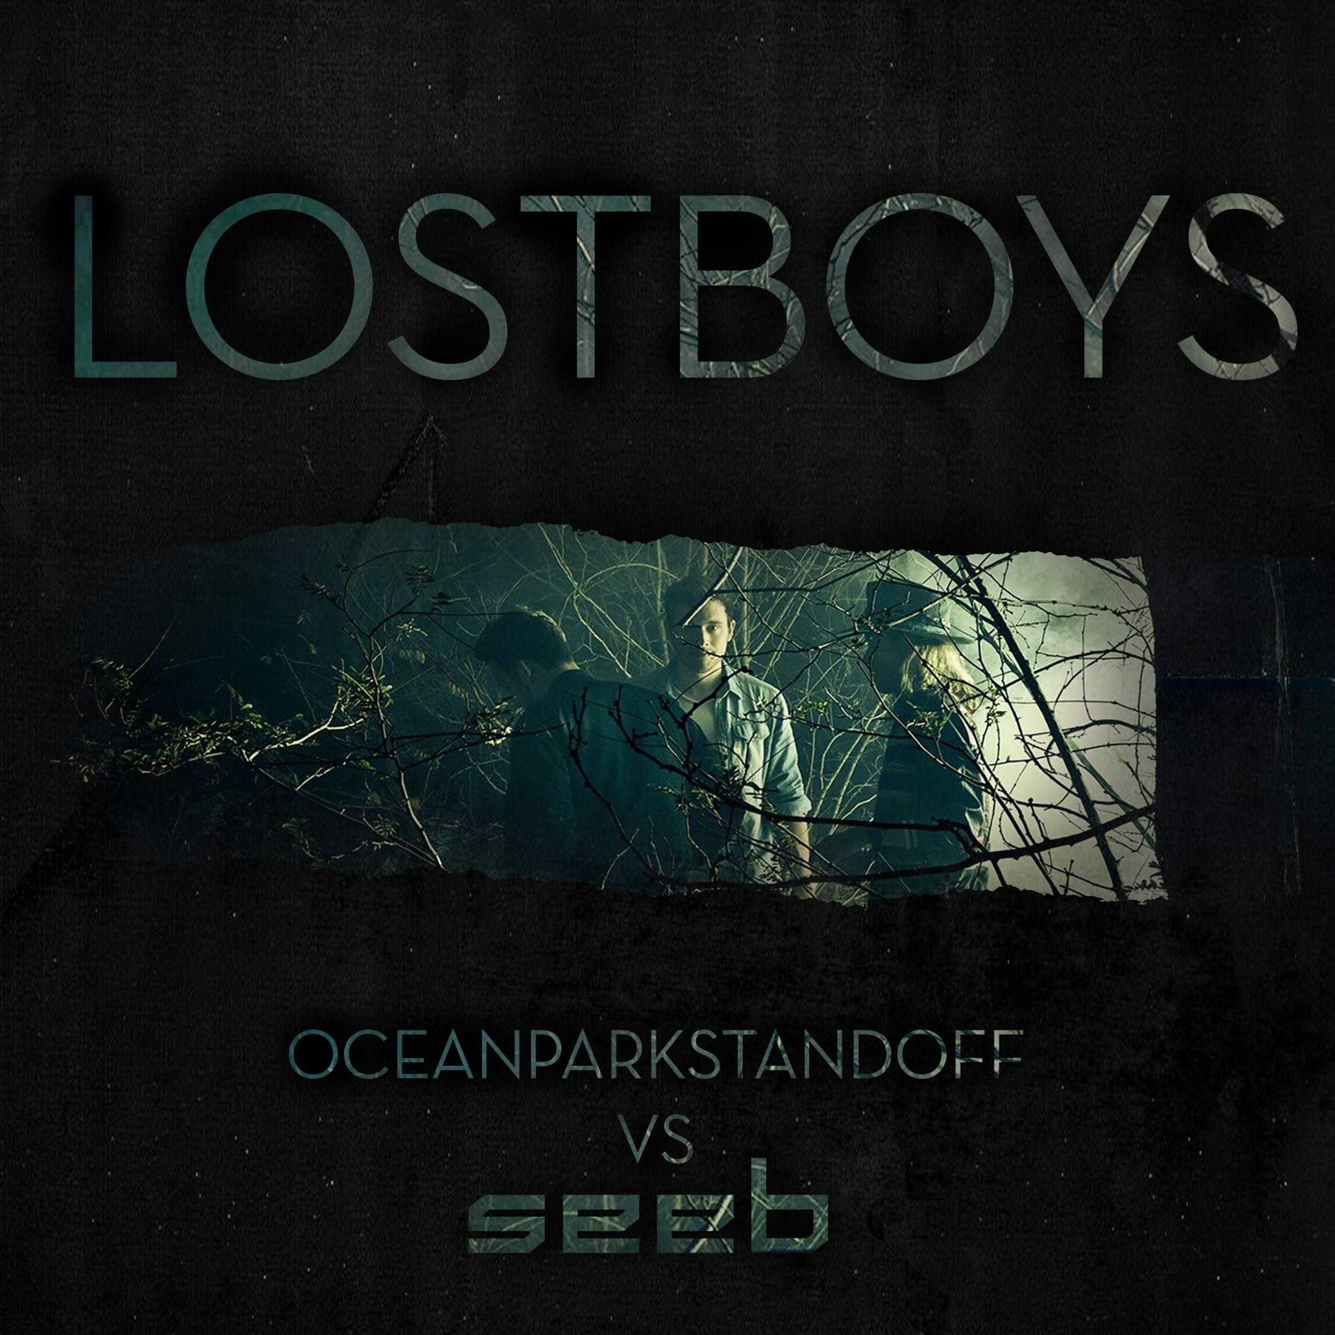

Listen Here - INSERT LINK

------------------------------------------------------------------------------------------------------------------------------------------------------------
LA based alt-pop trio Ocean Park Standoff reveal their latest single ‘Lost Boys’, an upbeat interpretation alongside Grammy-nominated Norwegian act Seeb.
The melodic production focuses on deep, bass-backed chords, and the rich vocals of Ethan Thompson, who describes ‘Lost Boys’ as “Forgetting the rules and living in complete freedom.”
”Lost Boys is about connecting to that freeness we felt when we were kids.” continues Thompson. “The older we get the more life seems to get serious and every once in a while, we need to remind ourselves to jump into the void of what we would do if there wasn't a tomorrow. ‘Lost Boys’ is that reminder for us."

“The song is about the Sunday night feeling of doom that everyone can relate to,” adds bandmate Samantha Ronson. “Or graduation day evening - dawning of the rest of your life. Just before you’ve gotta give up that fun for a life of assembly lines and yes sirs and yes ma'am's."

Each of the artists behind Ocean Park Standoff comes from a world all their own. A self-taught producer who built his own studio in the basement as a kid, Pete Nappi constructs deeply inventive productions equally inspired by art rock and underground hip-hop. A longtime DJ known for spinning at high-profile gigs around the globe, Samantha Ronson is also a songwriter/multi-instrumentalist who, like her superstar brother Mark, possesses sonic ingenuity rooted in her fascination with obscure vintage instruments.
Amassing over 951 million Spotify streams on their 2016 Mike Posner remix ‘I Took A Pill in Ibiza’, Norwegian trio Seeb have enjoyed further success with tracks like ‘Breathe’ (100 million streams) and their highly acclaimed Coldplay remix of ‘Hymn For The Weekend.’ Having supported Avicii on his farewell shows at Ushuaia Ibiza and Kygo at the Hollywood Bowl, the trio are also responsible for the official theme song of the X-Games 2017 with their R.City remake ‘Under Your Skin’.
Serving as an aural embodiment of both artist’s unique styles, ‘Lost Boys’ is set for release on 2nd February.

# # #
For more information on Ocean Park Standoff, please visit:
Instagram | Twitter | Facebook

For more information on Seeb, please visit:

Website I Instagram | Facebook

