DT: SEPTEMBER 6, 2017

AT&T and AUDIENCE® Network Present:

“Ocean Park Standoff”

Concert Special Airs Friday, September 8 at 9:30 p.m. ET/PT
On DIRECTV and U-verse (DIRECTV Ch 239/U-verse Ch 1114) and DIRECTV NOW

For A Preview, Watch The Band Perform “Lost Boys” (HERE)

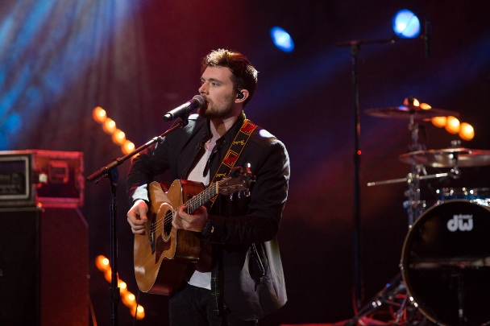
Ocean Park Standoff on AT&T AUDIENCE Network.

Tune in to the AT&T* AUDIENCE Network concert special “Ocean Park Standoff” airing Friday, September 8, at 9:30 p.m. ET/PT via DIRECTV Ch 239, AT&T U-verse Ch 1114 and on-demand through DIRECTV NOW. In this episode, the L.A. based alt-pop trio Ocean Park Standoff with series host Ted Stryker for an intimate interview about their beginnings and musical influences.

For a preview of the show, watch and share as Ocean Park Standoff deliver a full-song performance of “Lost Boys” (HERE).

Lead singer Ethan Thompson describes “Lost Boys” as, “‘Lost Boys’ is about forgetting the rules and living in complete freedom. Those special nights where you’re like, ‘I’m just gonna have a good time and be a kid.’ At the end of the day, we’re all basically just kids anyway.”

Watch “Lost Boys” here:
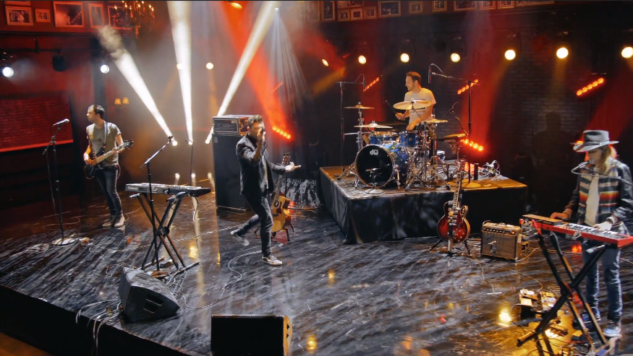

Watch the trailer for the “Ocean Park Standoff” concert special airing on AT&T AUDIENCE Network (HERE), and behind-the-scenes interview footage (HERE) and (HERE).

AUDIENCE Network's music slate continues to deliver groundbreaking concerts, unique stories and exclusive performances across all genres, plus select programming in ultra high-definition/4K¹, to audiences nationwide since multiple series began airing this past January. Recent concert specials include: Taylor Swift, Garth Brooks, Keith Urban, Sheryl Crow, CeeLo Green, Hank Williams Jr., Fall Out Boy, Panic! at the Disco, 2 Chainz, The Lumineers, Cole Swindell, Dan + Shay, Andra Day, Melissa Etheridge, Mac Miller, Brett Eldredge, Lukas Graham, Kelsea Ballerini, Tinashe, JoJo, Bebe Rexha, Brandy Clark, Chris Janson, Daya, Machine Gun Kelly, Trey Songz, Lauren Alaina, Rae Sremmurd, William Michael Morgan, X Ambassadors and others. New shows premiere via national broadcast Friday at 9:00 p.m. ET/PT on DIRECTV Ch 239/AT&T U-verse Ch 1114, as well as streaming on-demand at DIRECTV NOW, directv.com, uverse.com and on smartphones and tablets, via the DIRECTV and U-verse apps.²

AUDIENCE Network's multiple series of original and exclusive performances give music fans an intimate view of music's most influential artists today. The network collaborates directly with musicians to create a unique show from their perspective.

Ocean Park Standoff’s infectious and uplifting single “Good News,” from their self-titled debut EP on Hollywood Records, has garnered massive praise since its release with over 21 million streams to date, scoring the band a coveted spot on Spotify’s “Best Of” playlist. Elvis Duran spotlighted the group as an Artist of the Month and the band gave an explosive performance of the song on The Today Show. Ocean Park Standoff’ made their late night television debut on The Late Late Show with James Corden, just wrapped a U.S. arena tour supporting Third Eye Blind and Silversun Pickups and was featured on MTV’s VMA Weekend Special. Ocean Park Standoff is comprised of internationally renowned DJ and musician Samantha Ronson, singer/songwriter/vocalist and producer Ethan Thompson and producer/drummer Pete Nappi.

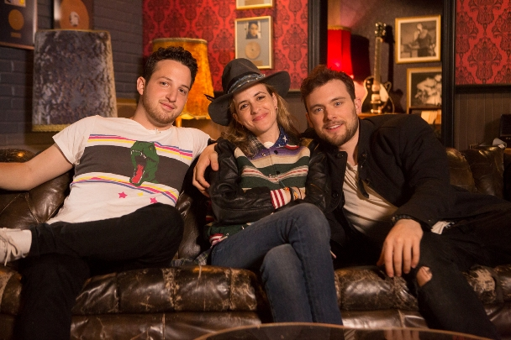
Ocean Park Standoff on AT&T AUDIENCE Network.

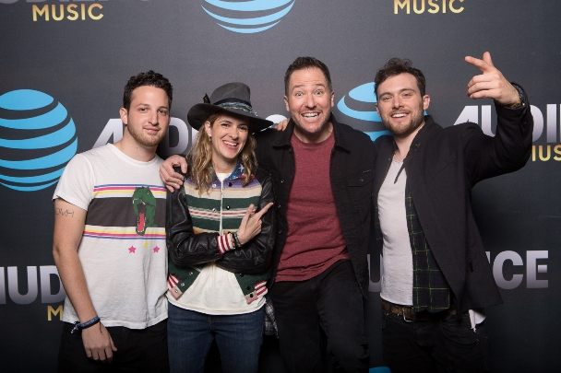
Ocean Park Standoff and series host Ted Stryker on AT&T AUDIENCE Network.

For more information on Ocean Park Standoff, visit:

Website: http://oceanparkstandoff.com/
Facebook: https://www.facebook.com/Oceanparkstandoff
Twitter: https://twitter.com/OPStandoff
Instagram: https://www.instagram.com/oceanparkstandoff/

@AUDIENCEMusic
TWITTER FACEBOOK INSTAGRAM

MSO Press Releases + Assets:
http://www.msopr.com/n/client-roster/at-t-audience-network/

Press Contact for Ocean Park Standoff
Sharrin Summers / Hollywood Records
Sharrin.summers@disney.com

¹Limited titles available. Requires a Genie HD DVR (model HR54 or later) and a DIRECTV 4K Ready TV, or 4K TV connected to a 4K Genie Mini. Additional & advanced receiver fees apply. SELECT Package or higher and 4K account authorization required. Visit directv.com/4K for complete details. Other conditions apply.

²Access via computer or app requires qualifying device and data connection. Access to content varies by device, TV plan, and viewing location. Data charges may apply.

*About AT&T
AT&T Inc. (NYSE:T) helps millions around the globe connect with leading entertainment, mobile, high speed internet and voice services. We’re one of the world’s largest providers of pay TV. We have TV customers in the U.S. and 11 Latin American countries. We offer the best global coverage of any U.S. wireless provider. And we help businesses worldwide serve their customers better with our mobility and highly secure cloud solutions.
AT&T products and services are provided or offered by subsidiaries and affiliates of AT&T Inc. under the AT&T brand and not by AT&T. Additional information about AT&T products and services is available at http://about.att.com. Follow our news on Twitter at @ATT, on Facebook at http://www.facebook.com/att and YouTube at http://www.youtube.com/att.
© 2017 AT&T Intellectual Property. All rights reserved. AT&T, the Globe logo and other marks are trademarks and service marks of AT&T Intellectual Property and/or AT&T affiliated companies. All other marks contained herein are the property of their respective owners.
###

