OCEAN PARK STANDOFF PERFORMS “GOOD NEWS” ON
THE LATE LATE SHOW WITH JAMES CORDEN

PERFORMANCE MARKS THE L.A. BASED TRIO’S LATE NIGHT TELEVISION DEBUT
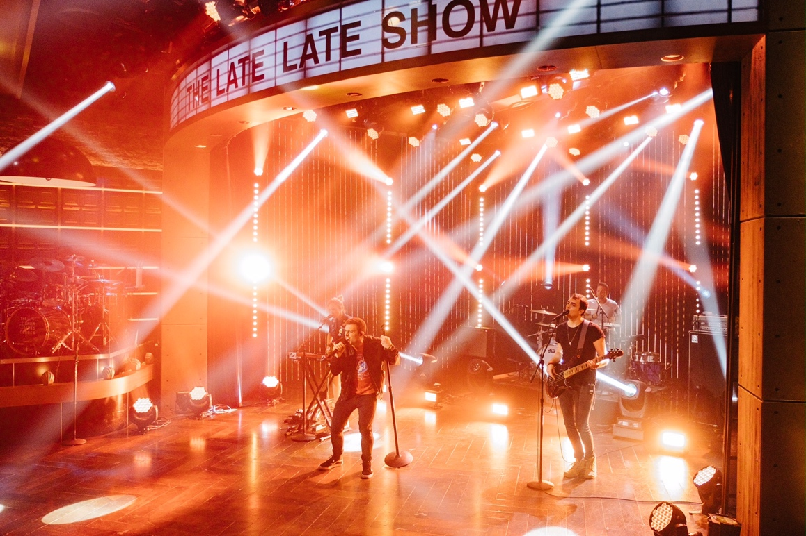

Photos: Terence Patrick/CBS ©2017 CBS Broadcasting, Inc. All Rights Reserved
DOWNLOAD PHOTOS FOR USE HERE

Performance: HERE

May 3, 2017 – Last night, L.A. based alt-pop trio Ocean Park Standoff (Samantha Ronson, Ethan Thompson, Pete Nappi) made their late night television debut on The Late Late Show with James Corden with a performance of their infectious and uplifting single “Good News” from her self-titled debut EP. Watch the performance HERE.

Ronson says of the song, “People kept saying 2016 is the worst year of all time, but it wasn’t even close and there were also a lot of good things happening if you looked. We wanted to make it easy for people to see those good things, and to give them light and hope.”

With “Good News” climbing the charts, it’s currently a top 20 hit at Hot AC, and on the heels of being tapped an iHeartRadio On The Verge Artist, OPS will hit the road on a U.S. arena tour supporting Third Eye Blind and Silversun Pickups beginning June 9 in Miami, FL, at the Bayfront Park Amphitheater, and hitting major cities including Nashville, Boston, Philly, Chicago, Dallas and Los Angeles among others. (For full list of tour dates, go HERE)

OCEAN PARK STANDOFF
Website: http://oceanparkstandoff.com/
Facebook: https://www.facebook.com/Oceanparkstandoff/?hc_ref=PAGES_TIMELINE
Instagram: https://www.instagram.com/oceanparkstandoff/
Twitter: https://twitter.com/OPStandoff

Press Contacts:
Sharrin Summers / Hollywood Records
Sharrin.summers@disney.com
Lillian Matulic / Hollywood Records
Lillian.Matulic@disney.com

Greg Cortez / greg.cortez@42west.net

Stephanie Durning / Stephanie.Durning@42west.net

