BRITISH TRIO NEW HOPE CLUB RELEASES
NEW SINGLE AND VIDEO FOR “CRAZY”

U.S. TOUR WITH THE VAMPS KICKS OFF SEPTEMBER 14
IN SEATTLE, WA

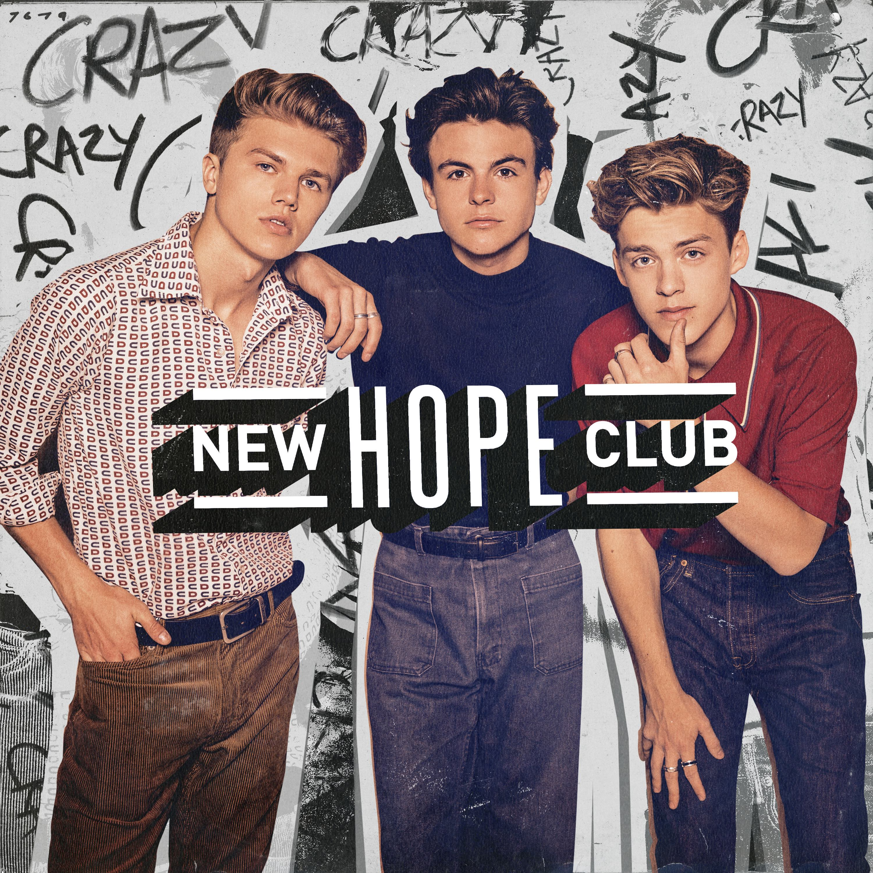

(Burbank, CA) – Sept. 14, 2018 – British trio New Hope Club have released their latest single “Crazy,” a pop track about a dysfunctional relationship. (Stream or Download) The accompanying music video, directed by Ed Rigg, channels a 70s vibe and follows the band as they hustle to get noticed, hoping to catch their big break busking around Venice Beach, CA. Watch the video HERE.

“The inspiration behind ‘Crazy’ is the idea that you’re in a volatile relationship but neither of you want to leave because you’re still in love,” explains Reece Bibby. “It’s about being a prisoner to your own heart, something that we’ve all felt at one point or another.”

New Hope Club, called out as “one of MTV’s bands to watch in 2018,” and “impossible to resist,” by Celebmix are currently back in the U.S. gearing up to hit the road with The Vamps on a string of US tour dates starting September 14th in Seattle and ending October 4th in New York City.

The trio have spent the past year touring the world, including making their US tour debut last summer on the sold-out Sabrina Carpenter DE-TOUR tour. Earlier this year, the band hit a milestone, playing two sold-out shows at London’s famed Shepherd’s Bush Empire. The band has amassed over 500K subscribers on YouTube and looks forward to seeing their US fans out on the road.

New Hope Club tour dates as follows:
Thurs., Sept 13 | Mexico City | El Plaza Condesa*
Sat., Sept. 15 | Seattle, WA | Showbox *
Sun., Sept. 16 | Portland, OR | Wonder Ballroom*
Tues., Sept. 18 | San Francisco, CA | August Hall*
Wed., Sept. 19 | Los Angeles, CA | Belasco Theatre*
Tues., Sept. 25 | Dallas, TX | HOB Cambridge Room*
Thurs., Sept. 27 | Chicago, IL | The Vic Theater*
Sun., Sept. 30 | Silver Springs, MD | The Filmore*
Tues., Oct. 2 | Philadelphia, PA | Theatre of the Living Arts*
Wed., Oct. 3 | Boston, MA | Paradise Rock Club*
Thurs., Oct. 4 | New York, NY | PlayStation Theatre*
Sun., Oct. 7 | Seoul, Korea | Korea Festival
Sat., Oct. 13 | Wembley, UK | SSE Arena

*supporting The Vamps
About New Hope Club
All lifelong musicians who began writing their own music as kids, Northern England natives Reece Bibby, Blake Richardson and George Smith bonded over their shared mission of creating acoustic-guitar-driven pop music. Forming in 2015 and signed jointly to Hollywood Records, Virgin EMI and The Vamps’ Steady Records, the band has already toured Europe, Latin America, Asia, Australia and New Zealand on major arena tours with The Vamps and opened for Sabrina Carpenter’s nationwide 2017 US tour. The band was recently named a Band to Watch in 2018 by MTV.

Twitter | Instagram | facebook | YouTube
Blake Twitter // Blake Instagram
George Twitter // George Instagram
Reece Twitter // Reece Instagram

NEW HOPE CLUB media kit HERE

Media Contacts:
Sharrin Summers // Hollywood Records // Sharrin.Summers@Disney.com
Lyssa Hurvitz // Hollywood Records // lyssa.hurvitz@disney.com

