BRITISH TRIO, NEW HOPE CLUB, RELEASE
MUSIC VIDEO FOR NEW SINGLE “FIXED”
BAND TAPPED TO SUPPORT SABRINA CARPENTER ON THE DE-TOUR
THE 30+ CITY SUMMER 2017 TOUR KICKS OFF JULY 6 IN VANCOUVER
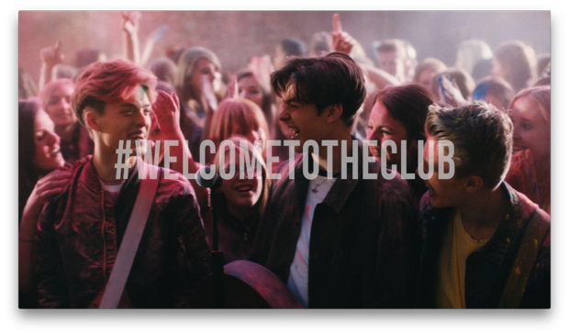
WATCH VIDEO HERE

Welcome To The Club
streaming link HERE // buy link HERE

(Burbank, CA) – May 10, 2017 – Hollywood Records/Virgin EMI Records artists, New Hope Club released the music video for their new single “Fixed,” off their debut EP Welcome to the Club.

Reece Bibby, Blake Richardson and George Smith wrote and recorded the EP in London and Los Angeles, teaming up with producers Red Triangle (Charlie Puth, 5 Seconds of Summer, and The Struts), Khris Lorenz (3Oh!3 and Janoskians), and Isaac Hasson (Demi Lovato and Selena Gomez).
The trio also announced they will be opening for Sabrina Carpenter this summer alongside Alex Aiono. The De-Tour will kick off on July 6th in Vancouver, BC, and continue across major North American cities including Seattle, San Francisco, Los Angeles, Dallas, New Orleans, Orlando, Atlanta, Nashville, Boston and Philadelphia.
This will be New Hope Club’s first US tour; the band is also set to support The Vamps and Sabrina Carpenter on a UK run this May.
Throughout the four song Welcome To The Club EP, New Hope Club offer up straight-from-the-heart lyrics told in powerful detail. The EP builds off the bright and breezy pop of “Perfume” and brings in elements of electronic music and R&B. With its sleek beats and dance-worthy grooves, “Friend of a Friend,” brilliantly captures the rush of instant infatuation. “Water” fuses hypnotic rhythms with jangly guitar tones and finds the band dreaming up their own vernacular. “It’s basically our way of describing hotness—a girl who makes you melt and turn to water,” explains George. And on “Fixed,” cascading guitar lines and soaring harmonies provide a perfect backdrop to New Hope Club’s portrait of the pain of obsession.

Catch New Hope Club on tour this summer. Dates as follows:

Date | City | Venue
July 6 | Vancouver, BC | Vogue Theatre
July 8 | Edmonton, AB | Winspear Centre
July 11 | Seattle, WA | Neptune Theatre
July 13 | Portland, OR | Crystal Ballroom
July 15 | San Francisco, CA | The Masonic
July 16 | Santa Rosa, CA | Luther Burbank Center for the Arts
July 18 | San Diego, CA | Balboa Theatre
July 19 | Anaheim, CA | House of Blues
July 21 | Los Angeles, CA | The Wiltern
July 22 | Phoenix, AZ | Comerica Theatre
July 24 | Denver, CO | Paramount Theatre
July 26 | Dallas, TX | Majestic Theatre
July 28 | New Orleans, LA | Saenger Theatre
July 30 | Houston, TX | Revention Music Center
Aug. 2 | Jacksonville, FL | Florida Theatre
Aug. 4 | Miami Beach, FL | The Fillmore Miami Beach at the Jackie Gleason Theater
Aug. 5 | Orlando, FL | Dr. Phillips Center for the Performing Arts – Walt Disney Theater
Aug 6. | Atlanta, GA | The Tabernacle
Aug. 8 | Nashville, TN | Ryman Auditorium
Aug. 9 | Indianapolis, IN | Murat Theatre at Old National Centre
Aug. 12 | Detroit, MI | The Fillmore
Aug. 16 | Pittsburgh, PA | Byham Theater
Aug. 17 | Cleveland, OH | Connor Palace at Playhouse Square
Aug. 20 | Boston, MA | House of Blues
Aug. 22 | Montclair, NJ | The Wellmont Theater
Aug. 25 | Charlotte, NC | Belk Theater At North Carolina Blumenthal Performing Arts Center

Twitter | Instagram | facebook | YouTube
Blake Twitter // Blake Instagram
George Twitter // George Instagram
Reece Twitter // Reece Instagram
NEW HOPE CLUB media kit HERE
Media Contacts:
Sharrin Summers // Hollywood Records // sharrin.summers@disney.com
Lyssa Hurvitz // Hollywood Records // lyssa.hurvitz@disney.com

