JORDAN FISHER RELEASES INVENTIVE VIDEO FOR “MESS”

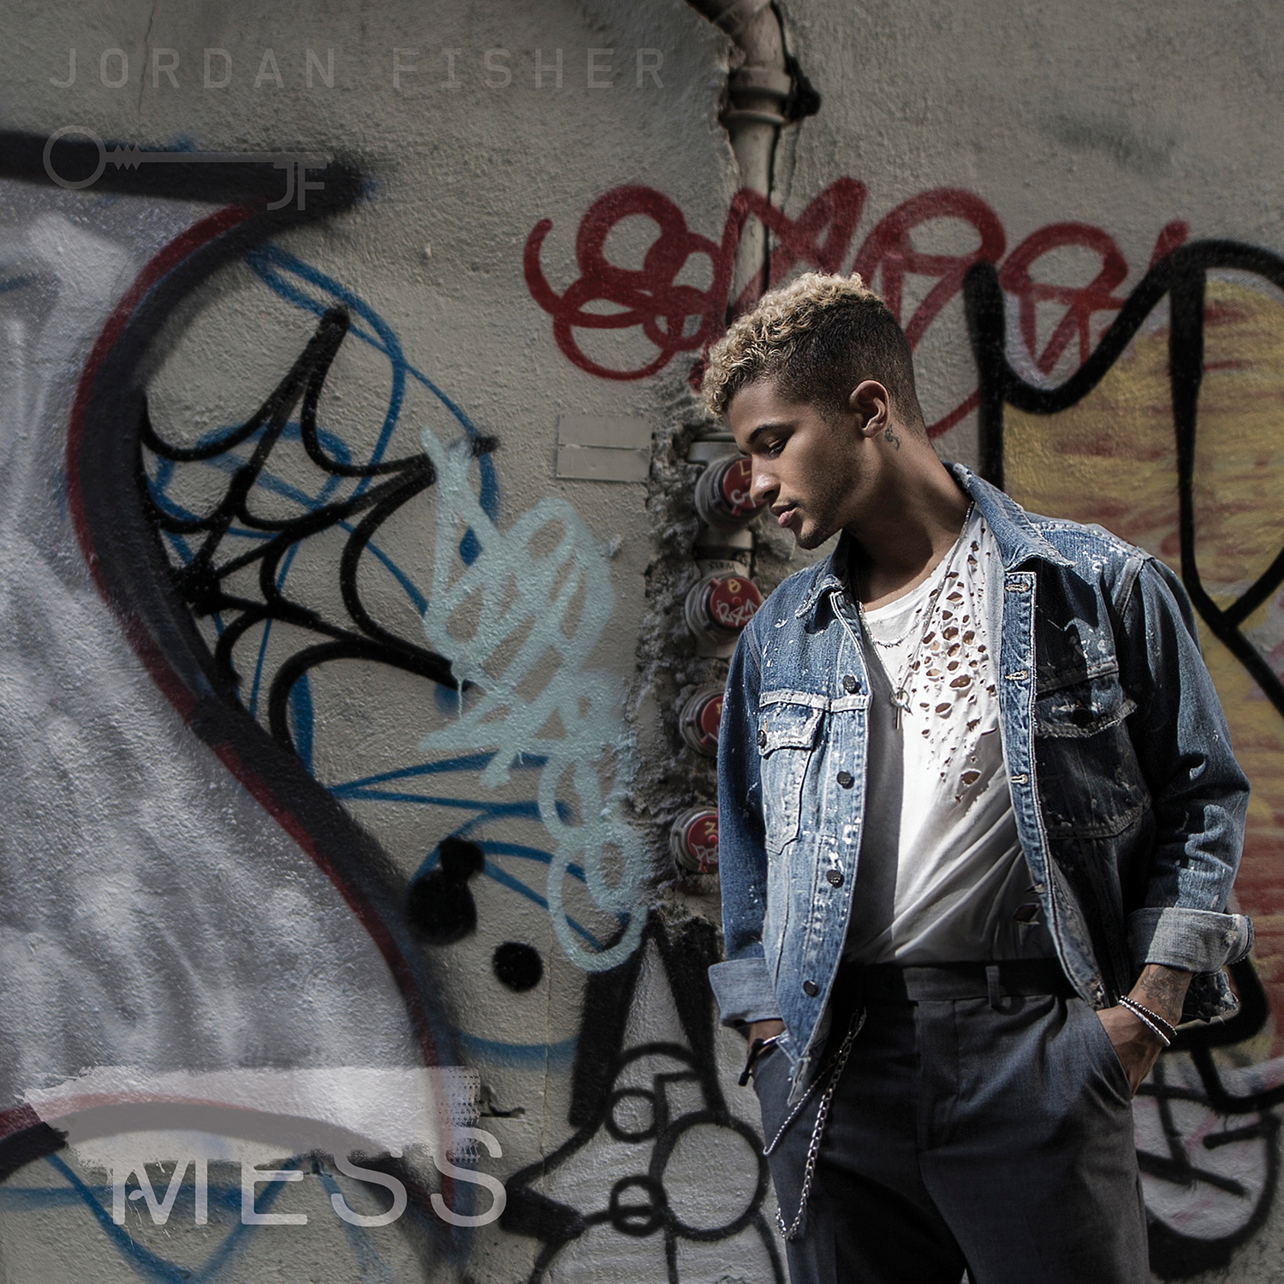

WATCH IT HERE

Hollywood Records artist Jordan Fisher has unleashed a wildly creative and visually stimulating video for his song “Mess.” The video, which was directed by TK McKamy and choreographed by Jordan’s longtime friend/collaborator Willdabeast and dancer Sean Lew, highlights Jordan’s gymnastic past and dance prowess

The single released last Friday (10/6) was co-written by Jordan along with Dewain Whitmore, Patrick “J-Que” Smith and Mike Sabath marks the first new music from the triple threat artist since the release of his self-titled EP in August 2016 which featured the top 40 hit, “All About Us.” Jordan is due to release a full-length album in 2018. “Mess” is available for purchase HERE and streaming HERE.

Currently, Jordan can be seen every Monday night along with dance pro Lindsay Arnold on ABC’s Dancing With The Stars Season 25 where the pair have been at the top of leaderboard since the show’s premiere.

ABOUT JORDAN FISHER Jordan Fisher made his mark in FOX’s “Grease: Live” with a scene stealing performance of “Those Magic Changes,” earning him rave reviews from Entertainment Weekly, People Magazine, Buzzfeed, MTV and Ariana Grande who called Jordan her “favorite vocalist.” Jordan’s debut single “All About Us” was the #2 most added song at Pop Radio, hitting the top of Billboard’s pop chart. Following the release of his self-titled EP, Jordan took a turn starring in the Broadway smash, HAMILTON, playing the dual roles of John Laurens and Philip Hamilton and was featured on the Moana soundtrack with a version of “You’re Welcome” with Lin-Manual Miranda.

MESS (AUDIO ONLY) HERE
PURCHASE LINK HERE
STREAMING LINK HERE

Facebook.com/ /JordanFisherOfficial
Twitter.com/Jordan_Fisher
Instagram.com/Jordan_Fisher
Snapchat: Jordan_Fisher
YouTube.com/jordanfishervevo

