JORDAN FISHER TO RELEASE NEW SINGLE “MESS” OCTOBER 6
JOINS CAST OF DANCING WITH THE STARS
SET TO APPEAR AT SUPER SCHOOL LIVE PRIMETIME SPECIAL THIS FRIDAY

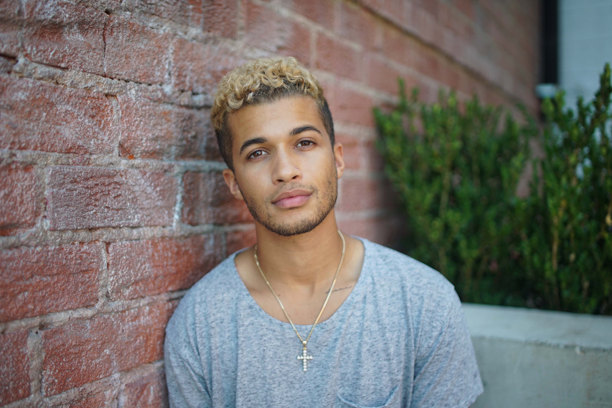

Hollywood Records artist Jordan Fisher is set to release his new single, “Mess” on October 6, 2017. Co-written by Fisher along with Dewain Whitmore, Patrick “J-Que” Smith and Mike Sabath, “Mess” marks the first new music from the triple threat artist since the release of his self-titled EP in August 2016 which featured the top 40 hit, “All About Us.”

This announcement follows the news that Fisher will be joining the cast of Dancing With The Stars Season 25 along with dance pro Lindsay Arnold. Season 25 of Dancing With The Starspremieres September 18th on ABC at 8p/7c.

In addition, Fisher will join Tom Hanks, Cate Blanchett, Lin-Manuel Miranda, DJ Khaled, Ringo Starr, Hunter Hayes and more for “EIF Presents: XQ Super School Live” a special one-hour, primetime telecast airing this Friday, September 8th at 8p/7c on ABC, NBC, CBS and FOX that will invite the public to help rethink the future of American high schools.

ABOUT JORDAN FISHER Jordan Fisher made his mark in FOX’s “Grease: Live” with a scene stealing performance of “Those Magic Changes,” earning him rave reviews from Entertainment Weekly, People Magazine, Buzzfeed, MTV and Ariana Grande who called Jordan her “favorite vocalist.” Jordan’s debut single “All About Us” was the #2 most added song at Pop Radio, hitting the top of Billboard’s pop chart. Following the release of his self-titled EP, Jordan took a turn starring in the Broadway smash, HAMILTON, playing the dual roles of John Laurens and Philip Hamilton and was featured on the Moana soundtrack with a version of “You’re Welcome” with Lin Manual Miranda.

Facebook.com/ /JordanFisherOfficial
Twitter.com/Jordan_Fisher
Instagram.com/Jordan_Fisher
Snapchat: Jordan_Fisher
YouTube.com/jordanfishervevo
FOR MORE INFORMATION, CONTACT: Heather.Davis@Disney.com

