JOYWAVE SET TO PLAY
THE LATE SHOW WITH STEPHEN COLBERT
FEBRUARY 8TH 2018

THANKS. THANKS FOR COMING TOUR 2018
KICKS OFF FEBRUARY 10
TICKETS HERE
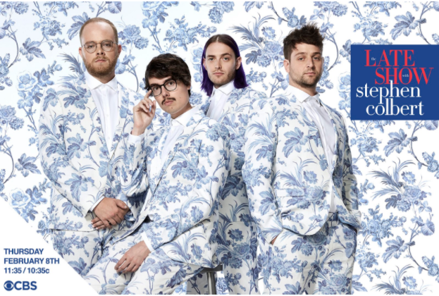
hi-res photo: Mary Ellen Matthews here
hi-res tour poster here
album artwork here

ALBUM CONTENT OUT NOW HERE AND HERE
SPOTIFY SINGLES HERE

Joywave will be taking the stage on The Late Show with Stephen Colbert onThursday, February 8th to perform “Doubt” from their latest album Content. The band is also set to release the video for “Doubt” by acclaimed director Olivier Gondry. Joywave’s headlining Thanks. Thanks For Coming 2018 tour kicks off two days later on February 10th, with supporting acts Sasha Sloan and KOPPS. See a full list of dates below and purchase tickets here.

Earlier this year, Joywave shared their new Spotify Singles here. The multi-track single includes an in-studio version of “Doubt” as well as a cover of Talk Talk’s“Life’s What You Make It.”

In 2017, Joywave released their sophomore album, Content, which debuted #10 on iTunes Alternative Album chart and features their hit single/video “It’s A Trip!,”launched a sold out US headline tour, Thanks, Thanks For Coming 2017 andtoured with Young the Giant and Cold War Kids.

Joywave live:
Sat 02.10 - Las Vegas, NV @ The Bunkhouse (SOLD OUT)
Sun 02.11 - Phoenix, AZ @ The Crescent Ballroom (SOLD OUT)
Tue 02.13 - West Hollywood, CA @ The Roxy Theatre (SOLD OUT)
Thu 02.15 - Santa Ana, CA @ Constellation Room
Fri 02.16 - San Francisco, CA @ Swedish American Hall (SOLD OUT)
Sun 02.18 - Seattle, WA @ The Crocodile (SOLD OUT)
Tue 02.20 - Salt Lake City, UT @ Urban Lounge
Wed 02.21 - Denver, CO @ Globe Hall
Thu 02.22 - Denver, CO @ Globe Hall (SOLD OUT)
Sat 02.24 - Austin, TX @ The Parish (SOLD OUT)
Sun 02.25 - New Orleans, LA @ Gasa Gasa
Tue 02.27 - Atlanta, GA @ Terminal West
Wed 02.28 - Nashville, TN @ The Basement East
Fri 03.02 - Carrboro, NC @ Cat's Cradle
Sat 03.03 - Washington, DC @ U Street Music Hall (SOLD OUT)
Tue 03.06 - Toronto, ON @ Adelaide Hall
Wed 03.07 - Buffalo, NY @ Town Ballroom

ABOUT JOYWAVE: Beyond the stream of mixtapes (2011’s 77777, 2013’s 88888), EP’s (2012’s Koda Vista, 2015’s How Do You Feel?) and albums (2015’s How Do You Feel Now?, 2016’s SWISH, 2017’s Content), Joywave have seen their songs top the alternative radio charts and created a collection of standout music videos, a visually stimulating YouTube short film series Joy Meets World and their instagram cult classic Coffee With Joywave. The Rochester-based band has launched numerous, sold-out US headline shows, have toured with The Killers, Bleachers, Foals, Metric, Young The Giant, Cold War Kids and performed at Lollapalooza (US & Berlin), Coachella, Bumpershoot and Hangout Festivals. Their entrepreneurial spirit includes a line of coffee, Joewave, sponsoring a local little league team, The Southside Joywaves, and the creation of a liquid crystal thermochromic finish aka ‘mood’ guitar.
Joywave is vocalist Daniel Armbruster, guitarist Joseph Morinelli, keyboardist Benjamin Bailey and drummer Paul Brenner.

Praise for Joywave

“The band has carved a niche fanbase far beyond Rochester thanks to their thoughtfully sarcastic and moderately progressive brand of indie rock, slowly morphing into alternative underdogs.” - Billboard

“(On Content) It's the work of a band full of ideas, confident enough to throw them all together and accomplished enough to pull it off.” - Under The Radar Magazine

Joywave - Content tracklist:
01. Content
02. Shutdown
03. It’s A Trip!
04. Rumors
05. Confidence
06. Doubt
07. Going To A Place
08. Little Lies You’re Told
09. When You’re Bored
10. Thanks. Thanks For Coming
11. Let’s Talk About Feelings
full bio here

joywavemusic.com
twitter.com/joywave
instagram.com/joywavemusic
facebook.com/joywave
youtube.com/joywavemusic

Press Contact
Heather Davis / Hollywood Records
Heather.Davis@disney.com

