JOYWAVE ANNOUNCE HEADLINING
THANKS. THANKS FOR COMING 2017

SUPPORT FROM THE ACES, MAYBIRD, THE DEMOS

NEW ALBUM CONTENT OUT NOW HERE AND HERE
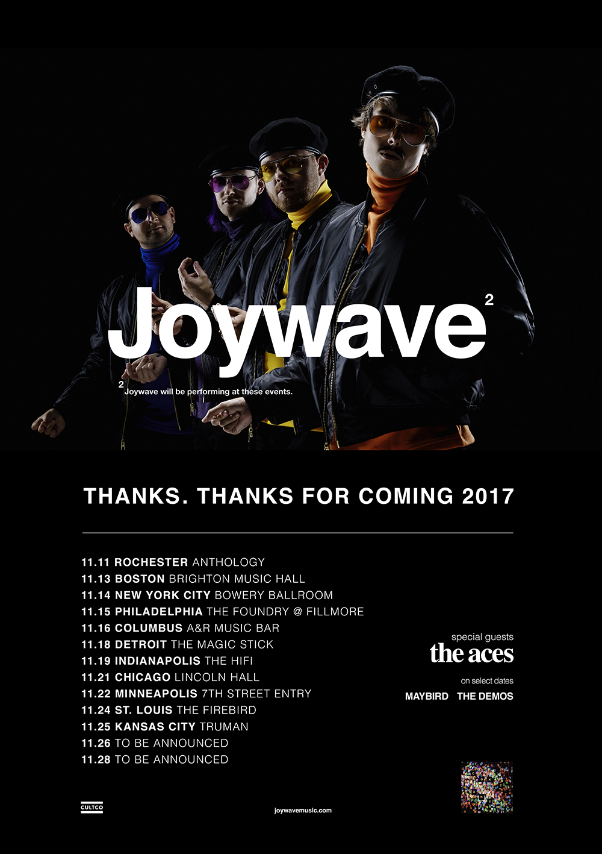
artist photo credit: Mary Ellen Matthews, hi-res here
hi-res tour poster here
album artwork here

Joywave have announced their fall headlining tour, Thanks. Thanks For Coming 2017. Kicking off on November 11th in their hometown of Rochester, NY, the band will be joined by The Aces as well as Maybird and The Demos on select dates. Tickets go on sale this Friday, September 29th at 10AM EST. See a full list of tour dates here. Joywave released their brand new album Content earlier this year via Hollywood Records/Cultco Music here. The band is currently wrapping a national tour supporting Young The Giant and Cold War Kids.

Their latest album Content is a heteronym that plays on the theme of CONtent vs ConTENT. The album is produced by Joywave’s own Daniel Armbruster & Sean Donnelly and mixed by Rich Costey, who has worked with artists like Haim, Foster The People, Vampire Weekend and At The Drive In. Joywave’s first single “It’s A Trip” is quickly closing in on the Top 20 at alternative radio while the video has over 1.4M views.

Joywave’s touring history is impressive to say the least; they’ve toured with Foals, The Killers, Brandon Flowers, Metric, Bleachers, and performing at some of the biggest festivals Coachella, Lollapalooza (US & Berlin), Reading & Leeds, Okeechobee, Osheaga, Hangout and Bumbershoot. Live, the band is electrifying and mesmerizing earning praise from Rolling Stone, Billboard, Boston Herald, Austin American Statesman, and more.

Always pushing the creative envelope, Joywave released a mixtape 77777(2011), their critically-acclaimed EP Koda Vista (2012), a second mixtape 88888 (2013), the How Do You Feel? EP (2014), a full-length debut album titled How Do You Feel Now? (2015) and in 2016 an entire album featuring alternative versions of their song “Destruction” called SWISH, a take on Kanye’s short-lived album title and more precisely the band titled it SWISH in response to the similarity between their 2015 tour art & “Destruction” ad campaign & The Life Of Pablo album art. They collaborated with Big Data on “Dangerous” which hit #1 at alternative radio, while “Somebody New”, “Destruction” and the track “Tongues” (feat KOPPS) off their album How Do You Feel Now? topped the US alternative radio charts as well.

Joywave is vocalist Daniel Armbruster, guitarist Joseph Morinelli, keyboardist Benjamin Bailey and drummer Paul Brenner.

Joywave live:
* = with Young The Giant, Cold War Kids
** = with The Aces, The Demos
^ = with The Aces, Maybird

Tue 09.26 - Birmingham, AL @ BJCC Concert Hall *
Thu 09.28 - Oklahoma City ,OK @ Criterion *
Fri 09.29 - Dallas, TX @ Irving Music Factory *
Sat 09.30 - Houston, TX @ White Oak Music Hall *
Wed 10.11 - Champaign, IL @ Foellinger Auditorium, University of Illinois
Sat 10.14 - Buffalo, NY @ HRVST Festival
Sat 11.11 - Rochester, NY @ Anthology**
Mon 11.13 - Boston, MA @ Brighton Music Hall**
Tue 11.14 - New York City, NY @ Bowery Ballroom**
Wed 11.15 - Philadelphia, PA @ The Foundry at Fillmore**
Thu 11.16 - Columbus, OH @ A&R Music Bar**
Sat 11.18 - Detroit, MI @ The Magic Stick^
Sun 11.19 - Indianapolis, IN @ The Hi-Fi
Tue 11.21 - Chicago, IL @ Lincoln Hall^
Wed 11.22 - Minneapolis, MN @ 7th Street Entry^
Fri 11.24 - St. Louis, MO @ The Firebird^
Sat 11.25 - Kansas City, MO @ Truman^
Sun. 11.26 - TBA
Tue 11.28 - TBA
Wed 11.29 - Washington, DC @ DC101 Office Party
Sat 12.02 - Fort Lauderdale, FL @ 104.3 The Shark Presents RIPTIDE FESTIVAL
Sun 12.03 - Tampa, FL @ 97x Next Big Thing
Mon 12.11 - Las Vegas, NV @ X107.5 Holiday Havoc ‘17 (Night 2)

Joywave - Content tracklist:
01. Content
02. Shutdown
03. It’s A Trip!
04. Rumors
05. Confidence
06. Doubt
07. Going To A Place
08. Little Lies You’re Told
09. When You’re Bored
10. Thanks. Thanks For Coming
11. Let’s Talk About Feelings

full bio here
album art, hi-res here
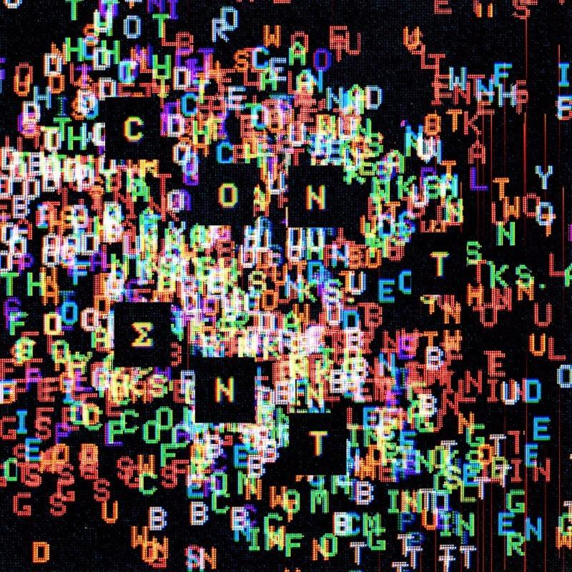

joywavemusic.com/
https://twitter.com/joywavemusic
https://www.instagram.com/joywavemusic/
https://www.facebook.com/joywave/
https://www.vevo.com/artist/joywave
https://m.youtube.com/user/joywavemusic

