JOYWAVE REVEAL
SPOTIFY “SINGLES” SESSION
HERE

THANKS. THANKS FOR COMING TOUR 2018 DATES
KICKOFF FEBRUARY 10
TICKETS HERE

ALBUM CONTENT OUT NOW HERE AND HERE

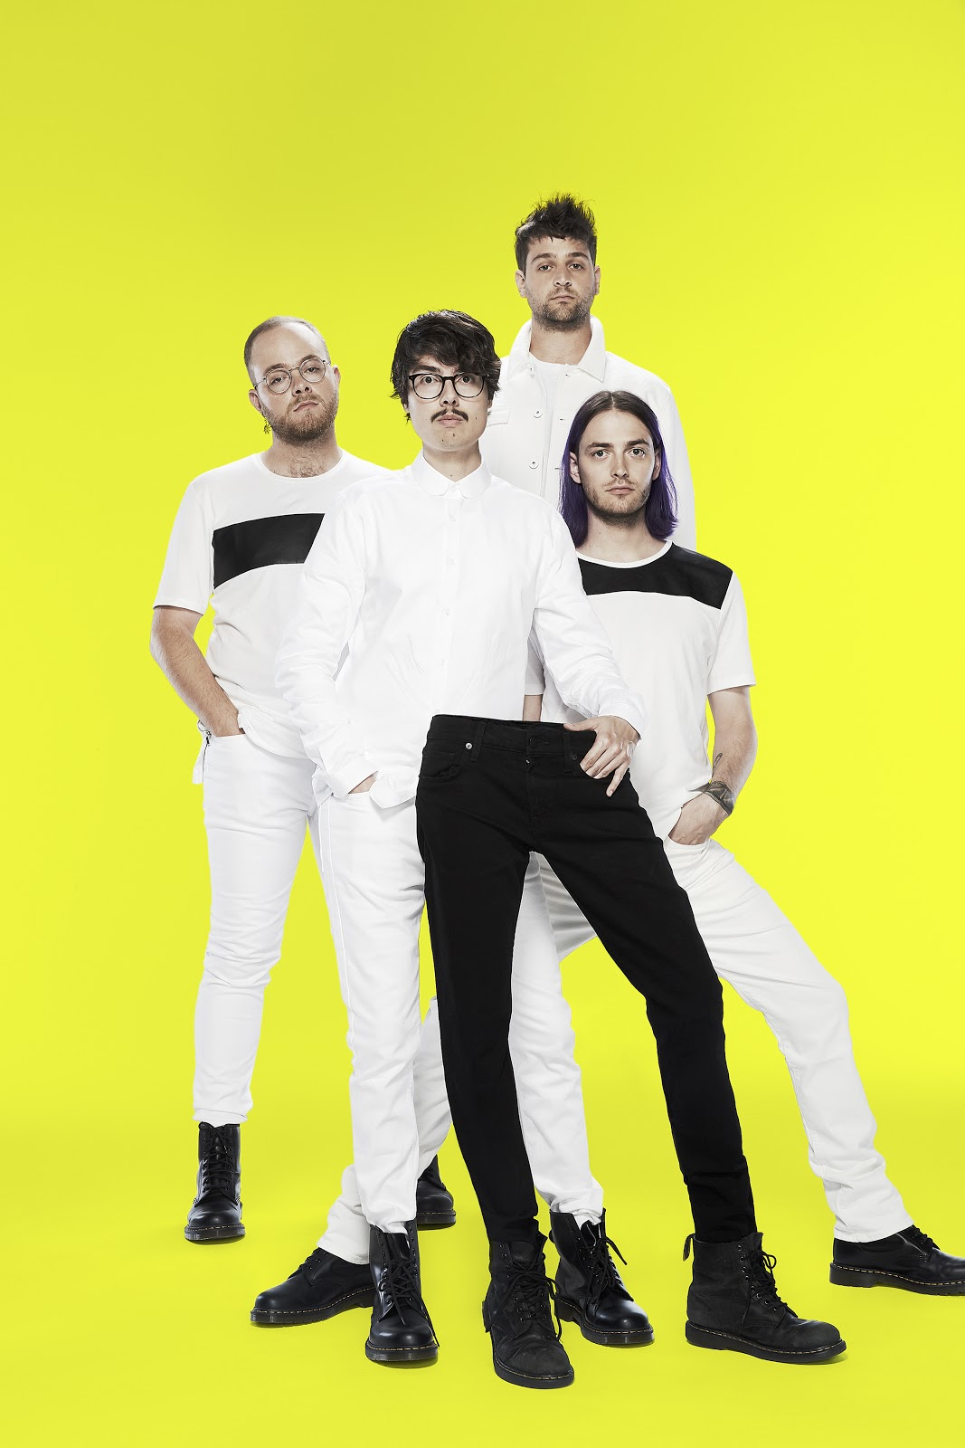
artist photo credit: Mary Ellen Matthews, hi-res here
hi-res tour poster here
album artwork here
Preparing for the 2018 leg of their headlining Thanks. Thanks For Coming tour, Joywave have revealed an exclusive Spotify “Singles” Session here. The multi-track single includes an in-studio version of “Doubt” as well as a cover of Talk Talk’s “Life’s What You Make It.” Next month, Joywave will hit the road with Sasha Sloan and Kopps, stopping in cities across the country. See a full list of dates below and purchase tickets here.

Last year, Joywave released their sophomore album, Content, produced by Joywave’s Daniel Armbruster & Sean Donnelly and mixed by Rich Costey (Haim, Foster The People, Vampire Weekend, At The Drive In) which debuted #10 on iTunes Alternative Album chart and #42 on the Overall Album Chart and features their hit single/video “It’s A Trip!”

Live, Joywave is electrifying and mesmerizing -- earning praise from Rolling Stone, Billboard, Boston Herald, Austin American Statesman, and more. Prior to this year’s Thanks. Thanks For Coming 2017 tour, the band toured with Cold War Kids and Young The Giant.

ABOUT JOYWAVE: Always pushing the creative envelope, Joywave released a mixtape 77777 (2011), their critically-acclaimed EP Koda Vista (2012), a second mixtape 88888 (2013), the How Do You Feel? EP (2014), a full-length debut album titled How Do You Feel Now? (2015) and in 2016 an entire album featuring alternative versions of their song “Destruction” called SWISH, a take on Kanye’s short-lived album title and more precisely the band titled it SWISH in response to the similarity between their 2015 tour art & “Destruction” ad campaign & The Life Of Pablo album art. They collaborated with Big Data on “Dangerous” which hit #1 at alternative radio, while “Somebody New”, “Destruction” and the track “Tongues” (feat KOPPS) off their album How Do You Feel Now? topped the US alternative radio charts as well.

Joywave is vocalist Daniel Armbruster, guitarist Joseph Morinelli, keyboardist Benjamin Bailey and drummer Paul Brenner.

Praise for Joywave

“The band has carved a niche fanbase far beyond Rochester thanks to their thoughtfully sarcastic and moderately progressive brand of indie rock, slowly morphing into alternative underdogs.” - Billboard

“They're genuinely extremely talented and their music is simply infectious.“ - Baeble

“Armbruster’s playful rapport and slightly operatic vocals make Joywave one of the most fun bands to see right now.” - Substream Magazine

“(On Content) It's the work of a band full of ideas, confident enough to throw them all together and accomplished enough to pull it off.” - Under The Radar Magazine

Joywave live:
Sat 02.10 - Las Vegas, NV @ The Bunkhouse
Sun 02.11 - Phoenix, AZ @ The Crescent Ballroom
Tue 02.13 - West Hollywood, CA @ The Roxy Theatre
Thu 02.15 - Santa Ana, CA @ Constellation Room
Fri 02.16 - San Francisco, CA @ Swedish American Hall
Sun 02.18 - TBD
Tue 02.20 - Salt Lake City, UT @ Urban Lounge
Wed 02.21 - Denver, CO @ Globe Hall
Thu 02.22 - Denver, CO @ Globe Hall (SOLD OUT)
Sat 02.24 - Austin, TX @ The Parish
Sun 02.25 - New Orleans, LA @ Gasa Gasa
Tue 02.27 - Atlanta, GA @ Terminal West
Wed 02.28 - Nashville, TN @ The Basement East
Fri 03.02 - Carrboro, NC @ Cat's Cradle
Sat 03.03 - Washington, DC @ U Street Music Hall (SOLD OUT)
Tue 03.06 - Toronto, ON @ Drake
Wed 03.07 - Buffalo, NY @ Town Ballroom

Joywave - Content track list:
01. Content
02. Shutdown
03. It’s A Trip!
04. Rumors
05. Confidence
06. Doubt
07. Going To A Place
08. Little Lies You’re Told
09. When You’re Bored
10. Thanks. Thanks For Coming
11. Let’s Talk About Feelings

full bio here
album art, hi-res here

joywavemusic.com/
https://twitter.com/joywavemusic
https://www.instagram.com/joywavemusic/
https://www.facebook.com/joywave/
https://www.vevo.com/artist/joywave
https://m.youtube.com/user/joywavemusic

