JOYWAVE’S PERFORMANCE ON
THE LATE SHOW WITH STEPHEN COLBERT HERE

NEW “DOUBT” OFFICIAL VIDEO (DIR: OLIVIER GONDRY) HERE

JOYWAVE JOINS THIRTY SECONDS TO MARS TOUR +
SOLD OUT HEADLINE THANKS. THANKS FOR COMING TOUR 2018 KICKOFF TOMORROW - INFO HERE

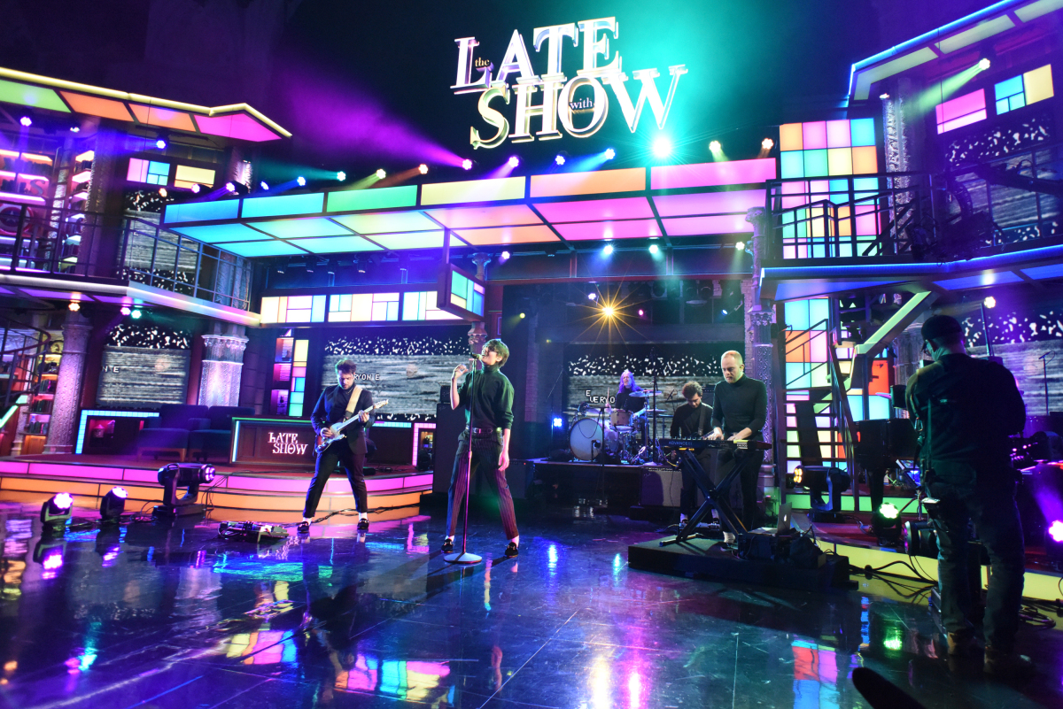
Hi-res artist photo: Mary Ellen Matthews here, hi-res tour poster here, album artwork here

ALBUM CONTENT OUT NOW HERE AND HERE

It’s been a whirlwind week for Joywave who performed their single, “Doubt” last night on The Late Show with Stephen Colbert here. Joywave’s energetic performance, framed by electronic text and data mirroring the band’s Content album art, resonated throughout the Ed Sullivan Theater. The band also released the video for “Doubt” -- a frenetic and arresting visual helmed by acclaimed director Olivier Gondry here. The video with its anthemic vibe is another arresting visual in a long line of boundary-pushing and mesmerizing videos.

Tomorrow, Joywave will hit the road for their headlining Thanks. Thanks For Coming 2018 tour, with support from Sasha Sloan and KOPPS. The tour which kicks off in Las Vegas has already sold out in Los Angeles, San Francisco, Denver, Austin and D.C., After the headline run, Joywave will head out on the Thirty Seconds To Mars tour which kicks off June 6.. See a full list of dates below and purchase tickets here.

Joywave live:
^supporting 30 Seconds to Mars
Sat 02.10 - Las Vegas, NV @ The Bunkhouse (SOLD OUT)
Sun 02.11 - Phoenix, AZ @ The Crescent Ballroom (SOLD OUT)
Tue 02.13 - West Hollywood, CA @ The Roxy Theatre (SOLD OUT)
Thu 02.15 - Santa Ana, CA @ Constellation Room
Fri 02.16 - San Francisco, CA @ Swedish American Hall (SOLD OUT)
Sun 02.18 - Seattle, WA @ The Crocodile (SOLD OUT)
Tue 02.20 - Salt Lake City, UT @ Urban Lounge
Wed 02.21 - Denver, CO @ Globe Hall
Thu 02.22 - Denver, CO @ Globe Hall (SOLD OUT)
Sat 02.24 - Austin, TX @ The Parish (SOLD OUT)
Sun 02.25 - New Orleans, LA @ Gasa Gasa
Tue 02.27 - Atlanta, GA @ Terminal West
Wed 02.28 - Nashville, TN @ The Basement East
Fri 03.02 - Carrboro, NC @ Cat's Cradle
Sat 03.03 - Washington, DC @ U Street Music Hall (SOLD OUT)
Tue 03.06 - Toronto, ON @ Adelaide Hall
Wed 03.07 - Buffalo, NY @ Town Ballroom
Wed 06.06 - Toronto, ON @ Budweiser Stage ^
Fri 06.08 - Montreal, QC @ Place Bell ^
Sat 06.09 - Hartford, CT @ Xfinity Theatre ^
Sun 06.10 - Boston, MA @ Xfinity Center ^
Tue 06.12 - Detroit, MI @ DTE Energy Music Theatre ^
Wed 06.13 - Pittsburgh, PA @ KeyBank Pavilion ^
Fri 06.15 - Chicago, IL @ Huntington Bank Pavilion ^
Sat 06.16 - Cleveland, OH @ Blossom Music Center ^
Sun 06.17 - Philadelphia, PA @ BB&T Pavilion ^
Tue 06.19 - Gilford, NH @ Bank of NH Pavilion ^
Wed 06.20 - New York, NY @ Madison Square Garden ^
Thu 06.21 - Holmdel, NJ @ PNC Bank Arts Center ^
Tue 06.26 - Washington DC @ Jiffy Lube Live ^
Wed 06.27 - Charlotte, NC @ PNC Music Pavilion ^
Thu 06.29 - Miami, FL @ Coral Sky Amphitheatre ^
Fri 06.30 - Tampa, FL @ Midflorida Credit Union Amphitheatre ^
Sat 07.01 - Jacksonville, FL @ Daily’s Place ^

ABOUT JOYWAVE: Beyond the stream of mixtapes (2011’s 77777, 2013’s 88888), EP’s (2012’s Koda Vista, 2015’s How Do You Feel?) and albums (2015’s How Do You Feel Now?, 2016’s SWISH, 2017’s Content), Joywave have seen their songs top the alternative radio charts and created a collection of standout music videos, a visually stimulating YouTube short film series Joy Meets World and their instagram cult classic Coffee With Joywave. The Rochester-based band has launched numerous, sold-out US headline shows, have toured with The Killers, Bleachers, Foals, Metric, Young The Giant, Cold War Kids and performed at Lollapalooza (US & Berlin), Coachella, Bumpershoot and Hangout Festivals. Their entrepreneurial spirit includes a line of coffee, Joewave, sponsoring a local little league team, The Southside Joywaves, and the creation of a liquid crystal thermochromic finish aka ‘mood’ guitar.

Joywave is vocalist Daniel Armbruster, guitarist Joseph Morinelli, keyboardist Benjamin Bailey and drummer Paul Brenner.

Praise for Joywave

“The band has carved a niche fanbase far beyond Rochester thanks to their thoughtfully sarcastic and moderately progressive brand of indie rock, slowly morphing into alternative underdogs.” - Billboard

“They're genuinely extremely talented and their music is simply infectious.“ - Baeble

“Armbruster’s playful rapport and slightly operatic vocals make Joywave one of the most fun bands to see right now.” - Substream Magazine

“(On Content) It's the work of a band full of ideas, confident enough to throw them all together and accomplished enough to pull it off.” - Under The Radar Magazine

Joywave - Content tracklist:
01. Content
02. Shutdown
03. It’s A Trip!
04. Rumors
05. Confidence
06. Doubt
07. Going To A Place
08. Little Lies You’re Told
09. When You’re Bored
10. Thanks. Thanks For Coming
11. Let’s Talk About Feelings

full bio here
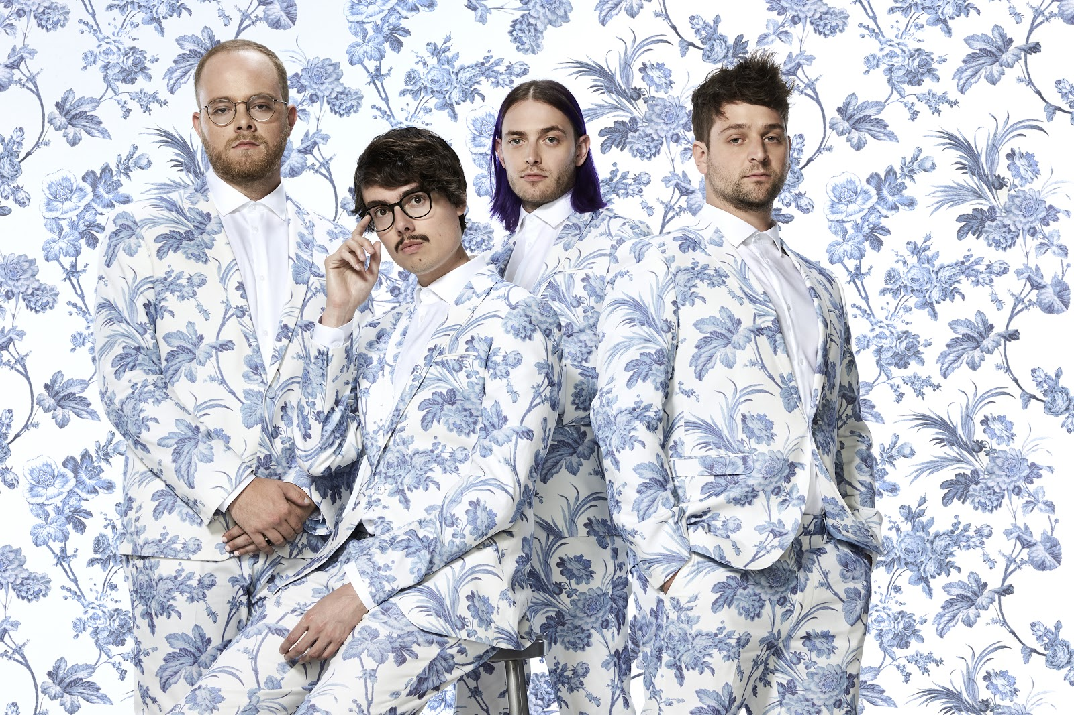
joywavemusic.com/
https://twitter.com/joywave
https://www.instagram.com/joywavemusic/
https://www.facebook.com/joywave/
https://www.vevo.com/artist/joywave
https://youtube.com/user/joywavemusic

