JORGE BLANCO ANNOUNCES EUROPEAN TOUR DATES

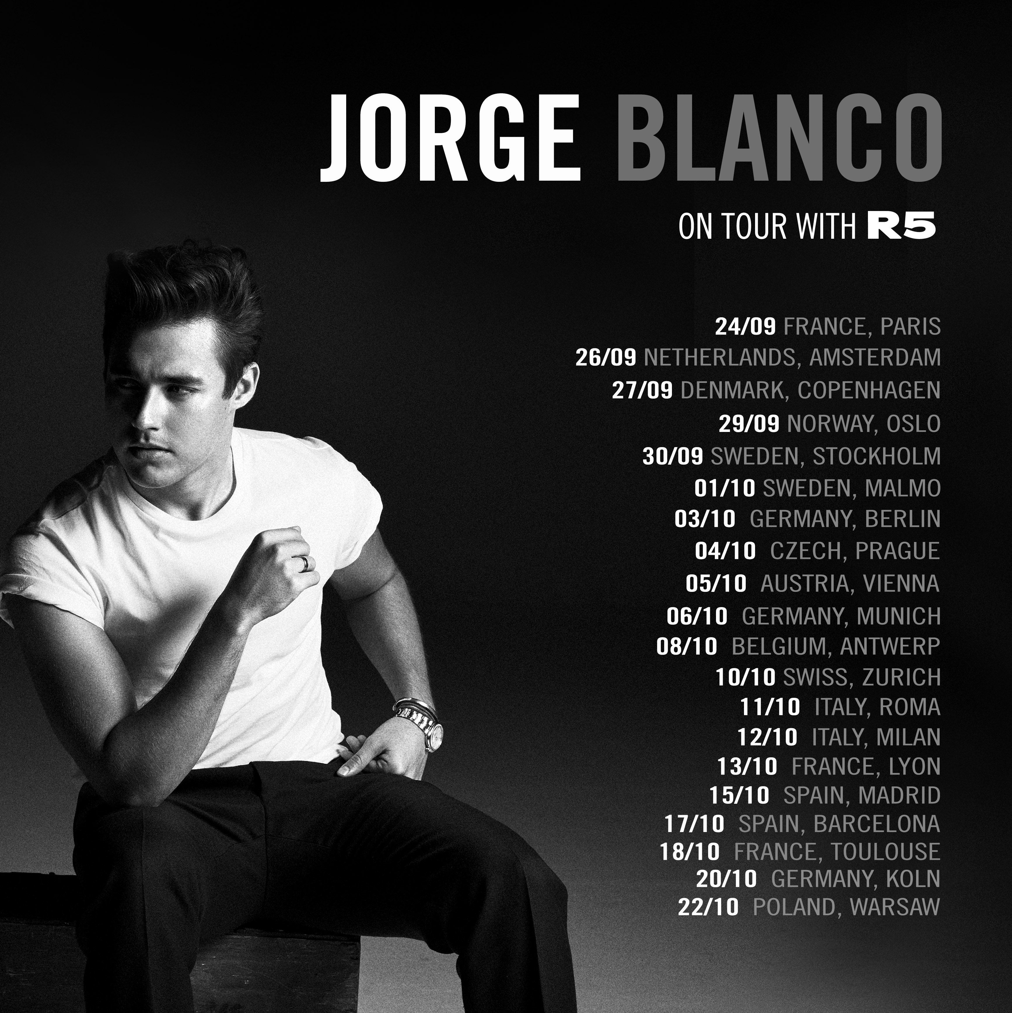

STREAM “SUMMER SOUL” HERE

(July xx, 2017) – Hollywood Records artist Jorge Blanco announced today he will be joining the R5 New Addictions European tour. Blanco joins the tour on September 24th in Paris, France and will play 20 cities in 13 countries ending in Warsaw, Poland on October 22nd.

Tickets and VIP Meet & Greet packages are on sale now and available at thejorgeblanco.com/tour/

Blanco recently released his two singles “Summer Soul,” available HERE, and “Risky Business,” available HERE. His cover of the classic Beatles’ song “Baby You Can Drive My Car,” was featured on the “Cars 3” soundtrack this summer, and he is gearing up to release his debut EP this fall. As a sports fanatic, Blanco was excited to have his music featured across ESPN and Major League Baseball, supporting some of the biggest sporting events of the summer.

Tour Dates:

Sept. 24 | Paris, France | Trianon *
Sept. 26 | Amsterdam, Netherlands | Nelkweg *
Sept. 27 | Copenhagen, Denmark | Amager Bio *
Sept. 29 | Oslo, Norway | Vulkan Arena *
Sept. 30 | Stockholm, Sweden | Fryshuset *
Oct. 1 | Malmo, Sweden | KB *
Oct. 3 | Berlin, Germany | Bi Nuu *
Oct. 4 | Prague, Czech | Roxy *
Oct. 5 | Vienna, Austria | WUK *
Oct. 6 | Munich, Germany | Techikum *
Oct. 8 | Antwerp, Belgium | Trix *
Oct. 10 | Zurich, Switzerland | Dynamo *
Oct. 11 | Rome, Italy | Orion Live Club *
Oct. 12 | Milan, Italy | Live Club *
Oct. 13 | Lyon, France | Ninkasi Kao *
Oct. 15 | Madrid, Spain | Sala Visa Alegre *
Oct. 17 | Barcelona, Spain | Razzmatazz *
Oct. 18 | Toulouse, France | Conexion Live *
Oct. 20 | Kohn, Germany | Gebaude 9 *
Oct. 22 | Warsaw, Poland | Progersja *

*Jorge Blanco supporting

About Jorge Blanco:
With the release of Summer Soul, Jorge Blanco is proving to be one of the great emerging talents of his generation. Despite how admittedly shy Jorge was growing up in Guadalajara, the multi-talented singer-songwriter found his passion for music when he first began playing the guitar at the age of five. “For the first time as a solo artist I will have the chance to perform my own music. I have been rehearsing for a few months with my band in LA and we can’t wait to finally share our music and meet up with the fans who have always given me so much love and support.”

FIND JORGE BLANCO ON SOCIAL MEDIA
YOUTUBE | FACEBOOK | VEVO | INSTAGRAM | TWITTER

