JOYWAVE AND SIR SLY ANNOUNCE FALL TOUR

‘Joywave and Sir Sly Present: An Evening With Sir Sly and Joywave’
Set to kick off October 18

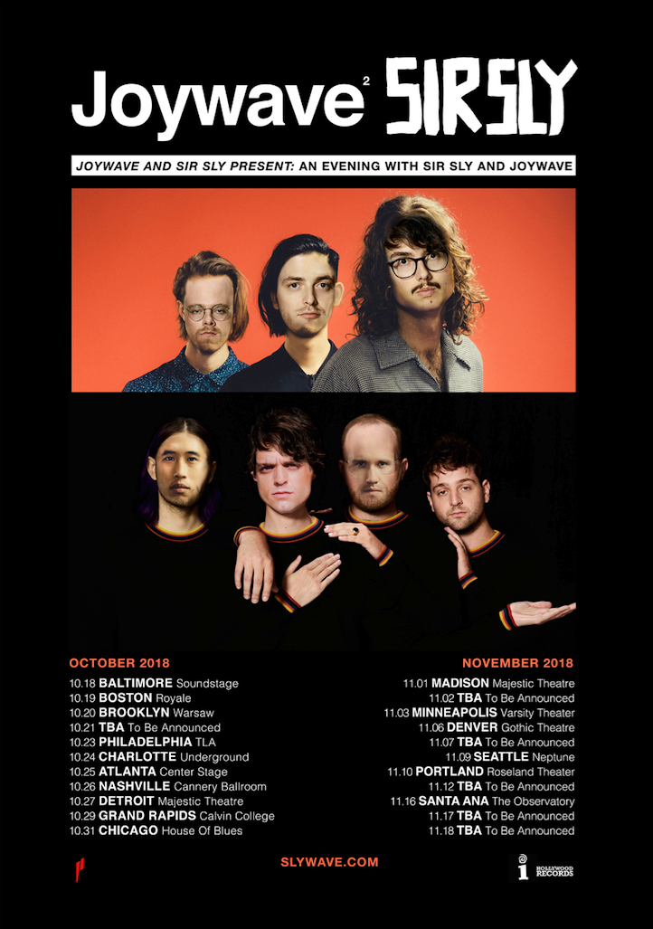

Joywave and Sir Sly have announced their fall co-headline tour, Joywave and Sir Sly Present: An Evening With Sir Sly and Joywave which will kick off on October 18th in Baltimore and will also hit Philadelphia, Atlanta, Nashville, Chicago, Seattle and Portland to name a few. Tickets go on sale to the general public on Friday, July 27th at 10 AM local time (visit www.slywave.com for more information) with a Sir Sly Spotify Presale on Wednesday, July 25 @ 10am local -- code: slywave2018.

Sir Sly and Joywave are no strangers to touring -- Joywave have launched several, sold-out headline tours and recently toured with Thirty Seconds to Mars on their Monolith tour, while Sir Sly won rave reviews for their set at Coachella, Bonnaroo and are headed to Lollapalooza next weekend. Daniel Armbruster of Joywave had this to say about the upcoming tour, “We spent quite a bit of time this past year on the road having some of the largest acts in music close for us. Using a “tour generator” website, we were assigned a co-headline tour with Sir Sly.” Landon Jacobs of Sir Sly retorted, “It’s been an extremely enjoyable year for us, and we were under the impression that we were the biggest band in the world. After talking to our managers, turns out we’re the exact same size as Joywave, which is pretty exciting too.”

Sir Sly’s “&Run” was a hit at alternative radio, recently hitting #1 on the alternative radio chart while Joywave recently released their first new music since last year’s Content, the song “Blastoffff” (download / stream) which premiered as part of the global rollout of Epic Games' highly-anticipated Season 5 of Fortnite.

ABOUT JOYWAVE: Always pushing the creative envelope, Joywave (Daniel Armbruster, guitarist Joseph Morinelli, keyboardist Benjamin Bailey and drummer Paul Brenner) have released a number of mixtapes, EP’s, two full-length albums and a host of unique visuals, including videos as well as original series Joy Meets World and Coffee With Joywave. Joywave’s most recent album, Content, debuted #10 on iTunes Alternative Album chart and featured the radio hits “It’s A Trip!” and “Doubt.” Previously, they released a mixtape 77777 (2011), Koda Vista EP (2012), a second mixtape 88888 (2013), the How Do You Feel? EP (2014), a full-length debut album titled How Do You Feel Now? (2015) and in 2016 an entire album featuring alternative versions of their song “Destruction” called SWISH. They collaborated with Big Data on “Dangerous” which hit #1 at alternative radio, while “Somebody New”, “Destruction” and the track “Tongues” (feat KOPPS) off their album How Do You Feel Now? topped the US alternative radio charts as well.

PHOTO CREDIT: MARY ELLEN MATTHEWS
HIGH RES AVAILABLE HERE

ABOUT SIR SLY: Since forming in 2012, West Coast rock trio SIR SLY have forged their singular sound by drawing upon each member’s long-honed musical talents: Landon Jacobs’s introspective yet infinitely searching lyricism, producer Jason Suwito’s in-studio ingenuity, and Hayden Coplen’s sophisticated musicianship and sense of songcraft. Orange County natives and friends since high school, Jacobs and Coplen connected with Suwito through the local music scene. Their early collaborations yielded songs like “Ghost,” a Neon Gold release that quickly earned buzz online. After making their Cherrytree Records debut with the Gold EP in 2013, Sir Sly put out You Haunt Me (which reached #14 on Billboard’s Alternative Albums chart) in September of the following year. In 2017 Sir Sly introduced their sophomore album Don’t You Worry, Honey via Interscope Records with the intoxicating first single, “High” which reached #3 on the alternative radio chart with over 45 million streams. Their follow-up , the #1 second single “&Run” topped the alternative radio chart and currently has over 28 million streams.

Over a rich sonic backdrop, Sir Sly tackle some heavy topics with emotion intact. As the tracks came together, frontman Landon went through a divorce and the death of his mom due to cancer. “It was a really tough couple of years, but we were able to translate those trails into art,” says Landon. The band, who Entertainment Weekly called “euphoric new wave” is a can’t miss act on the festival circuit with upcoming appearances at Lollapalooza, Osheaga and Life Is Beautiful. Sir Sly received raves from their performances at Coachella, Bonnaroo and Governors Ball.

PHOTO CREDIT: ELIOT LEE HAZEL
HIGH RES AVAILABLE HERE

Joywave and Sir Sly Present: An Evening With Sir Sly and Joywave

10/18/2018 Soundstage Baltimore, MD
10/19/2018 Royale Boston, MA
10/20/2018 Warsaw Brooklyn, NY
10/21/2018 TBA
10/23/2018 TLA Philadelphia, PA
10/24/2018 Underground Charlotte, NC
10/25/2018 Center Stage Atlanta, GA
10/26/2018 Cannery Ballroom Nashville, TN
10/27/2018 Majestic Theatre Detroit, MI
10/29/2018 Calvin College Grand Rapids, MI
10/31/2018 House of Blues Chicago, IL
11/1/2018 Majestic Theatre Madison, WI
11/2/2018 TBA
11/3/2018 Varsity Theater Minneapolis, MN
11/6/2018 Gothic Theatre Englewood, CO
11/7/2018 TBA
11/9/2018 Neptune Seattle, WA
11/10/2018 Roseland Portland, OR
11/12/2018 TBA
11/16/2018 The Observatory Santa Ana, CA
11/17/2018 TBA
11/18/2018 TBA

JOYWAVE SIR SLY
twitter | Instagram | facebook | youtube Facebook | Twitter | Instagram

FOR MORE INFORMATION, CONTACT:

SIR SLY JOYWAVE
Hillary Siskind Heather Davis
Interscope Records Hollywood Records
Hillary.Siskind@umusic.com Heather.Davis@disney.com

For tour requests: For tour requests:
Sasha Camacho Lyssa Hurvitz
Interscope Records Hollywood Records
Sasha.Camacho@umusic.com Lyssa.hurvitz@disney.com

