JOYWAVE RETURN - ANNOUNCE SOPHOMORE ALBUM CONTENT TO BE RELEASED ON 7.28

REVEAL FIRST SINGLE “IT’S A TRIP!” STREAM HERE + DOWNLOAD HERE

TOUR w/ YOUNG THE GIANT + COLD WAR KIDS STARTS 8.02

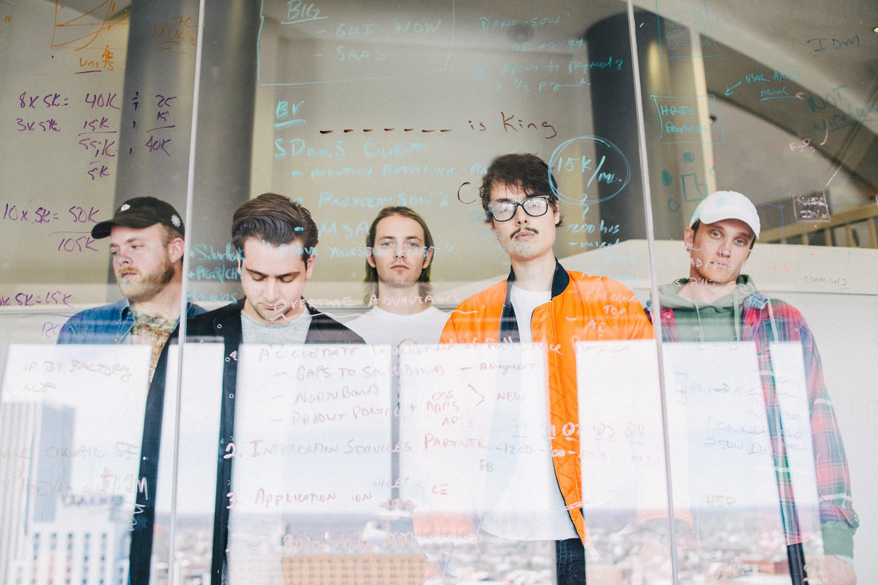
Photo credit: David O'Donohue, hi-res here

Rochester alternative band Joywave announce their sophomore studio album titled Content, release their first single ”It’s A Trip!” today (stream HERE + download HERE) and get ready to make their return to the live stage. The quintet will head out on tour with Young The Giant and Cold War Kids at the start of August.

Content, which has a playful double meaning, is produced by Joywave’s Daniel Armbruster & Sean Donnelly and mixed by Rich Costey and will be released on Hollywood Records/Cultco Music on 7.28 (pre-order HERE). Last month, they shared the title track “Content” HERE with their fans. The visual was shot on a vintage Super 8 and filmed on location at Kodak Tower, Rochester, NY.

Always pushing the creative envelope, Joywave released a mixtape 77777 (2011), their critically-acclaimed EP Koda Vista (2012), a second mixtape 88888 (2013), the How Do
You Feel? EP (2014), a full-length debut album titled How Do You Feel Now? (2015) and in 2016 an entire album featuring alternative versions of their song “Destruction” called SWISH, a take on Kanye’s short-lived album title and more precisely the band titled it SWISH in response to the similarity between their 2015 tour art & “Destruction” ad campaign & The Life Of Pablo album art. They collaborated with Big Data on “Dangerous” which hit #1 at alternative radio, while “Somebody New”, “Destruction” and the track “Tongues” (feat KOPPS) off their album How Do You Feel Now? topped the top of US alternative radio as well.

Joywave’s touring history is impressive to say the least; they’ve toured with Foals, The Killers, Brandon Flowers, Metric, Silversun Pickups, Bleachers, St. Lucia etc and played at festivals like Coachella, Lollapalooza (US & Berlin), Reading & Leeds, Okeechobee, Osheaga, Hangout and Bumbershoot etc.

TV shows like Jimmy Kimmel and Seth Meyers have welcomed the ingenious band and publications such at Rolling Stone, Billboard, Spin, Entertainment Weekly have praised their music and live performances.

Joywave is vocalist Daniel Armbruster, bassist Sean Donnelly, guitarist Joseph Morinelli, keyboardist Benjamin Bailey and drummer Paul Brenner.

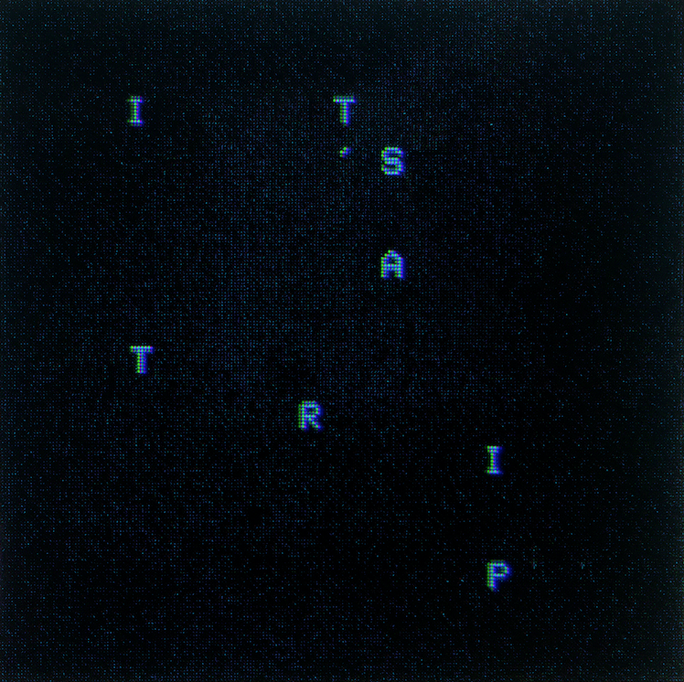
Single art - hi-res here

Joywave live:
* = with Young The Giant, Cold War Kids
Sat 05.20 - Tinley Park, IL @ Hollywood Casino Amphitheatre (101WKQX Piqniq)
Wed 08.02 - Louisville, KY @ Palace Theatre *
Thu 08.03 - Sterling Heights, MI @ Freedom Hill Amphitheatre *
Fri 08.04 - St. Louis, MO @ Hollywood Casino Amphitheatre *
Sat 08.05 - Kansas City, MO @ Starlight Amphitheatre *
Tue 08.08 - Papillion, NE @ Sumtur Amphitheatre *
Fri 08.11 - Seattle, WA @ Wamu Theater @ Qwest Field *
Tue 08.15 - Morrison,CO @ Red Rock Amphitheater *
Thu 08.17 - Albuquerque, NM @ Villa Hispana @ EXPO *
Fri 08.18 - Las Vegas, NV @ The Pearl *
Sat 08.19 - Reno, NV @ Grand Theatre at Grand Sierra *
Sun 08.20 - Eugene, OR @ Cuthbert Amphitheatre *
Thu 08.24 - San Diego, CA @ Open Air Theatre *
Fri 08.25 - Santa Barbara, CA @ Santa Barbara Bowl *
Sat 08.26 - Irvine, CA @ FivePoint Amphitheatre *
Thu 09.07 - Cincinnati, OH @ PNC @ Riverbend *
Fri 09.08 - Nashville, TN @ Ascend Amphitheatre *
Sat 09.09 - Chicago,IL @ Huntington Bank Pavilion *
Sun 09.10 - Columbus, OH @ Express Live! *
Wed 09.13 - New York, NY @ Central Park Summerstage *
Thu 09.14 - Boston, MA @ Blue Hills Bank Pavilion *
Fri 09.15 - Philadelphia, PA @ Festival Pier @ Penn’s Landing *
Sat 09.16 - Columbia, MD @ Merriweather Post Pavilion *
Tue 09.19 - Charlottesville,VA @ Sprint Pavilion *
Thu 09.21 - Orlando, FL @ Hard Rock Live *
Fri 09. 22 - Jacksonville,FL @ Daily's Place *
Sat 09.23 - Miami, FL @ Bayfront Park Amphitheatre *
Tue 09.26 - Birmingham, AL @ BJCC Concert Hall *
Thu 09.28 - Oklahoma City ,OK @ Criterion *
Fri 09.29 - Dallas, TX @ Irving Music Factory *
Sat 09.30 - Houston, TX @ White Oak Outdoors *
more dates to be announced

joywavemusic.com/
https://twitter.com/joywavemusic
https://www.instagram.com/joywavemusic/
https://www.facebook.com/joywave/

