JOYWAVE RELEASES ALBUM CONTENT HERE AND HERE

RADIO SINGLE “IT’S A TRIP!” w/ MUSIC VIDEO HERE

TOUR w/ YOUNG THE GIANT + COLD WAR KIDS STARTS 8.02

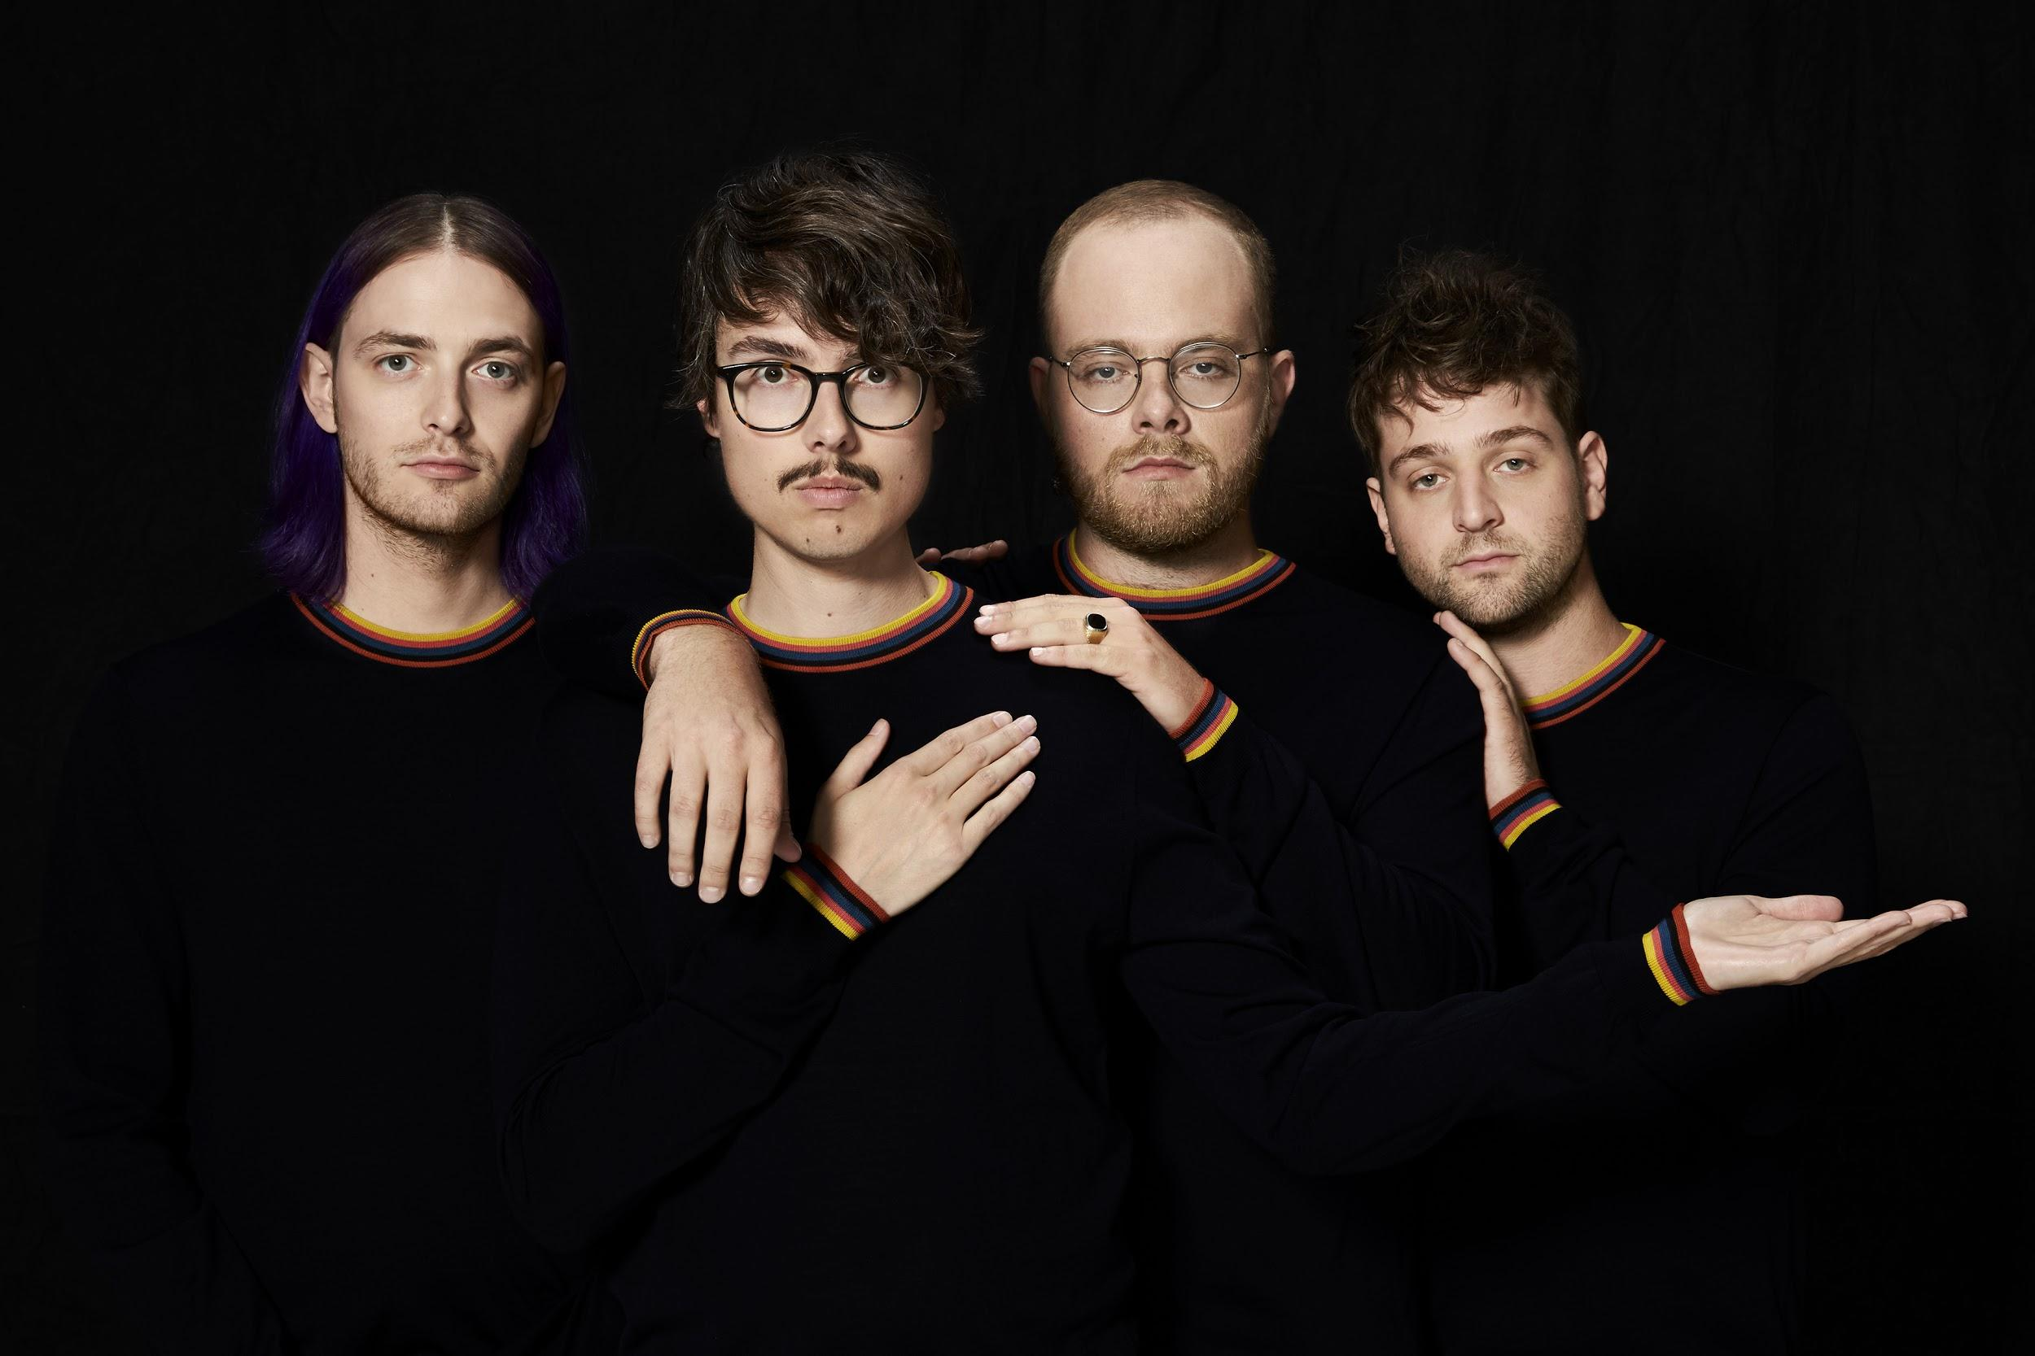
artist photo credit: Mary Ellen Matthews, hi-res here

Joywave have released their sophomore album Content today via Hollywood Records/Cultco Music today HERE. The album title, Content is a heteronym that plays on the theme of CONtent vs ConTENT. The album is produced by Joywave’s own Daniel Armbruster and Sean Donnelly, mixed by Rich Costey, who has worked with artists like Haim, Foster The People, Vampire Weekend and At The Drive In.

The band shared the title track “Content” HERE with their fans. The visual was shot on a vintage Super 8 and filmed on location at Kodak Tower, Rochester, NY. They shared a new song
"Shutdown" shortly thereafter HERE. Joywave will make their return to the live stage tonight with a hometown release party at Rochester's The Flying Saucer and will start touring with Young The Giant and Cold War Kids on August 2nd (tour dates below).

Always pushing the creative envelope, Joywave released a mixtape 77777(2011), their critically-acclaimed EP Koda Vista (2012), a second mixtape 88888 (2013), the How Do You Feel? EP (2014), a full-length debut album titled How Do You Feel Now? (2015) and in 2016 an entire album featuring alternative versions of their song “Destruction” called SWISH, a take on Kanye’s short-lived album title and more precisely the band titled it SWISH in response to the similarity between their 2015 tour art & “Destruction” ad campaign & The Life Of Pablo album art. They collaborated with Big Data on “Dangerous” which hit #1 at alternative radio, while “Somebody New”, “Destruction” and the track “Tongues” (feat KOPPS) off their album How Do You Feel Now? topped the US alternative radio charts as well.

Joywave’s touring history is impressive to say the least; they’ve toured with Foals, The Killers, Brandon Flowers, Metric, Silversun Pickups, Bleachers, St. Lucia and played stages like Coachella, Lollapalooza (US & Berlin), Reading & Leeds, Okeechobee, Osheaga, Hangout and Bumbershoot.

Late night has been kind to Joywave, where shows like Jimmy Kimmel and Seth Meyers have welcomed the ingenious band and publications such as Rolling Stone, Billboard, Spin, Entertainment Weekly have praised their music and live performances.

Joywave is vocalist Daniel Armbruster, guitarist Joseph Morinelli, keyboardist Benjamin Bailey and drummer Paul Brenner.

Joywave live:
* = with Young The Giant, Cold War Kids
** = with Cold War Kids
Fri 07.28 - Rochester, NY @ First Federal Plaza's The Flying Saucer
Wed 08.02 - Louisville, KY @ Palace Theatre *
Thu 08.03 - Sterling Heights, MI @ Freedom Hill Amphitheatre *
Fri 08.04 - St. Louis, MO @ Hollywood Casino Amphitheatre *
Sat 08.05 - Kansas City, MO @ Starlight Amphitheatre *
Sun 08.06 - Sioux Falls, SD @ The District **
Tue 08.08 - Papillion, NE @ Sumtur Amphitheatre *
Thu 08.10 - Boise, ID @ Knitting Factory **
Fri 08.11 - Seattle, WA @ Wamu Theater at Qwest Field *
Sat 08.12 - Portland, OR @ Crystal Ballroom (KNRK radio show)
Tue 08.15 - Morrison,CO @ Red Rock Amphitheater *
Thu 08.17 - Albuquerque, NM @ Villa Hispana @ EXPO *
Fri 08.18 - Las Vegas, NV @ The Pearl *
Sat 08.19 - Reno, NV @ Grand Theatre at Grand Sierra *
Sun 08.20 - Eugene, OR @ Cuthbert Amphitheatre *
Mon 08.21 - Sacramento, CA @ Ace Of Spades **
Wed 08.23 - Phoenix, AZ @ The Van Buren **
Thu 08.24 - San Diego, CA @ Open Air Theatre *
Fri 08.25 - Santa Barbara, CA @ Santa Barbara Bowl *
Sat 08.26 - Irvine, CA @ FivePoint Amphitheatre *
Thu 09.07 - Cincinnati, OH @ PNC @ Riverbend *
Fri 09.08 - Nashville, TN @ Ascend Amphitheatre *
Sat 09.09 - Chicago,IL @ Huntington Bank Pavilion *
Sun 09.10 - Columbus, OH @ Express Live! *
Tue 09.12 - Providence, RI @ Lupo’s Heartbreak Hotel **(WBRU radio)
Wed 09.13 - New York, NY @ Central Park Summerstage *
Thu 09.14 - Boston, MA @ Blue Hills Bank Pavilion *
Fri 09.15 - Philadelphia, PA @ Festival Pier @ Penn’s Landing *
Sat 09.16 - Columbia, MD @ Merriweather Post Pavilion *
Sun 09.17 - Atlanta, GA @ Music Midtown Festival
Tue 09.19 - Charlottesville,VA @ Sprint Pavilion *
Wed 09.20 - Charlotte, NC @ The Underground (WEND radio show)
Thu 09.21 - Orlando, FL @ Hard Rock Live *
Fri 09.22 - Jacksonville,FL @ Daily's Place *
Sat 09.23 - Miami, FL @ Bayfront Park Amphitheatre *
Mon 09.25 - Athens, GA @ The Georgia Theater **
Tue 09.26 - Birmingham, AL @ BJCC Concert Hall *
Thu 09.28 - Oklahoma City ,OK @ Criterion *
Fri 09.29 - Dallas, TX @ Irving Music Factory *
Sat 09.30 - Houston, TX @ White Oak Outdoors *

Joywave - Content tracklist:
01. Content
02. Shutdown
03. It’s A Trip!
04. Rumors
05. Confidence
06. Doubt
07. Going To A Place
08. Little Lies You’re Told
09. When You’re Bored
10. Thanks. Thanks For Coming
11. Let’s Talk About Feelings

full bio here
website here
album art, hi-res here
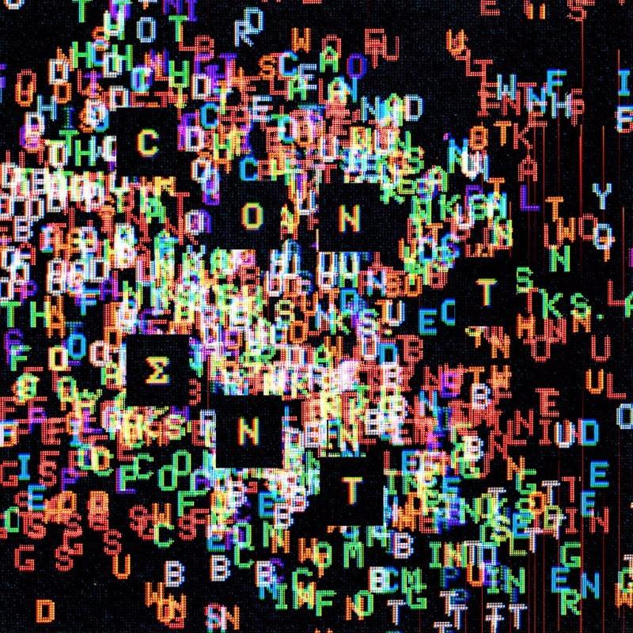

joywavemusic.com/
https://twitter.com/joywavemusic
https://www.instagram.com/joywavemusic/
https://www.facebook.com/joywave/
https://www.vevo.com/artist/joywave
https://m.youtube.com/user/joywavemusic

