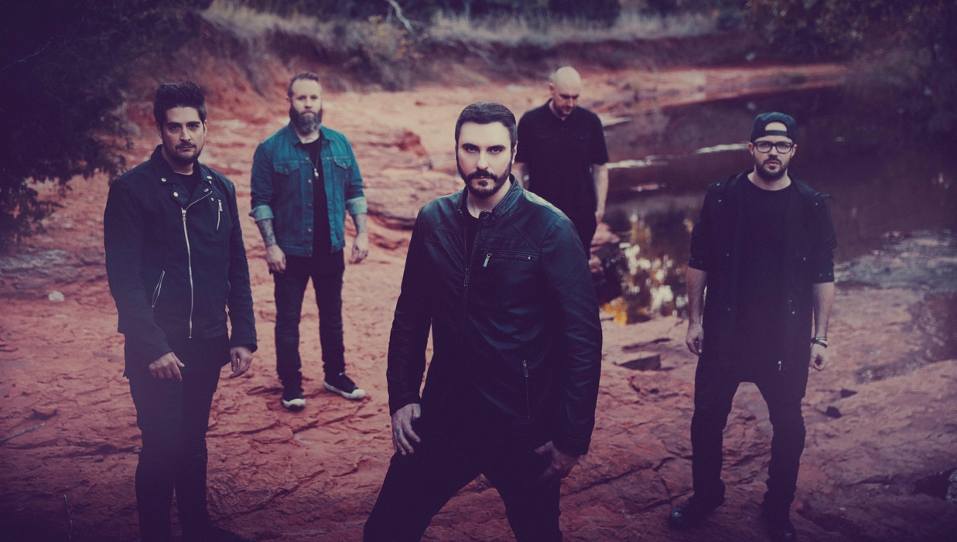

Breaking Benjamin are no strangers to the upper echelons of the rock charts. Since bursting onto the scene with 2002's Saturate, the band has amassed an impressive string of mainstream rock radio hits, including "The Diary of Jane," and the No. 1 singles "So Cold," "Failure," "Breath" and "I Will Not Bow."

The self-produced Ember, Breaking Benjamin's sixth album and first full-length since 2015's Dark Before Dawn, once again contains an abundance of high-caliber, melodic hard rock. But ask Breaking Benjamin guitarist/vocalist/songwriter Ben Burnley about the significance of the album title, and his answer hints at intriguing new dimensions: "An ember can either be the end of something or the beginning of it."

The band's new single, "Red Cold River," falls firmly into the latter camp. After starting with a subdued intro, the song explodes with stinging riffs, howling vocals and frenzied drumming. Later, an avalanche of churning guitars and mesmerizing harmonies cloak the ominous assertion, "I can't feel anything at all/This life has left me cold," before the song's verses retreat once again into sparser territory. It's an earworm that burrows deep, and begs repeated listens.

"Red Cold River," which Burnley says the band recognized as "one of the most powerful songs" they had written for the album, is emblematic of Ember's aggressive approach and dramatic dynamics. Although there are subdued moments—the somber piano intro of "Feed The Wolf," the crooning, melodic choruses on the yearning "Torn In Two" and "Close Your Eyes"—the record skews heavy. Abrasive guitar slashes dominate both "Blood" and "Feed The Wolf," while the chugging "Save Yourself" boasts a ferocious rhythmic backbone.

"People have always really liked the heavier side of the band," Burnley says. "I think that's what they sort of gravitate towards. But we also make sure to explore our melodic and softer side too. On Ember, we just tried to make it more extreme—the softer side on this album is really soft, and the heavy side is really heavy. We decided to give everybody what they want to the furthest degree."

This commitment to sonic progress is one of Breaking Benjamin's best qualities: Not only does it reflect Burnley's ambition, but it also explains the band's enduring success, and ability to weather changing musical trends and lineups. "Our records are very different from one another, as far as the actual technical aspects are concerned, such as how many tunings we use," Burnley says. "Every Breaking Benjamin album features something new we've never done before."

Ember is no exception. For example, the record features more prominent programming flourishes. The atmospheric "The Dark of You" features melancholy effects scurrying beneath jagged guitars, while electronic shirring adds rhythmic texture to the slow-burning "Tourniquet" and an eerie, haunted house vibe to the cinematic "Down."

In typical Breaking Benjamin fashion, however, these forays into the digital realm complement the band's rock-oriented sound. "Our programming is done in such a way that it's not obvious or intrudes on the core of the song," Burnley notes. "We found a way to do programming live, instead of having it on a track that just plays and then we play to it. We don't like to do that. We can separate the drum loops and all the other sounds, so that they can be played live instead of pre-recorded."
It helps that Breaking Benjamin's current lineup—which, in addition to Burnley, includes guitarists Jason Rauch and Keith Wallen, bassist Aaron Bruch and drummer Shaun Foist—features gifted players who can easily recreate even the most complicated parts. In fact, Ember contains Breaking Benjamin's most advanced and challenging music yet. Exhibit A: "Psycho," which finds Rauch unleashing gnarled, metal-leaning riffs and technically precise (but intricate) phrasing.
"It's difficult to play some of the songs," Burnley says. "They're not something somebody could just pick up and play."

Such complexity is also a testament to Ember's expanded, full-band songwriting approach. On previous Breaking Benjamin albums, Burnley would shoulder the bulk of the composition—something he was happy to do, but which made recording more of a labor-intensive experience. This time around, although he wrote the majority of Ember's lyrics and vocal melodies, his bandmates made significant contributions to the music, ranging from stacked background vocals to soaring hooks. Bruch even wrote the music and vocals for the chorus of "Red Cold River."

"They've really contributed a lot more than anybody else has in the past," Burnley says of his bandmates. "And they're more like-minded, musically, than people I've ever played with—and so everything that they gave me fit into songs that I already had.

"I wrote the majority of our last five albums, and so I'm good with that—you know, that's enough for me," he adds with a laugh. "Five albums pretty much by myself—I'm ready to pass it along. It's more fun when you're not doing everything by yourself."

This musical chemistry has buoyed Breaking Benjamin as the band embarked on U.S. tours with Shinedown and Sevendust and landed a headlining slot on the 2016 Axes & Anchors Cruise. They also booked their first overseas shows, including two tours of Europe—and appearances at festivals such as Rock am Ring and Austria's Nova Rock—and a visit to the U.K. and the 2016 Download Festival and the 2017 Reading and Leeds Festivals.

"There was a lot of support, and a lot of people that knew who we were," Burnley says of heading to Europe for the first time. "It was very much in a lot of ways exactly like what we have here in America. It was an awesome surprise, because the first time we went there, we didn't know what to expect."

Doing so much touring over the last few years hasn't necessarily had a direct influence on Breaking Benjamin's sound. However, being on the road has strengthened the relationship between the band members, which has had an organic influence on Ember's music. As Burnley and Breaking Benjamin look to tour heavily in 2018 (and beyond), expect this positive momentum to continue gathering steam.

"Creatively, we mesh really well, and so it makes us personally mesh really well," Burnley says. "We want to be together and tour; we're brothers. If anything, our friendship is growing stronger. And so that's why we tour so much, because we really enjoy that—we enjoy being there for the fans, and we enjoy playing together. Things just keep getting better for us."

