BOHEMIAN RHAPSODY ORIGINAL FILM SOUNDTRACK
TO BE RELEASED AS A TWO LP SET ON FEBRUARY 8, 2019

A LIMITED-EDITION DOUBLE ALBUM PICTURE DISC VERSION PLUS A SPECIAL
7” SINGLE TO BE RELEASED ON RECORD STORE DAY APRIL 13, 2019

Black Vinyl Available for Pre-order now
https://queen.lnk.to/BohemianRhapsodyOSTVinyl

Queen + Adam Lambert’s North American Rhapsody Tour kicks off July 10

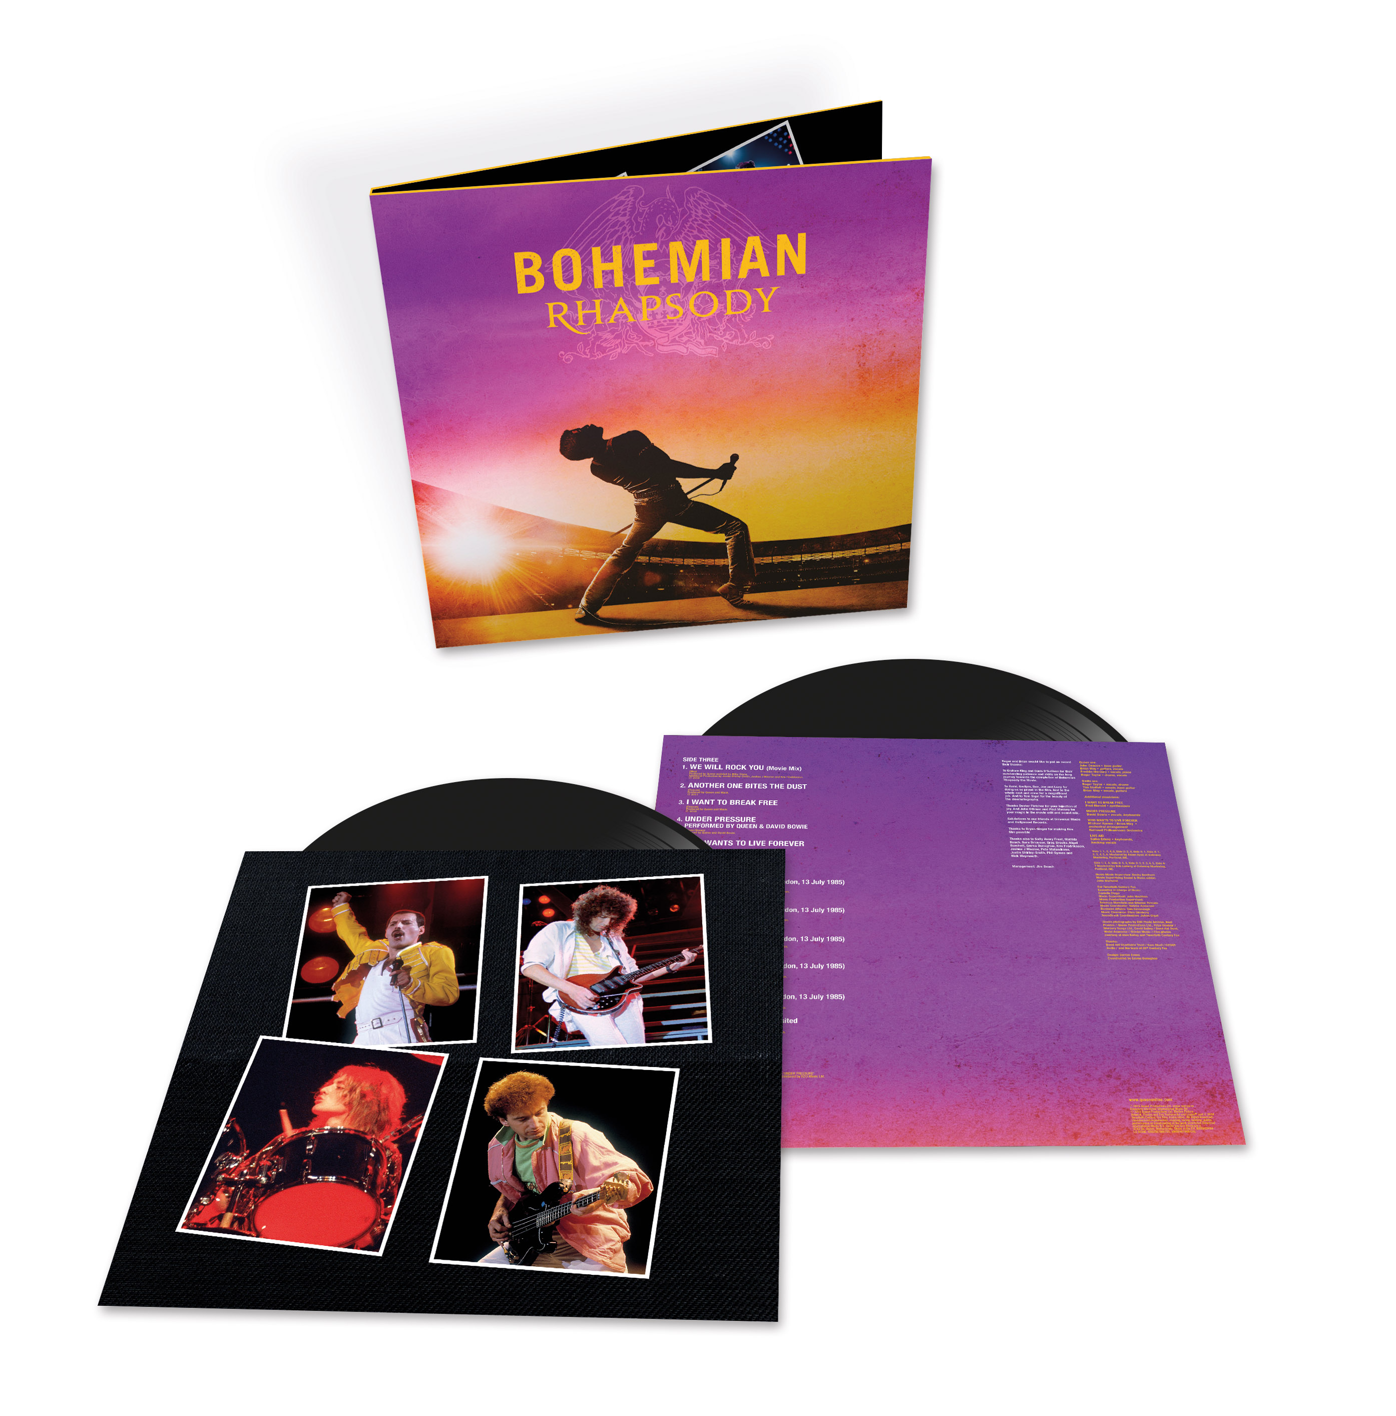
Cover art available HERE

Los Angeles, CA (December 12, 2018) - Providing Queen with its highest-charting album in 38 years in the US, where it’s approaching official gold status as well as becoming one of the band’s fastest ever selling albums throughout the world, Queen’s Bohemian Rhapsody film soundtrack is set to be released as a two LP set February 8 (pre-order available HERE). In continuing the celebration of Queen’s iconic music, a special picture disc edition as well as a 7” single featuring “Bohemian Rhapsody”/ “I’m In Love With My Car” will be released on Record Store Day, April 13.

The 22-song soundtrack album, produced by Brian May and Roger Taylor, features the first-ever release of audio tracks from Queen's legendary performance at Live Aid as well as other rare live tracks and their biggest hits. Rolling Stone hailed it as “more than just a greatest hits,” praising it as, “a fun imaginative way to relive the band’s genius.”

The Bohemian Rhapsody OST standard vinyl edition, the first of these special releases, will come as a four-side vinyl double album specially cut at Abbey Road Studios.

Most likely to be of interest to avid collectors will be two special Record Store Day releases: a double album picture disc version of the soundtrack and a special 7” single release of the original “Bohemian Rhapsody”/ ”I’m In Love With My Car” track coupling. While not featured in the film, “I’m In Love With My Car” is joke-referenced several times in the film. Now the track gets its moment.

Bohemian Rhapsody, the film, had its world premiere in the UK on October 23 and has since gone on to top the box office in more than 35 countries around the world with over half a billion dollars in global ticket sales to date. The film has received two nominations for the 2019 Golden Globe awards: Best Motion Picture – Drama and Best Actor in a Motion Picture – Drama for Rami Malek’s exceptional portrayal of the legendary Freddie Mercury,

The worldwide success of the film has also given a healthy boost to Queen’s music across all streaming services. “Bohemian Rhapsody” was not only the top trending song per Google’s 2018 Year In Search, but is now officially the most streamed track of the 20th century having surpassed 1.6 billion streams globally, followed by “Don’t Stop Me Now” at 700 million streams and counting.

As previously announced, Queen + Adam Lambert’s North American Rhapsody tour kicks off July 10 in Vancouver, BC, at Rogers Arena wrapping on August 23 at the Spectrum Center in Charlotte, NC. (Full list of tour dates HERE).

Full track listing for Bohemian Rhapsody the original soundtrack on vinyl is:

SIDE 1
1. 20th Century Fox Fanfare 0:25
2. Somebody To Love 4:56
3. Doing All Right... revisited (Performed by Smile) 3:17
4. Keep Yourself Alive (Live At The Rainbow) 3:56
5. Killer Queen 2:59
6. Fat Bottomed Girls (Live In Paris) 4:38
SIDE 2
1. Bohemian Rhapsody 5:55
2. Now I'm Here (Live At Hammersmith Odeon) 4:26
3. Crazy Little Thing Called Love 2:43
4. Love Of My Life (Rock In Rio) 4:29
SIDE 3
1. We Will Rock You (Movie Mix) 2:09
2. Another One Bites The Dust 3:35
3. I Want To Break Free 3:43
4. Under Pressure (Performed by Queen & David Bowie) 4:04
5. Who Wants To Live Forever 5:15
SIDE 4
1. Bohemian Rhapsody (Live Aid) 2:28
2. Radio Ga Ga (Live Aid) 4:06
3. Ay-Oh (Live Aid) 0:41
4. Hammer To Fall (Live Aid) 4:04
5. We Are The Champions (Live Aid) 3:57
6. Don't Stop Me Now… revisited 3:38
7. The Show Must Go On 4:32

http://www.queenonline.com || www.BohemianRhapsody.com

###

Media Contacts:

Queen
Sharrin Summers / Hollywood Records, sharrin.summers@disney.com

Rhapsody Tour
Cara Hutchinson, cara.hutchison@ledecompany.com

