BREAKING BENJAMIN TO RELEASE NEW SINGLE, "RED COLD RIVER"
TOURING WITH AVENGED SEVENFOLD AND BULLET FOR MY VALENTINE
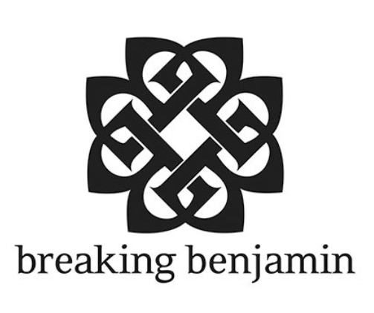
Multi-platinum rock band BREAKING BENJAMIN is set to release their next single, "Red Cold River," on January 5th, 2018. The single is the first off of their upcoming album, EMBER, and marks the first new music the band has released since 2015.

Following their successful fall acoustic tour throughout the U.S., the band will begin their nationwide tour with Avenged Sevenfold and Bullet for My Valentine on January 12th. The tour will kick off on in Nashville and hit arenas throughout North America, wrapping up in Washington in February. For VIP packages and more tour information, go to: www.breakingbenjamin.com.

BREAKING BENJAMIN is currently putting the finishing touches on their upcoming sixth studio album, titled EMBER. This will be the follow up to 2015’s DARK BEFORE DAWN, which debuted #1 on Billboard's Top 200, spun off three No. 1 rock radio tracks, “Failure” and “Angels Fall,” as well as their latest hit single “Never Again.” Selling over 500K, DARK BEFORE DAWN was certified gold in early 2017.

2018 Breaking Benjamin US Tour Dates:

1/12 Nashville, TN-Bridgestone Arena
1/14 Grand Rapids, MI-The Van Andel Arena
1/16 Reading, PA-Santander Arena
1/17 University Park, PA-Bryce Jordan Center
1/19 Uniondale, NY-Nassau Veterans Memorial Coliseum
1/20 Albany, NY-Times Union Center
1/22 Pittsburgh, PA-PPG Paints Arena
1/24 Green Bay, WI-Brown County Veterans Memorial Arena
1/25 Peoria, IL-Peoria Civic Center
1/27 Sioux Falls, SD-Denny Sanford Premier Center
1/29 Tulsa, OK-BOK Center
1/31 Biloxi, MS-Mississippi Coast Coliseum
2/2 North Little Rock, AR-Verizon Arena
2/3 Evansville, IN-Ford Center
2/6 Wichita, KS-INTRUST Bank Arena
2/8 Lincoln, NE-Pinnacle Bank Arena
2/9 Cedar Rapids, IA-US Cellular Center
2/11 Fargo, ND-Fargodome
2/13 Billings, MT-Metrapark
2/14 Missoula, MT-Adams Center
2/16 Kennewick, WA-Toyota Center

ABOUT BREAKING BENJAMIN: Multi-platinum band Breaking Benjamin has amassed a sizeable and diehard fan base, both through their chart-topping music, as well as their electrifying live performances. Their latest release, Dark Before Dawn certified GOLD (selling over 500K copies) debuted #1 on Billboard’s Top 200 chart and spun off two #1 rock tracks, “Failure” and “Angels Fall.” “Failure” was also named the most played song at Active Rock for 2015. 2009’s Dear Agony, certified PLATINUM (selling over 1MM copies) debuted #4 on the Billboard Top 200 and #1 on the iTunes Rock Album Chart. Dear Agony also spun off the platinum selling and #1 Active Rock single “I Will Not Bow” where it stayed #1 for five weeks straight. Their discography also includes 2002’s Saturate, 2004’s We Are Not Alone (certified PLATINUM) 2006’s Phobia (certified PLATINUM.) We Are Not Alone spawned a pair of #1 radio hits (“So Cold” and “Sooner Or Later.”) Phobia debuted at # 2 on Billboard’s Top 200, hit #1 on the Rock Album Chart and was one of the top 50 selling rock albums of 2006. It featured one #1 and two Top 5 rock radio hits (“Breath,” “Diary of Jane” and “Until The End”.)

Facebook | Instagram | Twitter | YouTube | VEVO

Press Contact:
Heather Davis / Heather.Davis@disney.com

Tour Requests:
Lyssa Hurvitz / Lyssa.Hurvitz@disney.com

