SABRINA CARPENTER
RELEASES MUSIC VIDEO FOR NEW SINGLE“WHY”

CLICK HERE TO WATCH

CARPENTER TO PERFORM “WHY” ON
LIVE WITH KELLY AND RYAN AUGUST 21

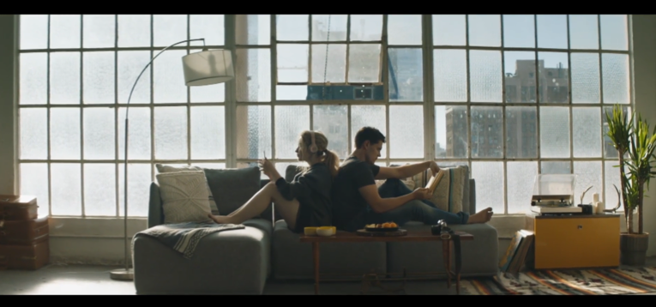

CARPENTER IS CURRETNLY HEADLINING THE 30+ CITY SUMMER DE-TOUR
FEATURING SPECIAL GUESTS ALEX AIONO & NEW HOPE CLUB

“WHY” COVER ART FOR MEDIA USE
https://www.dropbox.com/s/9hljvv7zfmm4mtg/WHY%20-%20SC%20ART.jpg?dl=0

(July 21, 2017) – Sabrina Carpenter has just released the companion video to new single “Why.” Shot in Los Angeles with director Jay Martin (Shawn Mendes, Christina Perri) and featuring Riverdale star Casey Cott as Carpenter’s love interest, “Why” explores the age-old theory that opposites attract, “and we don’t even know why.”

“Sometimes differences can hold us together and I think that’s a beautiful sentiment to how we deal with divergence and how it can furthermore prove our compatibility,” Carpenter says of the Jeberg-produced song. “In the end, we don’t really need to know ‘why’ if we are confident in our own emotions.”

In support of the new single and video, Carpenter will perform “Why” on Live with Kelly and Ryan August 21.
The track, co-written by Carpenter, Jonas Jeberg and Brett McLaughlin, is available now at all digital providers HERE and all streaming providers HERE.

Carpenter is currently crossing North American on her headlining summer De-Tour, which kicked off July 6 and runs through Aug. 27. The 30+ date summer trek marks Carpenter’s second headline tour, following her sold out EVOLution Tour last fall.

The De-Tour will continue to bring a summer of fun and music across major North American cities such as Denver, Dallas, New Orleans, Orlando, Atlanta, Nashville, and Boston before concluding on August 27 in Toronto, ON. The tour, presented by American Tourister, will feature special guests Alex Aiono & New Hope Club on all dates and resumes tomorrow night in Edmonton, AB. For more information, please visit www.sabrinacarpenter.com.

The De-Tour Summer 2017 Tour Dates:

Date | City | Venue
July 6 | Vancouver, BC | Vogue Theatre
July 8 | Edmonton, AB | Winspear Centre
July 9 | Calgary, AB | Calgary Stampede Coca Cola Stage
July 11 | Seattle, WA | Neptune Theatre
July 13 | Portland, OR | Crystal Ballroom
July 15 | San Francisco, CA | The Masonic
July 16 | Santa Rosa, CA | Luther Burbank Center for the Arts
July 18 | San Diego, CA | Balboa Theatre
July 19 | Anaheim, CA | House of Blues
July 21 | Los Angeles, CA | The Wiltern
July 22 | Phoenix, AZ | Comerica Theatre
July 24 | Denver, CO | Paramount Theatre
July 26 | Dallas, TX | Majestic Theatre
July 28 | New Orleans, LA | Saenger Theatre
July 29 | Hot Springs, AR | Timberwood Amphitheater
July 30 | Houston, TX | Revention Music Center
Aug. 2 | Jacksonville, FL | Florida Theatre
Aug. 4 | Miami Beach, FL | The Fillmore Miami Beach at the Jackie Gleason Theater
Aug. 5 | Orlando, FL | Dr. Phillips Center for the Performing Arts – Walt Disney Theater
Aug 6. | Atlanta, GA | The Tabernacle
Aug. 8 | Nashville, TN | Ryman Auditorium
Aug. 9 | Indianapolis, IN | Murat Theatre at Old National Centre
Aug. 11 | West Allis, WI | Wisconsin State Fair
Aug. 12 | Detroit, MI | The Fillmore
Aug. 13 | Tinley Park, IL | Hollywood Casino Amphitheatre
Aug. 15 | Hamburg, NY | Erie County Fair
Aug. 16 | Pittsburgh, PA | Byham Theater
Aug. 17 | Cleveland, OH | Connor Palace at Playhouse Square
Aug. 19 | Hershey, PA | Hersheypark Stadium
Aug. 20 | Boston, MA | House of Blues
Aug. 22 | Montclair, NJ | The Wellmont Theater
Aug. 23 | Philadelphia, PA | The Fillmore
Aug. 25 | Charlotte, NC | Belk Theater at North Carolina Blumenthal Performing Arts Center
Aug. 26 | Timonium, MD | Maryland State Fair
Aug. 27 | Toronto, ON | Budweiser Stage (formerly Molson Canadian Amphitheatre)

###

ABOUT SABRINA CARPENTER:
Eighteen-year-old singer, songwriter and actress Sabrina Carpenter’s journey into music, television and film began at the age of two when she followed in her older sister’s footsteps as a beginning ballerina. As her passion and skill in dance flourished, Sabrina surprised her family and friends by discovering her unique vocal talents. Her budding acting career began in theater before moving from the stage to film & television, landing her first role as a guest start on Law & Order SVU. Subsequent roles have included Young Chloe on Fox’s The Goodwin Games and Maya Hart in the Disney Channel series Girl Meets World, which concluded in early 2017. Staying true to her first love of music, Carpenter released her debut album Eyes Wide Open at the age of 15. Fueled by youthful exuberance and irresistibly buoyant singles such as “Eyes Wide Open” and “We’ll Be the Stars,” the album reflected Carpenter’s life over the previous three years. With the release of her sophomore album EVOLution in October 2016, the gestation period was shorter, but clearly encompassed even more growth. Having co-written on the album, Carpenter sought to “work with people who are young and hungry — people like me.” Outside of the studio, Carpenter’s live shows reflect her boundless energy. She embarked on her first-ever, sold out headline EVOLution Tour, traveling across 35+ cities in the United States, and joined The Vamps as a special guest on their UK arena tour this May as well as Ariana Grande’s Dangerous Woman tour in Brazil this June before heading out on The De-Tour, her 30+ date summer headline trek.

Sabrina Carpenter
Website: http://www.sabrinacarpenter.com
Facebook: http://www.facebook.com/sabrinacarpenter
Instagram: @sabrinacarpenter
Twitter: @SabrinaAnnLynn

PRESS CONTACTS:
Brit Reece & Natasha Desai – PMK*BNC
British.Reece@pmkbnc.com / Natasha.Desai@pmkbnc.com

Lillian Matulic & Sharrin Summers – Hollywood Records
Lillian.Matulic@disney.com / Sharrin.Summers@disney.com

