SABRINA CARPENTER PERFORMS “THUMBS” ON
THE LATE LATE SHOW WITH JAMES CORDEN
PERFORMANCE MARKS SABRINA’S LATE NIGHT TELEVISION DEBUT

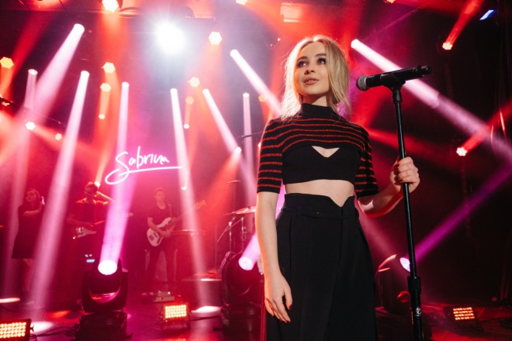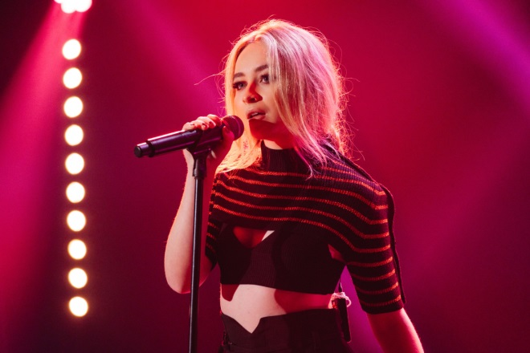
Photos: Terence Patrick/CBS ©2017 CBS Broadcasting, Inc. All Rights Reserved
DOWNLOAD PHOTOS FOR USE HERE

Performance: https://www.youtube.com/watch?v=4JHIR5o2J7k

April 18, 2017 – Last night, singer/songwriter SABRINA CARPENTER made her late night television debut on The Late Late Show with James Corden with a performance of her infectious single “Thumbs” from her sophomore album EVOLution. Watch the performance HERE. Sabrina was wearing Red Valentino Pre-Fall 2017 Collection.

In May, Sabrina will embark as special guest on The Vamp’s UK and Ireland tour and in June, join Ariana Grande’s Dangerous Woman World Tour in Brazil as special guest.

Sabrina Carpenter
Website: http://www.sabrinacarpenter.com
Facebook: http://www.facebook.com/sabrinacarpenter
Instagram: @sabrinacarpenter
Twitter: @SabrinaAnnLynn

Press Contacts:
Brit Reece & Natasha Desai / PMK*BNC
British.Reece@pmkbnc.com / Natasha.Desai@pmkbnc.com

Lillian Matulic & Sharrin Summers / Hollywood Records
Lillian.Matulic@disney.com / Sharrin.Summers@disney.com

