JOYWAVE SET TO OPEN 30 SECONDS TO MARS TOUR
ANNOUNCE SUMMER HEADLINE DATES
SURPRISE FANS WITH NEW TRACK ‘COMPROMISE’

Photo credit: Mary Ellen Matthews

Following their sold-out Thanks. Thanks For Coming 2017/2018 U.S. headline tours, Joywave will join 30 Seconds To Mars on their Monolith 2018 tour alongside Walk The Moon and Misterwives beginning June 6th in Toronto (full list of dates below.) The band has also announced an additional run of headline Thanks. Thanks For Coming tour dates beginning in July (dates below) with special guests grandson and fellow Rochester band, The Demos.

Touring in support of their sophomore album, Content, which debuted #10 on the iTunes Alternative Album chart and spun off two alternative radio hits, “It’s A Trip!” and “Doubt,” Joywave surprised fans today by releasing “Compromise,” (download + stream) a song the band has played live but had not made available until now.

ABOUT JOYWAVE: Always pushing the creative envelope, Joywave have released a number of mixtapes, EP’s, two full-length albums and a host of unique visuals, including videos as well as original series Joy Meets World and Coffee With Joywave. Joywave’s most recent album, Content, debuted #10 on iTunes Alternative Album chart and featured the radio hits “It’s A Trip!” and “Doubt.” Previously, they released a mixtape 77777 (2011), Koda Vista EP (2012), a second mixtape 88888 (2013), the How Do You Feel? EP (2014), a full-length debut album titled How Do You Feel Now? (2015) and in 2016 an entire album featuring alternative versions of their song “Destruction” called SWISH. They collaborated with Big Data on “Dangerous” which hit #1 at alternative radio, while “Somebody New”, “Destruction” and the track “Tongues” (feat KOPPS) off their album How Do You Feel Now? topped the US alternative radio charts as well.

Joywave is vocalist Daniel Armbruster, guitarist Joseph Morinelli, keyboardist Benjamin Bailey and drummer Paul Brenner.

JOYWAVE LIVE

DATE VENUE CITY

6/6/2018 Budweiser Stage Toronto
6/8/2018 Place Bell Montreal
6/9/2018 XFinity Theater Hartford CT
6/10/2018 XFinity Center Boston MA
6/12/2018 DTE Energy Music Ctr Detroit MI
6/13/2018 KeyBank Pavilion Burgettstown, PA
6/15/2018 Huntington Bank Pav Chicago IL
6/16/2018 Blossom Music Center Cleveland OH
6/17/2018 BB&T Pavilion Philadelphia PA
6/19/2018 Bank of New Hampshire Gilford, NH
6/20/2018 Madison Square Garden New York, NY
6/21/2018 PNC Bank Arts Center Holmdel, NJ
6/23/2018 Westword Music Festival Denver CO *
6/26/2018 Jiffy Lube Live Washington DC
6/27/2018 PNC Music Pavilion Charlotte, NC
6/29/2018 Coral Sky Amphitheatre W Palm Beach FL
6/30/2018 MidFlorida Credit Union Amp Tampa, FL
7/1/2018 Daly's Place Jacksonville FL
7/3/2018 Summerfest 2018 Milwaukee, WI*
7/17/2018 The Broadberry Richmond, VA ^
7/18/2018 The Grey Eagle Asheville, NC ^
7/19/2018 Saturn Birmingham, AL ^
7/20/2018 Stickyz Little Rock, AR ^
7/22/2018 Float Fest San Marcos, TX *
7/24/2018 Vanguard Tulsa, OK ^
7/25/2018 Slowdown Omaha, NE ^
7/26/2018 Delmar Hall St. Louis, MO ^
7/27/2018 KRBZ Beach Ball Kansas City, MO *
7/28/2018 Wooly’s Des Moines, IA ^
7/31/2018 Pyramind Scheme Grand Rapids, MI ^
8/2/2018 Upstate Concert Hall Clifton Park, NY ^
8/3/2018 The Ocean Mist Wakefield, RI ^
8/11/2018 91x X-Fest San Diego, CA *

*Festival performance
^ headline date

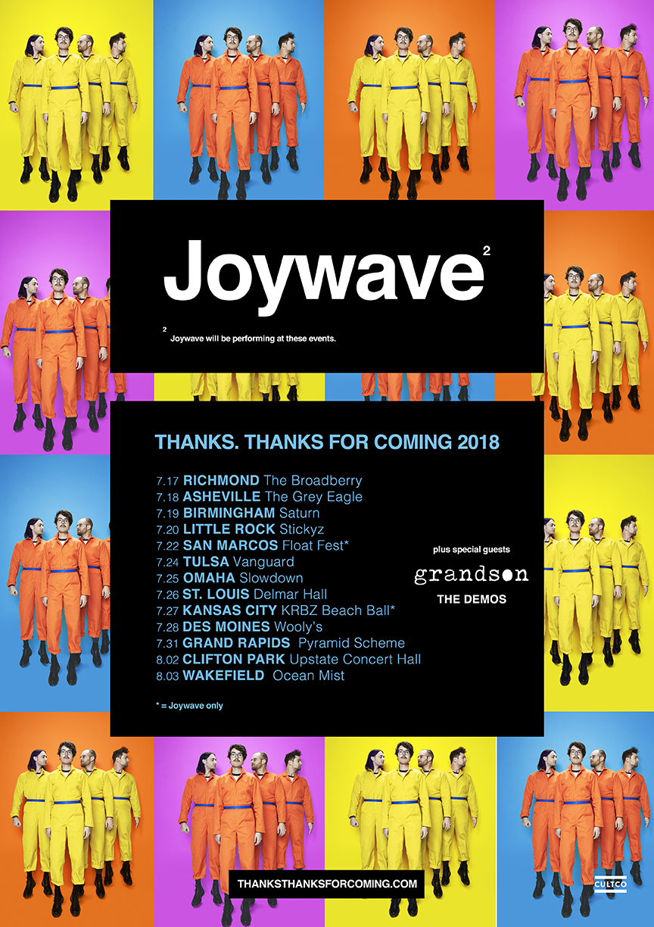

joywavemusic.com/
https://twitter.com/joywavemusic
https://www.instagram.com/joywavemusic/
https://www.facebook.com/joywave/
http://www.youtube.com/joywave

