FOR IMMEDIATE RELEASE
OCEAN PARK STANDOFF INTRODUCE THEMSELVES WITH
“GOOD NEWS” AND “PHOTOS & LIQUOR” OUT TODAY

BAND’S DEBUT EP DUE EARLY 2017

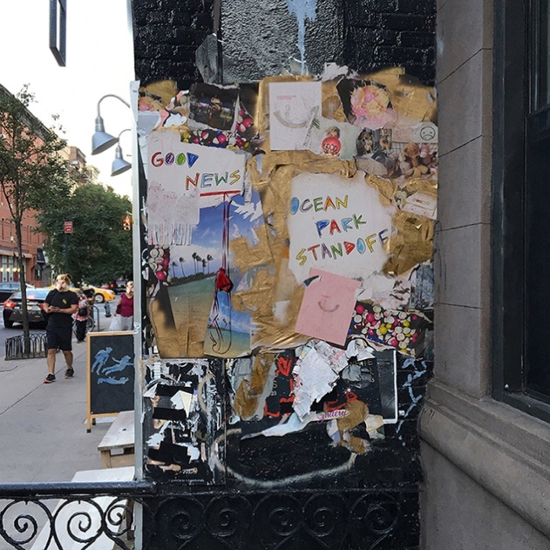
L to R: Samantha Ronson, Ethan Thompson, Pete Nappi // photo credit: James Minchin

HEAR “GOOD NEWS” & “PHOTOS & LIQUOR” HERE
WATCH HERE

Los Angeles, CA (October 7, 2016) – LA-based alt-pop trio Ocean Park Standoff are introducing themselves today with the release of two tracks in anticipation of their Hollywood Records debut EP, due for release in early 2017. The songs—“Good News” and “Photos & Liquor” — are available on all streaming services HERE and can be heard HERE. “Good News” is also feature on Spotify’s New Music Friday HERE.

Comprised of internationally renowned DJ and musician Samantha Ronson, singer/songwriter/vocalist and producer Ethan Thompson and producer/drummer Pete Nappi, Ocean Park Standoff came together in late 2014 when Ronson and Nappi paired up for a songwriting session. By early 2015 (with Thompson on board), the trio had begun writing together almost every day at Ronson’s place by the beach, working in a sun-soaked bedroom that slowly morphed into their home studio.

You can instantly feel all that sunshine in the luminous melodies and lush textures heard throughout their two-song release. Despite its sweeping, cinematic scope, it has an intimate feel that’s got much to do with the unbridled honesty that Ronson and Thompson channel into each lyric. And though it’s built on feel-good anthems, there’s also an undercurrent of melancholy that give “Good News” and “Photos & Liquor” a powerful depth.

With “Good News,” for instance, Ocean Park Standoff deliver a soulful, piano-laced pop number that embodies the band’s mission of making music that “celebrates the small victories in life,” as Ronson explains. “It’s about recognizing that you have no control over how insane the world is, and trying to have fireworks for the little things that make you feel good.” While “Photos & Liquor” infuses hypnotic guitar tones into a hazy meditation on how on booze and memory can warp reality. In crafting the song’s pained lyrics (The flashbacks are mixed up with photos and liquor/Cloudin’ my mind with what was real and what’s fiction), the band mined inspiration from an old picture of Thompson and his ex. “In the photo they’re kissing on the beach and it looks so romantic, but really they were fighting and Ethan kissed her to shut her up,” says Ronson. “It made me think about how easy it is to romanticize certain situations when the reality was completely different, and how we don’t have pictures that really show the bad times.”

In producing for Ocean Park Standoff—which involves sculpting tracks electronically as well as making use of Ronson’s vintage synths and drum machines—Nappi both draws on his expansive musical knowledge and sticks to a process that’s highly instinctual. “When I’m making something, I don’t really think that much,” he says. “I just do it and see what sounds good, and I know it’s done once I can really feel the song.”

That sense of experimentation shapes every aspect of Ocean Park Standoff, which all three members have found revitalizing. “We never have to ask, ‘What’s the vibe here?’,” notes Ronson. “We can make it whatever we want, and it’s so much more fun like that.” Within that freedom, Ocean Park Standoff have formed an intense connection that’s helped push their artistry even further than they’d envisioned. “When we first started, it wasn’t something I would’ve ever thought could work—but the more we play, the more it makes sense,” says Thompson. “We all come from very different places and believe in different things, but in the end we’re able to come together and make these songs that we all really love.”

102016
http://oceanparkstandoff.com
Teaser Video clips HERE
#goodnews

Press contact:
Sharrin Summers | Hollywood Records | sharrin.summers@disney.com

