OCEAN PARK STANDOFF ANNOUNCES UPCOMING TOUR DATES

FEBRUARY TOUR WITH LOLO &
SUMMER ARENA TOUR WITH THIRD EYE BLIND & SILVERSUN PICKUPS

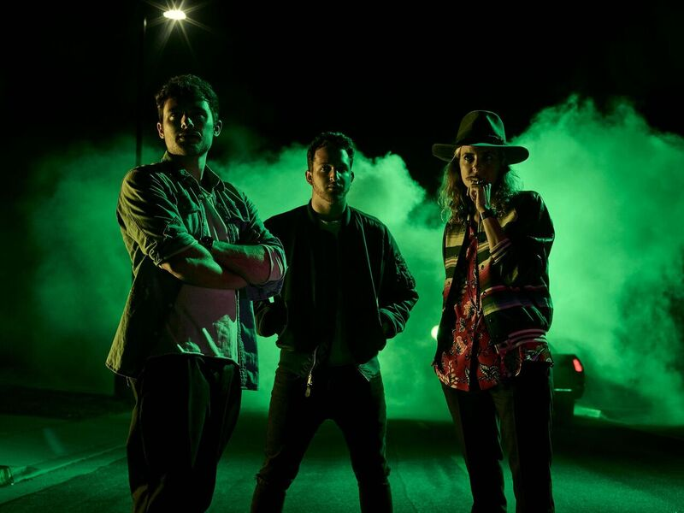
(photo credit: James Minchin)

January 27, 2017 - Los Angeles’ Ocean Park Standoff, will be kicking off a month-long tour with LOLO in New York City on February 2, 2017, with shows in Nashville, Chicago, DC, and more. The band will also be on Third Eye Blinds arena tour this summer alongside Silversun Pickups, beginning in June. Since the creation of the band, they’ve released two tracks, “Good News” and “Photos & Liquor” in anticipation of their debut EP release on March 3, 2017. “Good News” has accumulated over 2 million streams and landed on Spotify’s Best of 2016 playlist. PRESS HERE to listen.

Each of the artists behind alt-pop trio Ocean Park Standoff comes from a world all their own. A self-taught producer who built his own studio in the basement as a kid, Pete Nappi constructs deeply inventive productions equally inspired by art rock and underground hip-hop. A longtime DJ known for spinning at high-profile gigs around the globe, Samantha Ronson is also a songwriter/multi-instrumentalist who matches her lyrical smarts with a sonic ingenuity rooted in her fascination with obscure vintage instruments. And as a classically trained vocalist, Ethan Thompson has revealed his refined songcraft in penning hits for major artists and performing at singer/songwriter hotspots around L.A.

Ocean Park Standoff will also be performing shows at SXSW (details to be announced soon). Want to get to know them a little better? Check them out HERE. Tickets for their February tour available for purchase HERE.

Good News / Photos and Liquor Single -
Wide Download Link:
http://smarturl.it/OPSGoodNews
Wide Streaming Link:
http://smarturl.it/OPSGoodNewsWS

OCEAN PARK STANDOFF with LOLO FEBRUARY TOUR DATES
2/2 New York, NY @ Mercury Lounge
2/7 Nashville, TN @ 12th & Porter
2/8 Chicago, IL @ SPACE
2/13 Atlanta, GA @ Vinyl
2/21 Orlando, FL @ The Social
2/23 Chapel Hill, NC @ Local 506
2/24 Washington, DC @ Dc9
2/26 Troy, NY @ Hangar on the Hudson
2/27 Burlington, VT @ Higher Ground

OCEAN PARK STANDOFF with THIRD EYE BLIND SUMMER & SILVERSUN PICKUPS TOUR DATES
6/9 Miami, FL @ Bayfront Park Amphitheater
6/10 Clearwater, FL @ Coachman
6/11 Jacksonville, FL @ TBD
6/13 New Orleans, LA @ Champions Square-Superdome
6/15 Nashville, TN @ Ascend Amphitheater
6/16 Charlotte, NC @ Charlotte Metro Credit Union Amphitheater
6/17 Raleigh, NC @ The Red Hat Amphitheater
6/18 Baltimore, MD @ TBD
6/21 Boston, MA @ Blue Hills Bank Pavillion
6/23 Holmdel, NJ @ PNC Bank Arts Center
6/24 Wantagh, NJ @ Nikon at Jones Beach Theater
6/25 Philadelphia, PA @ Festival Pier
6/28 Toronto, ON @ TD Echo Beach
6/29 Darien Center, NY @ Darien Lake Performing Arts Center
6/30 Syracuse, NY @ Lakeview Amphitheater-Syracuse
7/1 Saratoga Springs, NY @ Saratoga Performing Arts Center
7/2 Wallingford, CT @ Toyota Presents the Oakdale Theatre
7/6 Chicago, IL @ First Merit Bank Pavilion
7/7 Clarkston, MI @ DTE Energy Music Theatre
7/8 Cleveland, OH @ Jacobs Pavilion at Nautica
7/9 Indianapolis, IN @ Farm Bureau Insurance Lawn at White River State Park
7/12 Rogers, AR @ Walmart Amp – Arkansas Music Pavilion
7/14 The Woodlands, TX @ Cynthia Woods Mitchell Pavilion presented by Huntsman
7/15 Dallas, TX @ Gexa Energy Pavilion
7/18 Phoenix, AZ @ Comerica Theatre
7/20 Los Angeles, CA @ Greek Theatre
7/21 San Diego, CA @ Cal Coast Credit Union Open Air Theatre
7/22 Las Vegas, NV @ The Joint
7/23 Berkeley, CA @ Greek Theatre

For press inquiries on Ocean Park Standoff please contact:

HOLLYWOOD RECORDS
Sharrin Summers
Sharrin.summers@disney.com

