





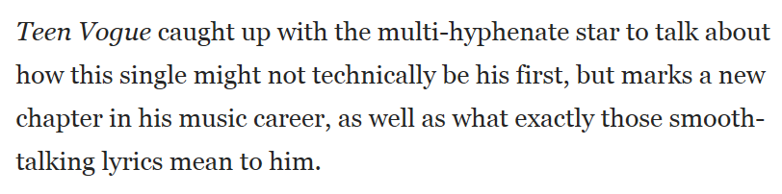

READ MORE [HERE](http://www.teenvogue.com/story/jordan-fisher-single-all-about-us)