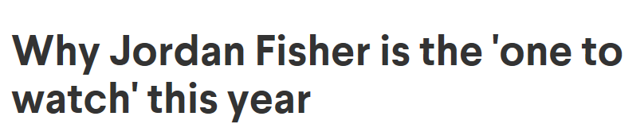

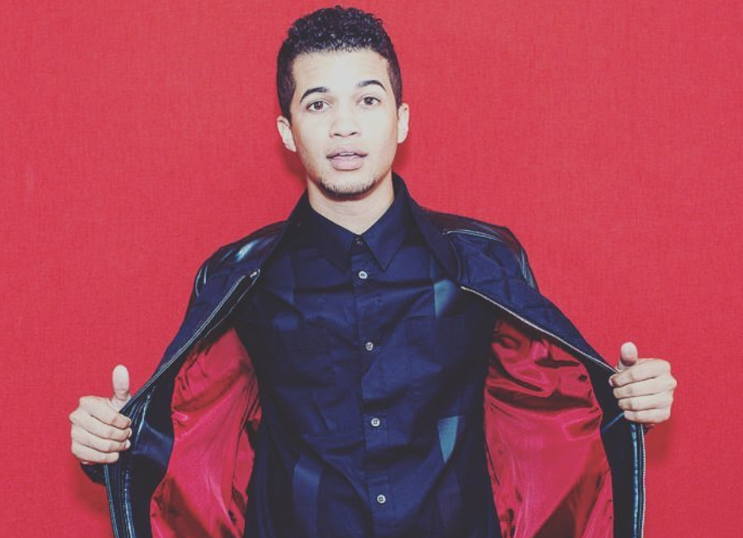
"One to watch" is a coveted title for any in young Hollywood to gain. Not only does it mean that you've perfected your craft at an age that's unprecedented, but it also is proof that you're career isn't going unnoticed. If anyone deserves this high accolade, it's Jordan Fisher. The young actor quickly became thrust into the spotlight after his critically-acclaimed performance in "Grease Live!" His epic rendition of "Those Magic Changes" solidified Fisher's presence in mainstream media as the quintessential triple threat.
Fisher is using his newfound notoriety to his advantage. Trading in show tunes for pure, unadulterated R&B, the young performer is once again ready to show the world his incredible range of talents. His new single "All About Us" flexes Fisher's skill as a singer. The genre-bending track plays on the hard-hitting beats of dance music, the emotional soul lyrics, and the catchiness of modern pop music, all with the swagger and you'd expect from favorite R&B artists.
Trust us, "All About Us" is about to be your newest summer song. So if you haven't had a chance to get to know the incredible singer on a more personal level, here's your chance. We recently spoke to Jordan Fisher about where his love of music first began, his first ever radio tour, and more!
When did you first realize that you loved performing?
It started in fifth grade and there was this girl that I had a crush on. She was in drama club and asked me if I was going to join and I said, "Of course!" Mind you I had never acted, danced, or even sung a day in my life prior. That was what happened and I really just fell in love with the art in fifth grade. That was when it began for me. I was a gymnast for years before that and it was all I knew. I was a gymnast, played soccer, and baseball here and there and that was it. I walked into drama club, realized how much fun it was to create something from nothing and I enjoyed that experience. Then it progressed.
That one year I did my first play, then my first community theater show, then my first regional theater show, to my first professional theater show. Then a few years later I went out to LA for the first time and began auditioning for different television shows and commercials. The guest spots on the random commercials here and there turned into a random role on an ABC Family show "The Secret Life of the American Teenage" back in 2011.
When I got to LA more permanently I thought if I don't make music I'm going to go bananas. So I started writing and working with different producers from all over the place and one thing led to another. After multiple TV and film projects, I got signed to Hollywood Records and here we are now. The album is done and I'm on a promo run across the country talking about the first single off of the record and having a great time.
And now I'm finishing up this 8 week long radio tour going every day to multiple cities a day, and sometimes I'm on multiple flights a day even. It's been a good time and daunting in terms of the schedule but it's let me see a lot of the country I haven't seen yet.
That sounds like insanity!
It is insanity. I can't even tell you the exact amount of cities we've hit -- probably close to 90. It's been a heck of a last eight weeks. We're playing 2-3 shows a day, then going to the meet and greets, then visiting local radio stations and doing it all over again.

