ZELLA DAY ADDED TO
BILLBOARD HOT 100 FEST AND IHEARTRADIO FEST LINEUPS
U.S. HEADLINE TOUR DATES KICK OFF AUGUST 23
DEBUT ALBUM KICKER OUT NOW
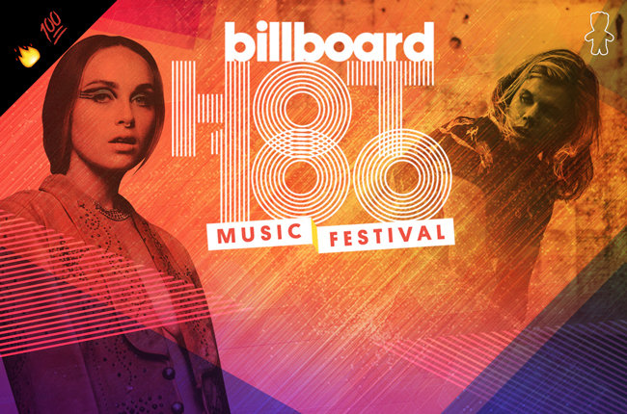
About Zella Day’s stunning set at Lollapalooza, the Chicago Tribune said, “This is rock, make no mistake about it… Hooks galore, and choruses that swing for the fences.” If you missed the show, don’t worry, Zella’s added two more big festival dates to her upcoming tour schedule.

She’s joining a who's who (The Weeknd, Skrillex, Nicki Minaj, Lil Wayne, Cold War Kids, Fetty Wap, ILove Makonnen, Santigold among others) on the cutting edge of modern pop music at the Billboard Hot 100 Fest taking place Aug 22-23 in NYC. Billboard will document Zella’s experience on the road leading up to the festival culminating with her performance on Aug. 23 at Nikon at Jones Beach. Exclusive, behind-the-scenes video content will be hosted onBillboard.com, Billboard’s YouTube channel and on ThePatchHouse.com and The Patch’s YouTube page. Zella’s festival participation includes supporting a new partnership between Billboard and The Patch, a program created by Sour Patch Kids, that provides a free home-away-from home for emerging musicians on the road. For more on Billboard and The Patch go HERE
The Billboard Hot 100 Fest marks just one stop on her upcoming U.S. headline tour, which also includes a performance at iHeartRadio Music Festival ‘s Daytime Village in Las Vegas where Zella will share the stage with artists such as Hozier, Tove Lo, Walk The Moon and George Ezra among others at the MGM Resorts on Sept. 19.

The Arizona native released her debut album KICKER this past June via Pinetop Records / Hollywood Records. A bold statement for the budding songstress exploring the depths of toxic relationships and modes for resilience, KICKER has The New York Times affirming, "…(there’s) a hint of genuine darkness behind each treacherous romance."
In June, Zella made her U.S. television debut on CONAN, delivering a stunning performance of hit single "High." View HERE. Her track “Compass” can be heard in theatres across the country in the trailer for the Chris Pine, Casey Affleck heroic action-thriller “The Finest Hours” in theaters January 2016.
Zella Day headlining tour dates as follows.
** Festival dates
† with Cold War Kids, Manchester Orchestra, Charles Bradley & His Extraordinaires, The Mowgli’s

Sun, Aug 23 | Wantagh, NY | Billboard Hot 100 Fest, Nikon at Jones Beach** | TICKETS
Mon, Aug 24 | Cambridge, MA | The Sinclair | TICKETS
Wed, Aug 26 | Toronto, ON | Lee’s Palace | TICKETS
Thu, Aug 27 | Youngstown, OH | Suzie’s Dogs & Drafts
Fri, Aug 28 | Cleveland, OH | Grog Shop | TICKETS
Sat, Aug 29 | Detroit, MI | Shelter | TICKETS
Fri, Sep 11 | Nashville, TN | Live on The Green Music Festival (main stage / free show)** | INFO
Sat, Sep 12 | Louisville, KY | Zanzabar | TICKETS
Sun, Sep 13 | St Louis, MO | Off Broadway | TICKETS
Mon, Sep 14 | Little Rock, AR | Juanita’s Cantina | TICKETS
Wed, Sep 16 | Santa Fe, NM | Santa Fe Railyard Plaza (free show) | INFO
Thu, Sep 17 | Phoenix, AZ | The Rebel Lounge | TICKETS
Fri, Sep 18 | Tucson, AZ | 191 Toole | TICKETS
Sat, Sep 19 | Las Vegas, NV | iHeartRadio Fest**
Mon, Sep 21 | Boise, ID | Neurolux | TICKETS
Tue, Sep 22 | Seattle, WA | Chop Suey | TICKETS
Wed, Sep 23 | Portland, OR | Star Theater | TICKETS
Thu, Sep 24 | Orangevale, CA | The Boardwalk | TICKETS
Sat, Sep 26 | Fresno, CA | Strummer’s | TICKETS
Sun, Sep 27 | Santa Barbara, CA | SOhO – Restaurant & Music Club | TICKETS
Mon, Sep 28 | Santa Ana, CA | The Observatory | TICKETS
Fri, Oct 9 | Clinton, NY | Hamilton College – Tolles Pavilion
Sat, Oct 17 | Reno, NV | Cargo at Whitney Peak Hotel† | TICKETS

More dates to be announced.

About Zella Day
This summer, Zella released the art concept video for album track "Jameson," a gorgeous visual depiction of the song set in the mountains of Mammoth. View HERE. Also this spring, Zella released new single "High" as well as the official video for hit single "Hypnotic," which has over 2 million views since its spring debut. View HERE.
2014 saw Zella assert herself firmly among the top new artists to watch with inclusion in Spotify's 'Emerge' program, attaining an impressive nine #1's on the Hype Machine 'Popular Chart', and earning critical acclaim from the likes of The FADER, The Guardian (New Band of the Week), Pigeons and Planes, NYLON, The Line of Best Fit, Noisey (VICE), Interview Magazine, and Paste Magazine, as well as spins from KCRW and Sirius XMU. She released her self-titled debut EP fall 2014 via tastemaker label B3SCI Records, featuring tracks such as "Sweet Ophelia," "East of Eden," and "Hypnotic" (also named iTunes 'Single of the Week').
Zella has moved effortlessly between music and fashion with features in Teen Vogue, V Magazine, KENTON Magazine, The LATERALS, Playboy (fully-clothed 'Artist to Watch' feature), as well as Free People (mini-documentary here).
Zella Day first made a splash in 2012 with a cover of The White Stripe's "Seven Nation Army," which topped the Hype Machine. Raised in Pinetop, Arizona, a small mountain town of 7,000, Zella embraced creativity early on inspired by a vast backdrop of natural beauty. Surrounding herself with other musicians, Zella's family-owned Mor Mor Coffee House became a sanctuary for budding artists where she first performed sets of Bob Dylan, Elvis Presley, and Bobby Darin songs with only a guitar. Pulling dually from such songwriting legends and her old-West, Clint Eastwood-clad surroundings, Zella began writing songs with a distinct raw grit that continues to define her sound today.
Now based in Los Angeles, Zella continues her strong upward momentum with a debut album out now and a stunning live show taken worldwide.

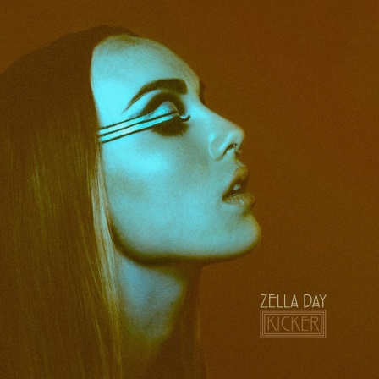
MEDIA ASSETS
http://www.hollywoodrecords.com/press/zella-media-kit/

BUY
KICKER album (iTunes) │ KICKER album (Amazon) │KICKER album (Streaming services) │Zella Day EP (10" limited edition vinyl)

STREAM
"High" (SoundCloud) │ "Hypnotic" official video (YouTube) │"East of Eden" (SoundCloud) │"Sweet Ophelia" official video (YouTube)

GET SOCIAL
Official Website │ Facebook │ Twitter │ Instagram │ SoundCloud

For more information, please contact
Mark Simek, Drill Down Media, Sharrin Summers, Hollywood Records
815.651.1818, mark@drilldown-media.com 818.560.5787, sharrin.summers@disney.com
"broad-stroke, all-or-nothing pop" - The New York Times
"it’s just something that pops...bright and well arranged." - KCRW
"manages to take her folky, western influences and merge them with a current indie pop sound, creating a production that feels both modern and organic" - Pigeons and Planes
"The only thing better than discovering your new favorite indie folk pop star is when you also find out that she’s your new favorite style icon." - NYLON
"nothing short of enchanting" - V Magazine
"an engrossing approach to songwriting and a lilting, mesmerizing voice" -Billboard
"A classic American girl influence...the songwriter has her own charmed style" - Interview Magazine
"an epic feel to the tracks...not a million miles from the windswept pop grandeur of a CHVRCHES or MØ." - The Guardian
"enchanting timbre and suave songwriting" – SF Weekly
"it's safe to say this girl's on her way to being a household name" - BlackBook Magazine

