FOR IMMEDIATE RELEASE
ZELLA DAY ANNOUNCES NORTH AMERICAN HEADLINE DATES
IN JUNE AND JULY

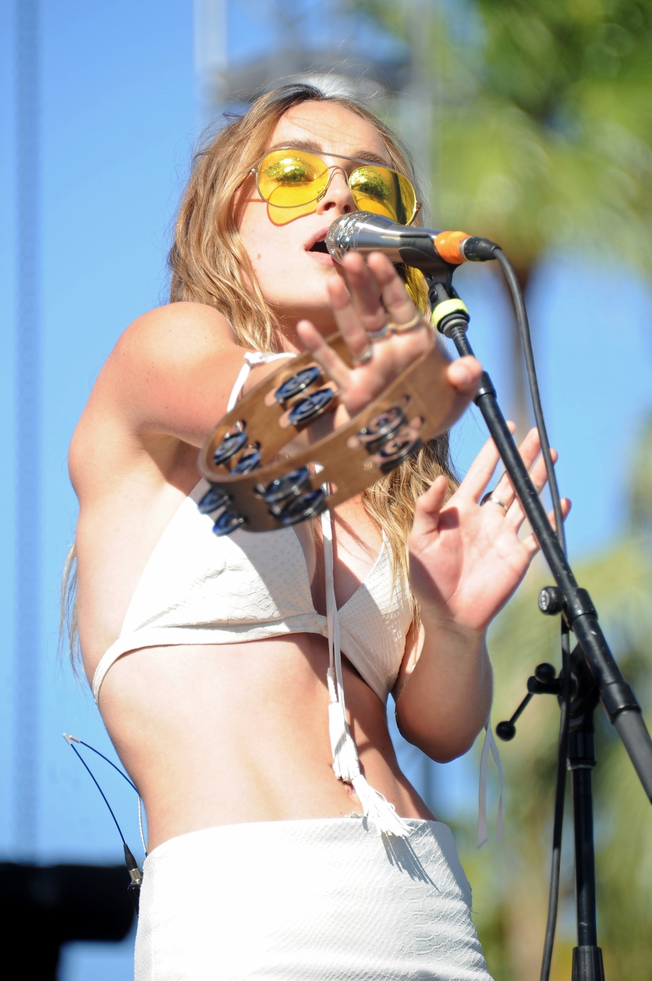
SUPPORTING DATES WITH FITZ AND THE TANTRUMS IN JULY
AND MICHAEL FRANTI IN AUGUST
ZELLA DAY PERFORMS NEW SINGLE "MUSTANG KIDS" ON
LAST CALL WITH CARSON DALY (WATCH HERE)
LISTEN TO NEW SINGLE "MUSTANG KIDS" HERE
(May 10, 2016 ) Los Angeles magazine described ZELLA DAY’s recent Coachella performance as “hypnotic.” Idolator said she “mesmerized the crowd,” Billboard hailed her “stellar Zella debut” and Consequence of Sound exclaimed “it's entirely possible that Zella Day looks back on Coachella 2016 as the moment that launched her career in earnest...Day is an undeniably powerful vocalist." The Arizona native is now taking her show on the road, announcing a headlining tour of North America set to kick off June 21st in Kansas City, MO. After that comes a run with Fitz and the Tantrums, then an August tour supporting Michael Franti & Spearhead.

Tickets for the headline dates go on sale Friday, May 13 at 10am local time. More information can be found below and by visiting Zella’s site HERE.

Zella’s touring in support of debut album KICKER and new single “Mustang Kids,” which you can hear HERE. She recently performed the song on Last Call with Carson Daly and shot a companion video in the bucolic environs of Bishop, California, with director Tim Mattia (The 1975, Halsey, Cage The Elephant), due to premiere at the end of May.

“Mustang Kids,” follows lead single “Hypnotic,” which iTunes spotlighted as a “Single of the Week” and is currently featured in a trailer for the upcoming film, Alice Through The Looking Glass.

ZELLA DAY tour dates as follows:
Jun 21 // Kansas City, MO @ The Tank Room (tix)
Jun 22 // Minneapolis, MN @ Triple Rock (tix)
Jun 24 // Chicago, IL @ Lincoln Hall (tix)
Jun 25 // Grand Rapids, MI @ The Stache (tix)
Jun 26 // Detroit, MI @ The Shelter (tix)
Jun 28 // Columbus, OH @ The Basement (tix)
Jun 29 // Madison, WI @ The Frequency (tix)
Jun 30 // Milwaukee, WI Summerfest (tix)
Jul 2 // Montauk, NY @ Surf Lodge (free show)
Jul 3 // Amagansett, NY @ The Stephen Talkhouse (tix)
Jul 6 // Washington, DC @ U Street Music Hall (tix)
Jul 7 // Brooklyn, NY @ Rough Trade (tix)
Jul 8 // Philadelphia, PA @ The Foundry at the Fillmore (tix)
Jul 9 // Cambridge, MA @ The Sinclair (tix)
Jul 11 // Montreal, QC @ La Sala Rossa (tix)
Jul 12 // Toronto, ON @ Mod Club (tix)
Jul 14 // Pittsburgh, PA @ Stage AE (tix) #
Jul 15 // Richmond, VA @ The National (tix)
Jul 17 // Nashville, TN @ 3rd and Lindsley (tix)
Jul 19 // New Orleans, LA @ Civic Theatre (tix) #
Jul 20 // Little Rock, AR @ Metroplex (tix) #
Jul 22 // Tulsa, OK @ Cain's Ballroom (tix) #
Jul 23 // Dallas, TX @ House of Blues (tix) #
Jul 24 // Austin, TX @ Stubb's (tix) #
Jul 26 // Albuquerque, NM @ Sunshine Theater (tix) #
Jul 27 // Tempe, AZ @ Marquee Theater (tix) #
Jul 29 // San Diego, CA @ Quartyard (tix)
Aug 4 // Mammoth Lakes, CA @ Mammoth Festival (tix) *
Aug 5 // Flagstaff, AZ @ Pepsi Amphitheater (tix) *
Aug 6 // Durango, CO @ Three Springs (tix) *
Aug 7 // Morrison, CO @ Red Rocks Amphitheater (tix) *
Aug 11 // Bend, OR @ Les Schwab Amphitheater (tix) *
Aug 12 // Troutdale, OR @ McMenamins Edgefield Amphitheatre (tix) *
Aug 16 // Missoula, MT @ Big Sky Brewing Company (tix) *
Aug 17 // Spokane, WA @ Knitting Factory Concert House (tix) *
Aug 19 // Lake Tahoe, NV @ Montbleu Resort (tix) *
Aug 21 // Saratoga, CA @ Mountain Winery (tix)
Aug 23 // Rohnert Park @ Somo Village Center (tix)
Aug 25 // San Luis Obispo, CA @ Avila Beach Resort (tix) *
Aug 26 // Las Vegas, NV @ Brooklyn Bowl (tix) *
Aug. 27 // Orem, UT @ Timpanogos Music Festival (tix)
Aug 30 // Aspen, CO @ Belly Up (tix)
Sept 2-4 // Seattle, WA @ Bumbershoot (tix)
Sept 3-4 Edmonton, AB @ Sonic Boom Festival (tix)
Sept 3-4 Calgary @ X-Fest (tix)
Sept 17 // Piedmont Park, AT @ Music Midtown (tix)
Oct 2 // New York, NY @ Citi Field - The Meadows Music and Arts Festival (tix)
# w/ Fitz and the Tantrums
* w/ Michael Franti & Spearhead

More dates to be announced.
Over the course of the past year Zella has performed on Late Night with Seth Meyers and CONAN, been covered by The FADER, The Guardian, SPIN, Noisey, Interview Magazine, Vogue, InStyle, ELLE, Vanity Fair, W Magazine, Harper's Bazaar, Refinery29, FLAUNT, PAPER Mag, V Magazine, NYLON, WhoWhatWear, forged partnerships with clothing brands Coach, Maje and Free People, appeared at several NYFW 2016 shows (including a performance at Rebecca Minkoff’s runway show), performed at Coachella, Billboard Hot 100 Fest, iHeartRadio Music Fest and Lollapalooza, and built a diehard international following on a strength of an electrifying live show hailed by the Chicago Tribune for being filled with “Hooks galore, and choruses that swing for the fences.”

BUY
KICKER (iTunes) Ι KICKER (Amazon) Ι KICKER (Streaming services)
STREAM
"Hypnotic" official video (YouTube)
"Jameson" art/concept video (YouTube) │ "Sweet Ophelia" official video (YouTube)
ASSETS
Photos / Art / Bio
GET SOCIAL
Official Website │ Facebook │ Twitter │ Instagram │ SoundCloud
For more information, please contact
Sharrin Summers, Hollywood Records, 818.560.5787, sharrin.summers@disney.com
Mark Simek, Drill Down Media, 815.651.1818, mark@drilldown-media.com

