FOR IMMEDIATE RELEASE
ZELLA DAY TO SUPPORT FITZ AND THE TANTRUMS ON RUN OF SUMMER 2016 DATES
STUNS AT COACHELLA
CATCH HER WEEKEND TWO SATURDAY, APRIL 23 - OUTDOOR THEATER STAGE – 4:15PM
LISTEN TO NEW SINGLE "MUSTANG KIDS" HERE
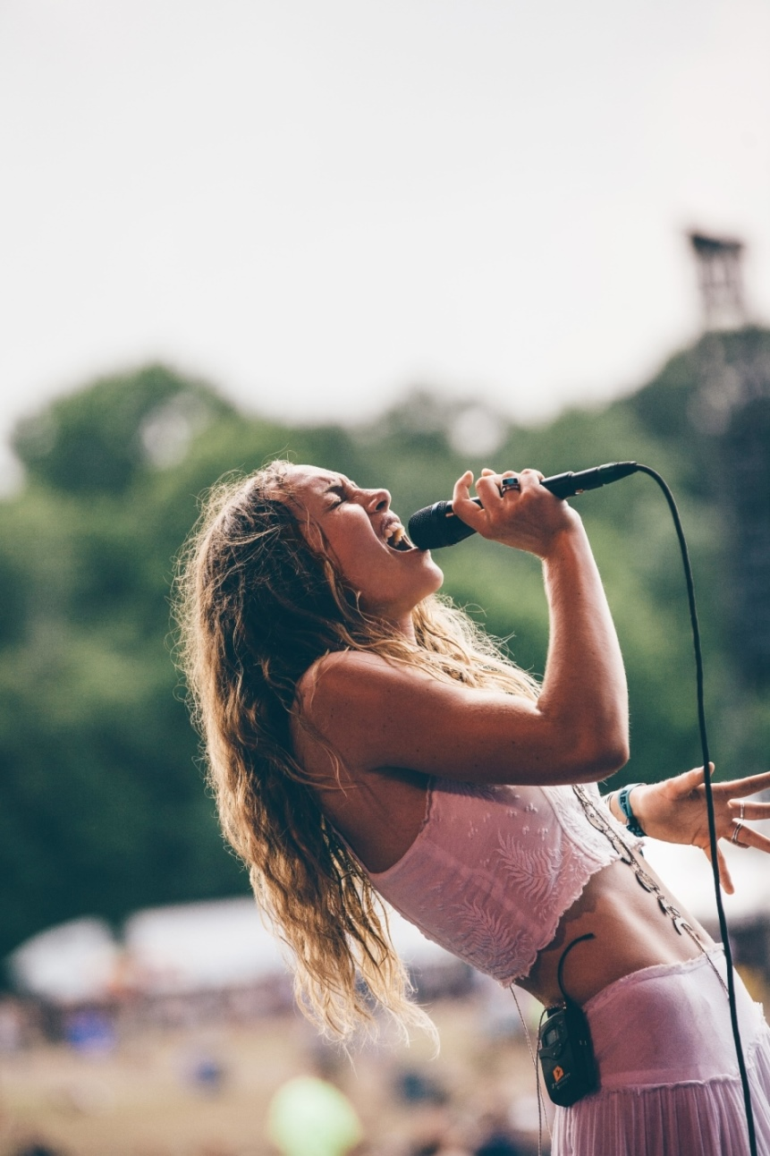
(April 20, 2016) Today, rising songstress Zella Day has announced a summer 2016 support run with LA neo-soul
outfit Fitz and The Tantrums:
Jul 14 // Pittsburgh, PA @ Stage AE
Jul 19 // New Orleans, LA @ Civic Theater
Jul 20 // Little Rock, AR @ Metroplex
Jul 22 // Tulsa, OK @ Cain's Ballroom
Jul 23 // Dallas, TX @ House of Blues
Jul 24 // Austin, TX @ Stubb's
Jul 26 // Albuquerque, NM @ Sunshine Theater
Jul 27 // Tempe, AZ @ Marquee Theater
**Headlining dates to be announce shortly
The announcement comes on the heels of a momentous performance at the first weekend of Coachella 2016, which has Consequence of Sound declaring, "It's entirely possible that Zella Day looks back on Coachella 2016 as the moment that launched her career in earnest...Day is an undeniably powerful vocalist."
Zella has recently graced the stage of several television programs including Late Night with Seth Meyers, Last Call with Carson Daly live from a recent LA show at The Fonda Theatre, and her television debut on CONAN last year.
The Arizona native released her debut album KICKER last year via Pinetop Records / Hollywood Records.
A bold statement for the budding singer-songwriter exploring the depths of toxic relationships and modes for resilience, The New York Times lauds KICKER’s depth finding “…a hint of genuine darkness behind each treacherous romance.”
2015 saw Zella embark on an expansive U.S. and European tour that included highlight plays at Billboard Hot 100
Fest, iHeartRadio Music Fest and Lollapalooza, of which the Chicago Tribune proclaimed, “Hooks galore, and choruses that swing for the fences.”
Since her self-titled debut EP fall 2014 via tastemaker label B3SCI Records, Zella Day has seen support from the likes of The FADER, The Guardian, SPIN, Pigeons and Planes, Noisey (VICE), Interview Magazine, and Paste Magazine.
Zella continues to trailblaze a distinct edge in the fashion world via partnerships with clothing brands Coach, Maje, and Free People, appearances at several NYFW 2016 shows (including a performance at Rebecca Minkoff), as well as editorial features with Vogue, ELLE, Vanity Fair, W Magazine, Harper's Bazaar, Refinery29, FLAUNT, PAPER Mag,
V Magazine, NYLON, LADYGUNN, The LATERALS, WhoWhatWear, and Playboy (fully-clothed 'Artist to Watch'
Zella Day first made a splash in 2012 with a cover of The White Stripe’s “Seven Nation Army,” which topped the Hype Machine. Raised in Pinetop, Arizona, a small mountain town of 7,000, Zella embraced creativity early on inspired by a vast backdrop of natural beauty. Surrounding herself with other musicians, Zella’s family-owned Mor Mor Coffee House became a sanctuary for budding artists. Pulling dually from songwriting legends and her old-West, Clint Eastwood-clad surroundings, Zella began writing songs with a distinct raw grit that continues to define her sound today.
Now based in Los Angeles, Zella continues her strong upward momentum with a debut album out now and a riveting live show that will captivate many more audiences in 2016.

BUY
KICKER (iTunes) Ι KICKER (Amazon) Ι KICKER (Streaming services)│ Zella Day EP (10" limited edition vinyl)
STREAM
Full KICKER album (SoundCloud, For Review) │ "Hypnotic" official video (YouTube)
"Jameson" art/concept video (YouTube) │ "Sweet Ophelia" official video (YouTube)
ASSETS
Photos / Art Ι Bio
GET SOCIAL
Official Website │ Facebook │ Twitter │ Instagram │ SoundCloud
For more information, please contact
Sharrin Summers, Hollywood Records, 818.560.5787, sharrin.summers@disney.com
Mark Simek, Drill Down Media, 815.651.1818, mark@drilldown-media.com

