FOR IMMEDIATE RELEASE  
pinetopRecordsLogo_black(s) HOLLYWOOD  BLACK

**ZELLA DAY RELEASES OFFICIAL VIDEO FOR NEW SINGLE “MUSTANG KIDS”**[**WATCH HERE**](https://www.youtube.com/watch?v=0V7HANV4yhc)

**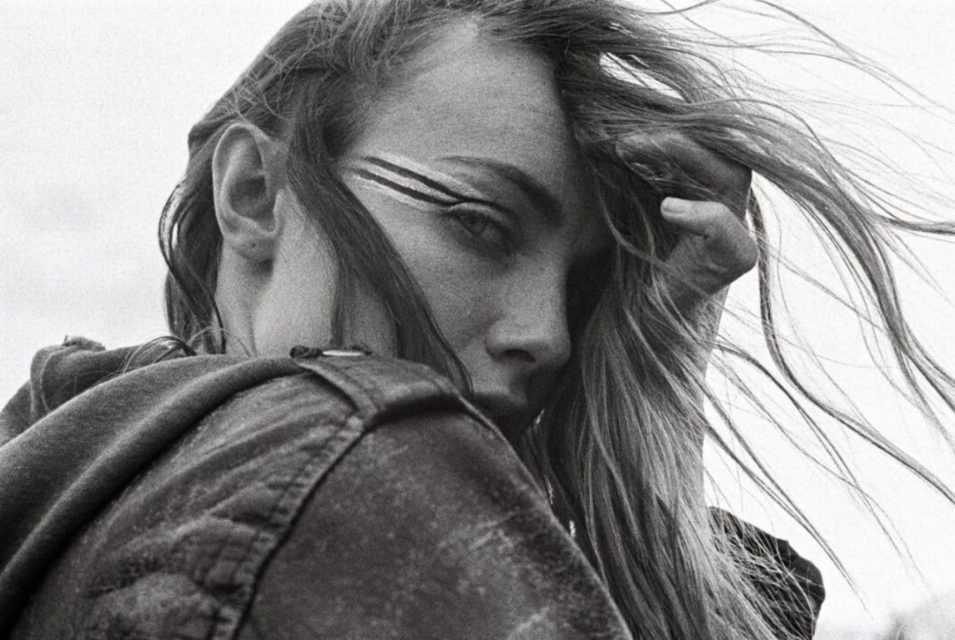**[The Musician](https://www.facebook.com/ZellaDay/photos/a.179846278810293.37261.179843028810618/891318947663019/?type=3&theater) **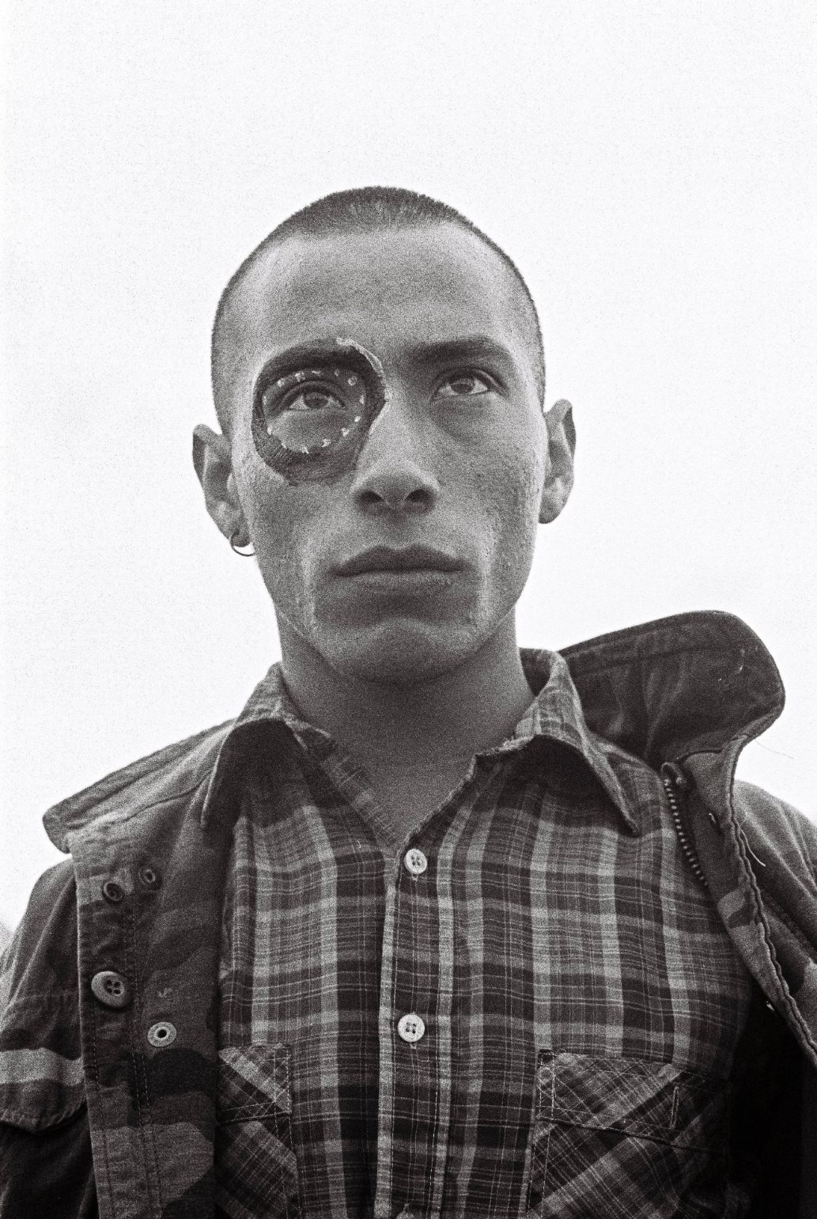 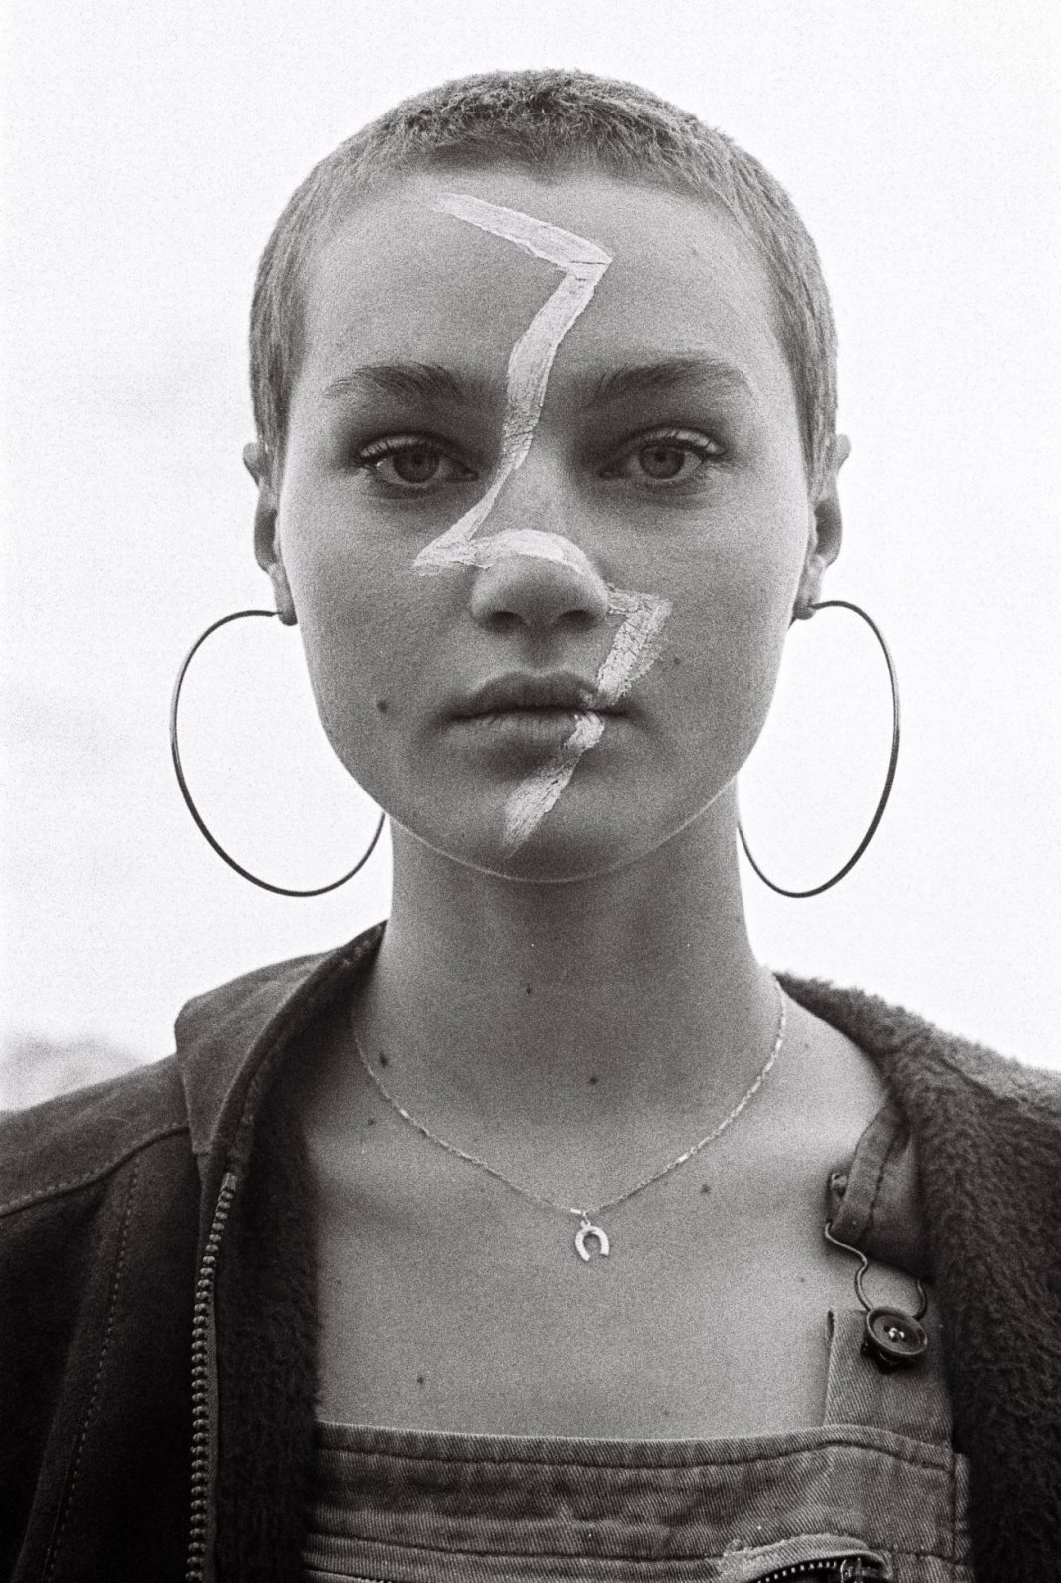 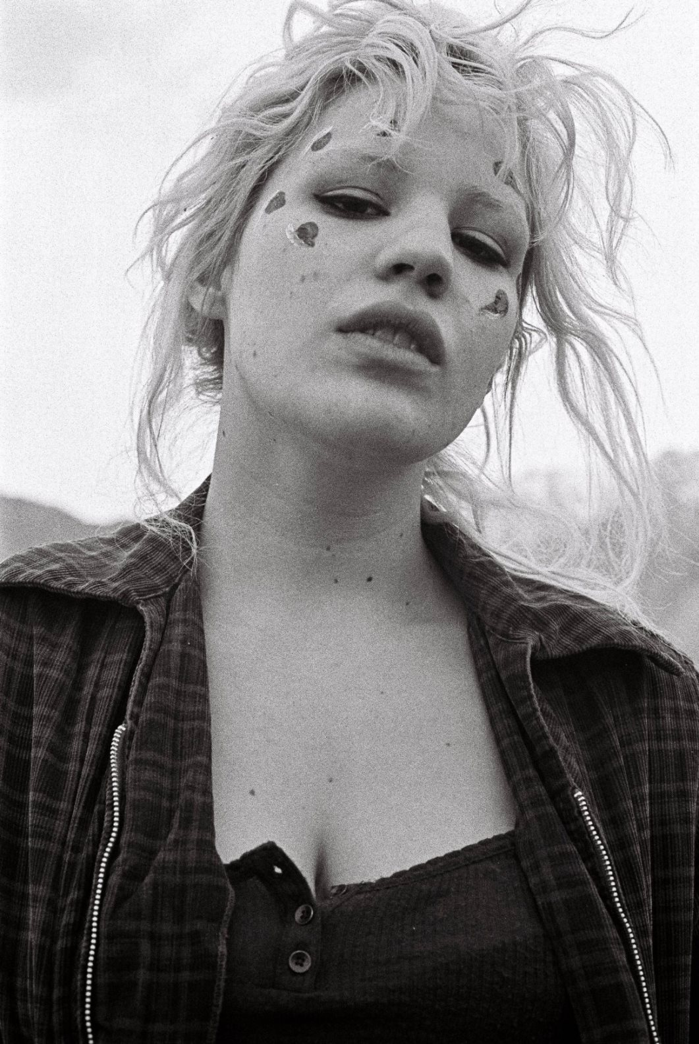 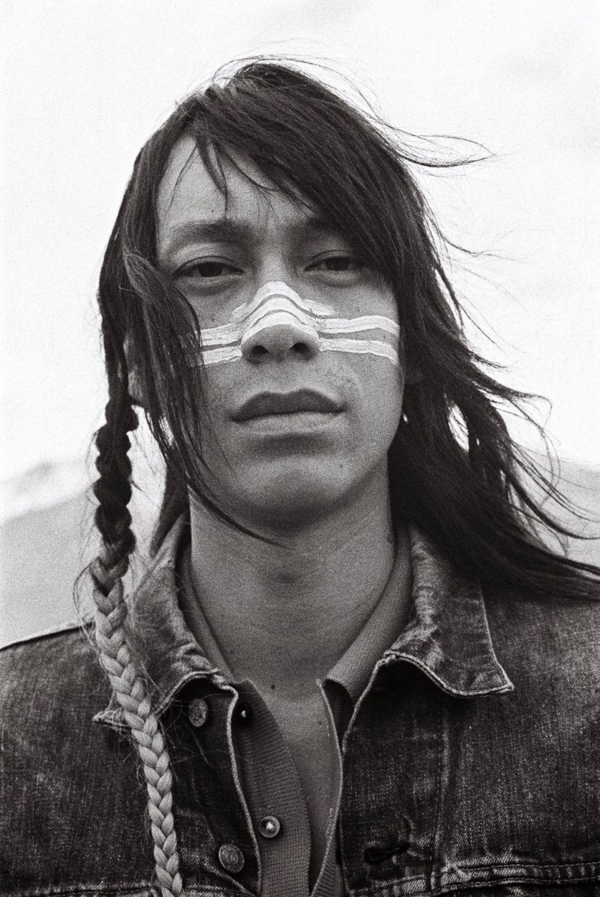** [The Dancer](https://www.facebook.com/ZellaDay/photos/a.179846278810293.37261.179843028810618/890794507715463/?type=3&theater) [The Painter](https://www.facebook.com/ZellaDay/photos/a.179846278810293.37261.179843028810618/889627974498783/?type=3&theater) [The Photographer](https://www.facebook.com/ZellaDay/photos/a.179846278810293.37261.179843028810618/890312174430363/?type=3&theater) [The Poet](https://www.facebook.com/ZellaDay/photos/a.179846278810293.37261.179843028810618/889223961205851/?type=3&theater)

**(photo credit: Saamuel Richard)**

**NORTH AMERICAN HEADLINE DATES KICK OFF JUNE 21**

**SUPPORTING DATES WITH FITZ AND THE TANTRUMS IN JULY,  
MICHAEL FRANTI IN AUGUST, AND MIIKE SHOW IN SEPTEMBER AND OCTOBER**

(June 9, 2016 ) **ZELLA DAY** has released the striking video for new single “**Mustang Kids.”** Shot in the bucolic environs of Bishop, CA, with director Tim Mattia (The 1975, Halsey, Cage The Elephant), the video finds Zella amongst a group of small town outcasts – *mustang kids* (*The Musician, The Dancer, The Painter, The Photographer, The Poet*) – escaping the trappings of societal confines and chasing the sweet release of rebellion. View now [HERE](https://www.youtube.com/watch?v=0V7HANV4yhc).

“I'm a Mustang Kid along with all of the rest of you. This is our story of triumph with all of the odds stacked against us. Some of us have different upbringings, belief systems, financial situations, and family dynamics but we all have one very serious thing in common and it's that each of us have a soul purpose. A Mustang Kid's soul purpose is what guides them, and in the end guides us to each other. I believe in all of the Mustang Kids who are creating, dedicating themselves, studying their craft, and pushing on through the heat of the world. We are powerful.   Love, -Z / [The Musician](https://www.facebook.com/ZellaDay/photos/a.179846278810293.37261.179843028810618/891318947663019/?type=3&theater)

In support of “[Mustang Kids](https://vimeo.com/user6142769/review/161684876/1a054a6ca0)” and debut album, [*KICKER*](http://zelladay.tumblr.com/tagged/MUSIC), the Arizona native is now taking her show on the road, with a string of headlining dates kicking off **June 21st** in **Kansas City, MO**. After that comes a run with Fitz and the Tantrums, followed by an August tour supporting Michael Franti & Spearhead.

Of her live show, ***Los Angeles***magazine described [ZELLA DAY’s](file:///C:\Users\sharrin%20summers\AppData\Local\Microsoft\Windows\Temporary%20Internet%20Files\Content.Outlook\XCTRCKFP\ZELLA%20DAY’s) recent Coachella performance as “hypnotic.” ***Idolator***said she “mesmerized the crowd*,”* ***Billboard***hailed her set as “stellar” and ***Consequence of Sound*** exclaimed *“*it's entirely possible that Zella Day looks back on Coachella 2016 as the moment that launched her career in earnest...Day is an undeniably powerful vocalist."

Tickets for the headline dates are on sale now. More information can be found by visiting Zella’s site [HERE](http://zelladay.tumblr.com/tour).

**ZELLA DAY tour dates as follows:**Jun 21 // Kansas City, MO @ The Tank Room **SOLD OUT**  
Jun 22 // Minneapolis, MN @ Triple Rock   
Jun 24 // Chicago, IL @ Lincoln Hall   
Jun 25 // Grand Rapids, MI @ The Stache   
Jun 26 // Detroit, MI @ The Shelter   
Jun 28 // Columbus, OH @ The Basement    
Jun 29 // Madison, WI @ The Frequency   
Jun 30 // Milwaukee, WI Summerfest   
Jul 2 // Montauk, NY @ Surf Lodge (free show)  
Jul 3 // Amagansett, NY @ The Stephen Talkhouse   
Jul 6 // Washington, DC @ U Street Music Hall   
Jul 7 // Brooklyn, NY @ Rough Trade

Jul 8 // Philadelphia, PA @ The Foundry at the Fillmore   
Jul 9 // Cambridge, MA @ The Sinclair   
Jul 11 // Montreal, QC @ La Sala Rossa   
Jul 12 // Toronto, ON @ Mod Club   
Jul 14 // Pittsburgh, PA @ Stage AE #  
Jul 15 // Richmond, VA @ The National   
Jul 17 // Nashville, TN @ 3rd and Lindsley   
Jul 19 // New Orleans, LA @ Civic Theatre #  
Jul 20 // Little Rock, AR @ Metroplex #

Jul 21 // Lafayetteville, AR @ George’s Magjestic Lounge #  
Jul 22 // Tulsa, OK @ Cain's Ballroom #  
Jul 23 // Dallas, TX @ House of Blues #  
Jul 24 // Austin, TX @ Stubb's # **SOLD OUT**  
Jul 26 // Albuquerque, NM @ Sunshine Theater #  
Jul 27 // Tempe, AZ @ Marquee Theater #  
Jul 29 // San Diego, CA @ Quartyard   
Aug 4 // Mammoth Lakes, CA @ Mammoth Festival \*  
Aug 5 // Flagstaff, AZ @ Pepsi Amphitheater  \*  
Aug 6 // Durango, CO @ Three Springs \*  
Aug 7 // Morrison, CO @ Red Rocks Amphitheater \*  
Aug 11 // Bend, OR @ Les Schwab Amphitheater \*  
Aug 12 // Troutdale, OR @ McMenamins Edgefield Amphitheatre \*  
Aug 16 // Missoula, MT @ Big Sky Brewing Company \*  
Aug 17 // Spokane, WA @ Knitting Factory Concert House \*  
Aug 19 // Lake Tahoe, NV @ Montbleu Resort   
Aug 21 // Saratoga, CA @ Mountain Winery   
Aug 23 // Rohnert Park @ Somo Village Event Center

Aug 25 // San Luis Obispo, CA @ Avila Beach Resort \*  
Aug 26 // Las Vegas, NV @ Brooklyn Bowl \*  
Aug. 27 // Orem, UT @ Timpanogos Music Festival   
Aug 30 // Aspen, CO @ Belly Up   
Sept 2 // Seattle, WA @ Bumbershoot   
Sept 3 // Edmonton, AB @ Sonic Boom Festival   
Sept 4 // Calgary @ X-Fest

Sept 10 // Reno, NV @ John Sala Intramural Fields  
Sept 17 // Atlanta, GA @ Music Midtown

Sept 27 // Boston, MA @ House of Blues ^

Sept 29 // New Haven, CT @ College Street Music Hall ^

Oct 2 // New York, NY @ Citi Field - The Meadows Music and Arts Festival

Oct. 3 // Albuquerque, NM @ El Rey Theater ^

Oct. 7 // Tucson, AZ @ Rialto Theatre ^

# w/ Fitz and the Tantrums   
\* w/ Michael Franti & Spearhead

^ w/ Miike Snow

More dates to be announced.  
  
[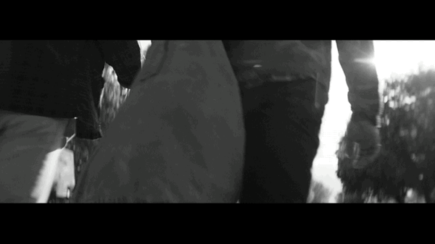](http://www.hollywoodrecords.com/wp-content/uploads/2016/06/IMG_9928.gif) [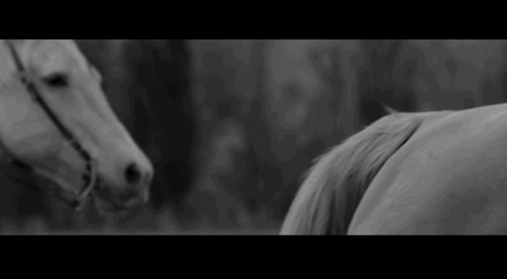](http://www.hollywoodrecords.com/wp-content/uploads/2016/06/IMG_9930.gif)

Over the course of the past year Zella has performed on ***Late Night with Seth Meyers*** and ***CONAN***, been covered by [*The FADER*](http://www.thefader.com/2014/02/25/stream-zella-day-sweet-ophelia)**,**[*The Guardian*](http://www.theguardian.com/music/2014/aug/15/zella-day-new-band-of-the-week-18)**,** [SPIN](http://www.spin.com/2015/02/zella-day-new-hypnotic-video/)**,**[*Noisey*](http://noisey.vice.com/blog/zella-day-isnt-your-typical-rising-pop-star)*,* [*Interview Magazine*](http://www.interviewmagazine.com/music/zella-day)*,* [*Vogue*](http://www.vogue.com/13390604/zella-day-jameson-acoustic-performance/), [*InStyle*](http://www.instyle.com/news/zella-day-coachella-2016-interview)*,* [*ELLE*](http://www.elle.com/culture/music/news/g27317/zella-day-tour-photo-diary/)***,***[*Vanity Fair*](http://www.vanityfair.com/culture/photos/2015/08/lollapalooza-portraits-backstage#9)*,* [W Magazine](http://www.wmagazine.com/sponsorarticle/zella-day-musician-style)***,***[*Harper's Bazaar*](http://www.harpersbazaar.com/culture/art-books-music/a13787/zella-day-interview/)***,***[*Refinery29*](http://preview.refinery29.com/how-to-prep-for-coachella-by-the-numbers?controller=index&action=entry&type=blog_entry&type_id=106836&preview=1&site=US)***,***[*FLAUNT*](http://flaunt.com/music/zella-day/)***,***[*PAPER Mag*](http://www.papermag.com/rising-singer-songwriter-zella-day-falls-in-love-with-an-alcoholic-hit-1427582817.html)***,***[*V Magazine*](http://www.vmagazine.com/site/content/4597/sounds-of-summer-zella-day)***,***[*NYLON*](http://www.nylon.com/articles/artist-to-watch-zella-day)***,*** [*WhoWhatWear*](http://www.whowhatwear.com/zella-day-coachella-interview), forged partnerships with clothing brands **Coach**, **Maje** and **Free People**, appeared at several **NYFW 2016** shows (including a performance at Rebecca Minkoff’s runway show), performed at **Coachella**, **Billboard Hot 100 Fest, iHeartRadio Music Fest** and **Lollapalooza,** and built a diehard international following on a strength of an electrifying live show hailed by the [*Chicago Tribune*](http://www.chicagotribune.com/entertainment/music/ct-lollapalooza-2015-day-two-20150801-story.html) for being filled with “Hooks galore, and choruses that swing for the fences.”

**BUY**[*KICKER*](http://smarturl.it/zda1)(iTunes) Ι [*KICKER*](http://smarturl.it/zdama1)(Amazon) Ι [*KICKER*](http://smarturl.it/zdsta1)(Streaming services)

**STREAM**["Hypnotic" official video](http://t.sidekickopen14.com/e1t/c/5/f18dQhb0S7lC8dDMPbW2n0x6l2B9nMJW7t5XZs4XXW0TW8qm6pM3M2lL-W1p1gwR56dy6tf4YQy0402?t=http%3A%2F%2Fvevo.ly%2FbTFL15&si=5135872386662400&pi=8a20a3a5-3957-4e53-8723-95f6c59f798d) (YouTube)  
 ["Jameson" art/concept video](https://www.youtube.com/watch?v=9nIgjrtqWmU) (YouTube) │ ["Sweet Ophelia" official video](http://t.sidekickopen14.com/e1t/c/5/f18dQhb0S7lC8dDMPbW2n0x6l2B9nMJW7t5XZs4XXW0TW8qm6pM3M2lL-W1p1gwR56dy6tf4YQy0402?t=https%3A%2F%2Fwww.youtube.com%2Fwatch%3Fv%3DtWpMFF5rxTo&si=5135872386662400&pi=8a20a3a5-3957-4e53-8723-95f6c59f798d) (YouTube)

**ASSETS**[Photos / Art / Bio](http://www.hollywoodrecords.com/press/zella-media-kit/)

**SOCIALS**[Official Website](http://t.sidekickopen14.com/e1t/c/5/f18dQhb0S7lC8dDMPbW2n0x6l2B9nMJW7t5XZs4XXW0TW8qm6pM3M2lL-W1p1gwR56dy6tf4YQy0402?t=http%3A%2F%2Fwww.zelladay.com%2F&si=5135872386662400&pi=8a20a3a5-3957-4e53-8723-95f6c59f798d) │ [Facebook](http://t.sidekickopen14.com/e1t/c/5/f18dQhb0S7lC8dDMPbW2n0x6l2B9nMJW7t5XZs4XXW0TW8qm6pM3M2lL-W1p1gwR56dy6tf4YQy0402?t=https%3A%2F%2Fwww.facebook.com%2FZellaDay&si=5135872386662400&pi=8a20a3a5-3957-4e53-8723-95f6c59f798d) │ [Twitter](http://t.sidekickopen14.com/e1t/c/5/f18dQhb0S7lC8dDMPbW2n0x6l2B9nMJW7t5XZs4XXW0TW8qm6pM3M2lL-W1p1gwR56dy6tf4YQy0402?t=https%3A%2F%2Ftwitter.com%2Fzelladay&si=5135872386662400&pi=8a20a3a5-3957-4e53-8723-95f6c59f798d) │ [Instagram](http://t.sidekickopen14.com/e1t/c/5/f18dQhb0S7lC8dDMPbW2n0x6l2B9nMJW7t5XZs4XXW0TW8qm6pM3M2lL-W1p1gwR56dy6tf4YQy0402?t=http%3A%2F%2Finstagram.com%2Fzelladay&si=5135872386662400&pi=8a20a3a5-3957-4e53-8723-95f6c59f798d) │ [SoundCloud](http://t.sidekickopen14.com/e1t/c/5/f18dQhb0S7lC8dDMPbW2n0x6l2B9nMJW7t5XZs4XXW0TW8qm6pM3M2lL-W1p1gwR56dy6tf4YQy0402?t=https%3A%2F%2Fsoundcloud.com%2Fzella-day&si=5135872386662400&pi=8a20a3a5-3957-4e53-8723-95f6c59f798d)

**For more information, please contact  
Sharrin Summers, Hollywood Records,**[**818.560.5787**](tel:818.560.5787)**,**[**sharrin.summers@disney.com**](mailto:sharrin.summers@disney.com) **Mark Simek, Drill Down Media,**[**815.651.1818**](tel:815.651.1818)**,**[**mark@drilldown-media.com**](mailto:mark@drilldown-media.com)