Queen Performs Freddie Mercury Solo Song 'Love Kills' for First Time Ever

By Lyndsey ParkerJune 16, 2014 11:41 PMMaximum Performance
https://music.yahoo.com/blogs/live/queen-performs-freddie-mercury-solo-song--love-kills--for-first-time-ever-034144123.html
- 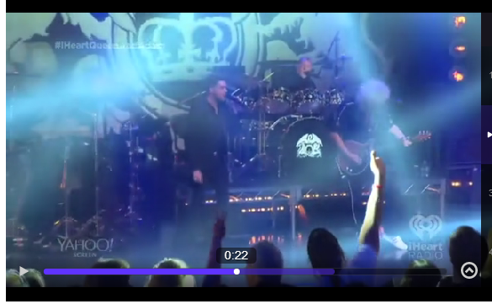

Queen + Adam Lambert embark on their first U.S. arena tour this Thursday, June 19, but on Monday night at their iHeartRadio Live show streamed on Yahoo Screen, 400 lucky fans got a preview of the tour, at the much more intimate iHeartRadio Theater in Burbank. And there, they were treated to a massive surprise on the new Queen setlist: "Love Kills."
[Related: 10 Facts You Might Not Have Known About Queen]
"Love Kills" is a relatively obscure song, but Queen fanatics definitely know (and love) it. It was late, great original Queen frontman Freddie Mercury's first song recorded as a solo artist, and was featured on electronic music legend Giorgio Moroder's soundtrack for the 1984 rerelease of Fritz Lang's classic 1927 silent film, Metropolis. While the track wasn't necessarily well-received at the time (it was actually nominated for "Worst Original Song" at the 1985 Razzie Awards), it did make it to No. 10 on the U.K. singles chart, and it went on to become a cult classic.View pho
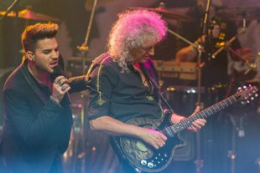
photo: Paul A. Hebert/Invision/AP
According to Queen's publicist, Queen never performed "Love Kills" live with Freddie, who died in 1991. Freddie never performed it solo, either. But almost 30 years after the song's release, Queen members Brian May and Roger Taylor debuted a live version at the iHeartRadio Theater, with Adam Lambert singing lead.
This was a gutsy move. With rock purists likely already wondering if any singer, even one as talented as Adam, could ever "replace" Freddie Mercury, Queen + Adam Lambert reviving a Freddie solo song could have massively backfired.
[Related: Adam Lambert Admits He Discovered Queen Through 'Wayne's World']
But by putting a unique, semi-acoustic spin on the track, they remained respectful to the original — and to Freddie's legacy. "We're going to do it in our own way, minus the disco," Adam explained to the iHeartRadio audience.
Compare and contrast Queen + Adam Lambert's version of "Love Kills" above with Freddie's original below:
While the entire iHeartRadio show was basically one 50-minute highlight, another standout performance was definitely the "Under Pressure" duet, with Adam singing Freddie's stratospherically high parts and drummer Roger Taylor taking on the David Bowie role. Roger sounded so uncannily Bowie-esque, in fact, that if any fans watching this number had closed their eyes, they might have actually believed that the Thin White Duke himself was making a surprise cameo.
"I don't know about you, but I could have heard 15 more songs," gushed the concert's host, Mötley Crüe bassist/Sixx Sense iHeartRadio DJ/avowed Queen fan Nikki Sixx, once the show was over. And it is true that Queen left spectators wanting more on Monday night. But they gave those concertgoers one very special song they'll never forget.
[Related: They Are the Champions: A Queen + Adam Lambert Timeline]
The complete Queen + Adam Lambert iHeartRadio Live setlist was:
We Will Rock You
Another One Bites the Dust
Crazy Little Thing Called Love
Love Kills
Fat Bottomed Girls
Under Pressure
We Are the Champions
Don't Stop Me Now
Follow Lyndsey on Twitter, Instagram, Google+, Amazon, Tumblr, Vine, Spotify
View Comments (335)

